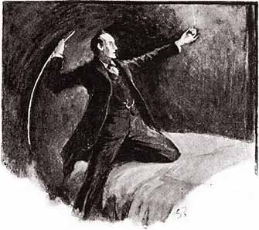
THE GAME IS AFOOT
ONCE AGAIN!

Watson’s Tin Box of Ellicott City
In collaboration with

Howard County Library and
Howard County Public School System

Present

The 2nd Annual Sherlock Holmes Essay Contest for Seventh Graders

Howard County Public, Private, and Home Schooled Seventh Graders are eligible to participate.

Read the Adventure of the Speckled Band
by Sir Arthur Conan Doyle!
Write an analytical essay!
Prizes will be awarded!

Entrants must obtain a copy of the Contest booklet which includes the story, the essay questions, the official entry form, and other information. This booklet is available on the web site of Howard County Library (www.hclibrary.org).
Essays must be received by May 5, 2006.

This Contest Is Funded By


