Evening Program

7pm-Everyone Seated

7-7:30pm- Speeches

7:30- Dinner

8:45- Cake cutting
&
Piano Played by Andrew Fong

9pm- First Dance: Lao Music
Followed by Lao Dancing for all

9:30 First Dance: English Music
Followed by Dancing

10:30pm-Special Guest Performance

11pm Last Call at bar

11:30 Bar closes

Midnight- END

Morning Program

9:30am- Buddhist Ceremony

10:45am- Guests Assemble Outside

11am- Civil Ceremony

Noon- Lunch

1-2pm Photographs with Grooms

-Intermission-

Reconvene at Heritage Hall- 6pm

3102 Main Street, Vancouver

Peter
-&-
David

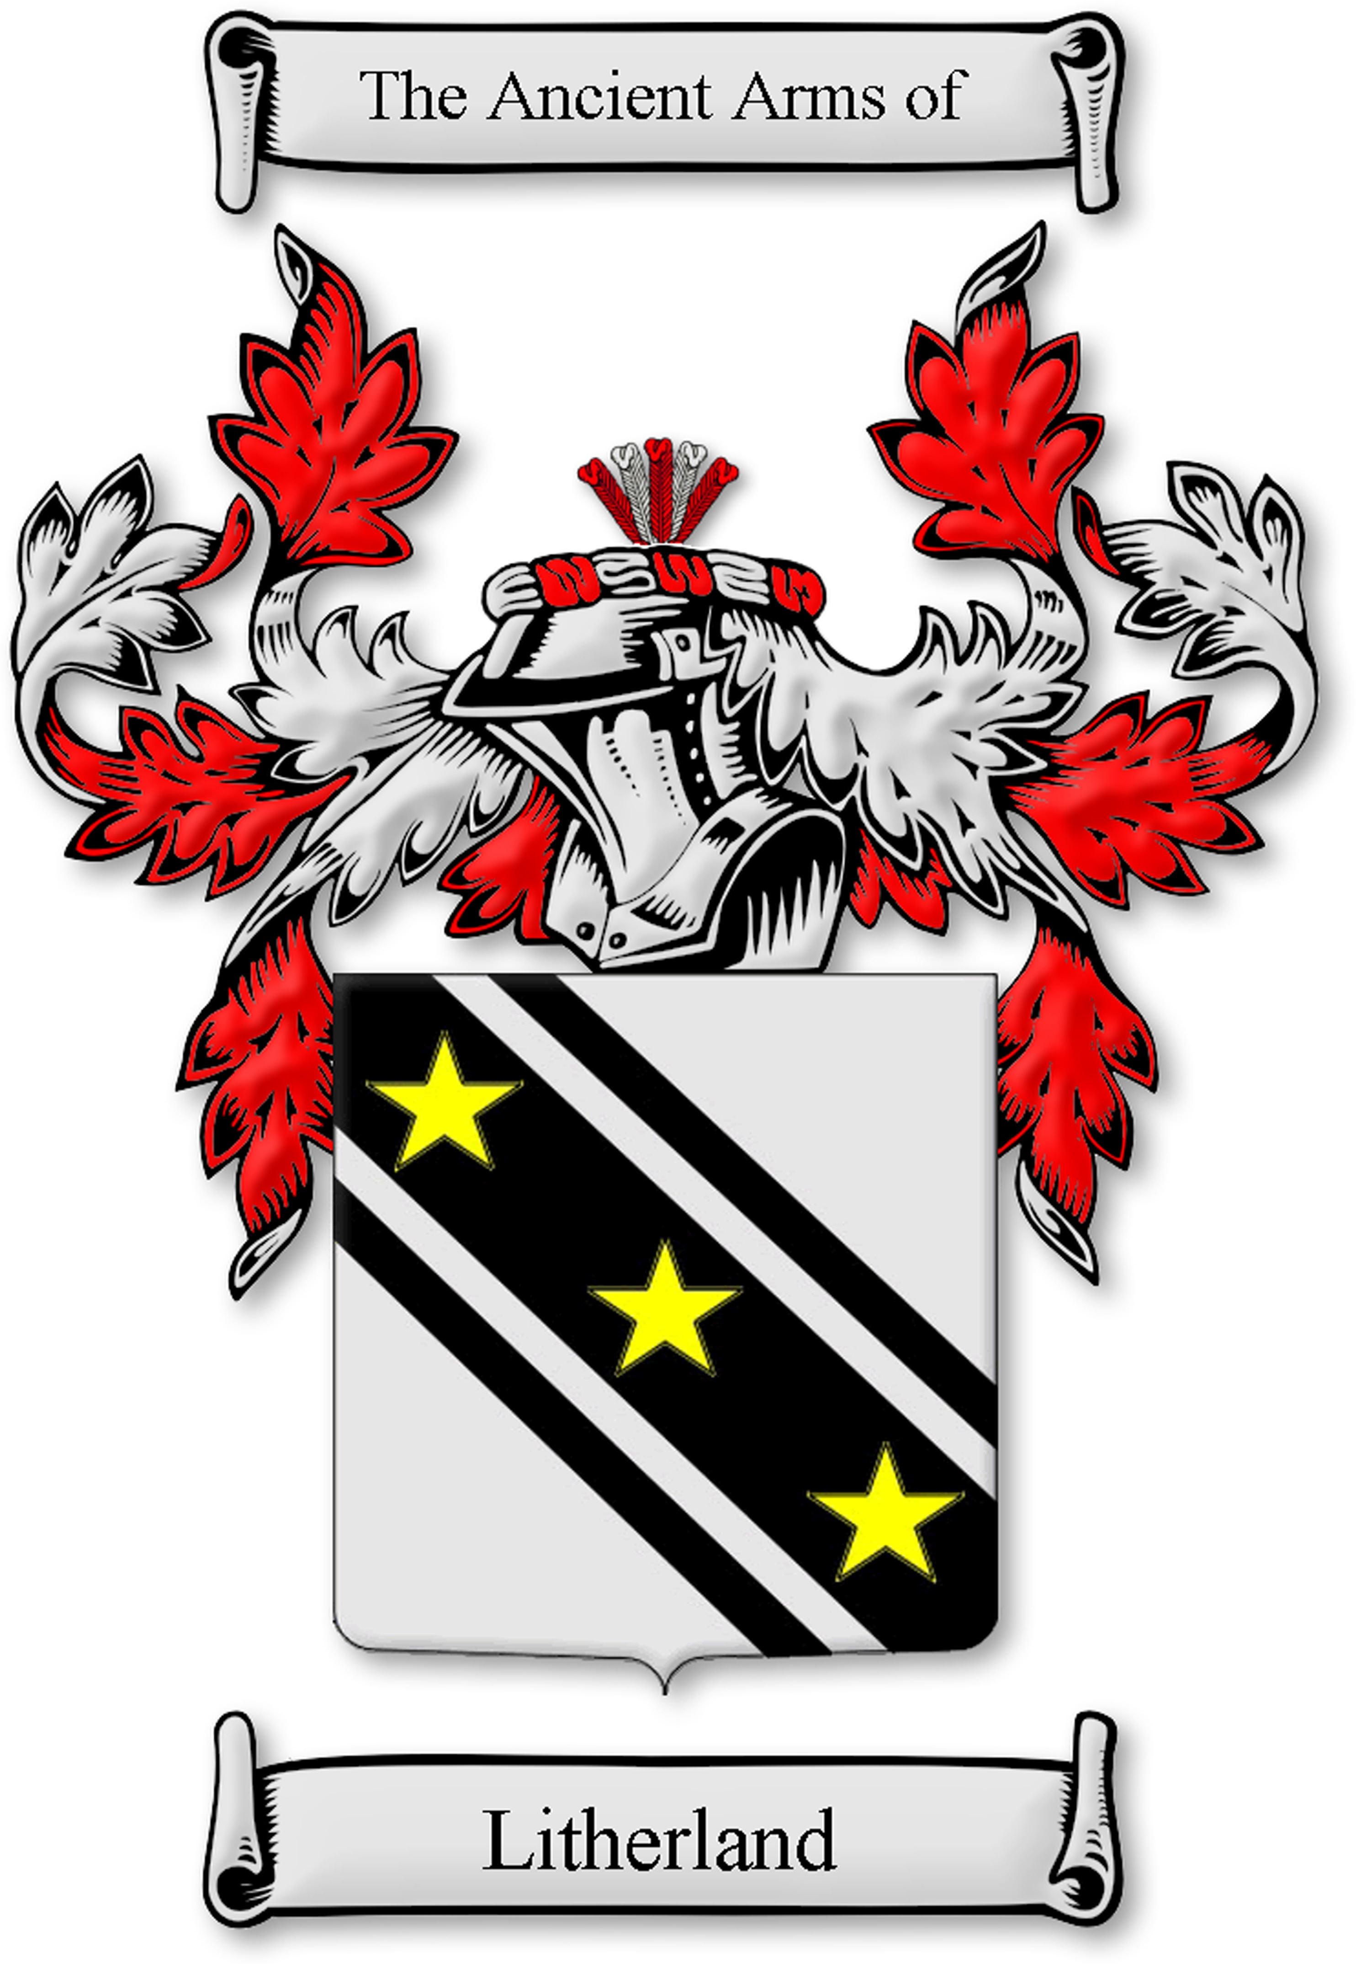

Friday May 2nd, 2008

