Breeds of buffalo in India

Buffalo belongs to family Bovidae and from time immemorial has been a domestic animal in India, Malaya, and Egypt. It occupies an important place amongst the domestic animals of tropic as a provider of dairy production, for draught powers and major source of beef production. According to an estimation of F A O 1956, in India there are 44766000 numbers of buffalo. Only in India there are found well-defined tropical breeds with standard qualities and, even there, well-bred individuals are far out numbered by nondescript animals. In other countries, although distinct types are to be found, no type has the specific physical characteristics which mark it from other types so that it can be unquestionably recognized.
Good, well defined, milk breeds are found only in the Punjab, Rajasthan, and the Gujarat district on Bombay, but in central and south India there is a noted draught breed (Olver, 1938). The best known Indian buffaloes are the Murrah, the Nili/Ravi, Jaffarabadi, Surti, Mehsana and Nagpuri or Ellichpuri.
1-MURRAH

Murrah breed of buffalo, the pride of Haryana, is a milk type animal. The Murrah is the most important Indian breed of buffalo, and is the most efficient producer of milk, not only in the India but probably in the world. Bulls of this breed are used extensively for up-grading inferior stock. She-buffaloes are used in most of the important cities for the supply of milk and ghee.
- Home:-
The home tract of Murrah buffalo is Rohtak, Jind and Hisar districts of Haryana (India). It is also found in Nabha and Patiala districts of Punjab (India) and around Delhi.
- PHYSICAL CHARACTERISTICS:-
Some of the important physical characteristics of Murrah are given below:-
  - Body: Sound built, heavy and wedge shaped.
  - Head: Comparatively small.
  - Face: Comparatively long.
  - Neck: Comparatively long.
  - Body color: Jet-black.
  - White markings on face and leg extremities may be there (2, 3), but are not generally preferred.
  - Eyes: Should not be walled i.e. the cornea should not have whiteness.
  - Tail: Long reaching up to fetlock joint (2, 3, and 6) with black or white switch up to (maximum) 8.0 inches (4).
  - Horns: Different from other breeds of buffaloes; short, tight, turning backward and upward and finally spirally curving inward. The horns should be somewhat flattened. As the age advances the horns get loosened slightly but spiral curves increases.
  - Limbs: Comparatively short but strong built.
  - Skin: Soft, smooth with scanty hairs as compared to other buffaloes.
  - Udder: Fully developed, drooping.
  - Teats: Equally distributed over the udder but hind teats are longer than fore teats.
  - Loin: Broader and sliding forward.
  - Body weight: The average body weight of males, 1200 pounds (544.3 Kg) and the females, 1000 pounds (453.6 Kg.)
  - Height: The average height at withers; male: 1.42 meter; female: 1.32 meter.
  - Length: The length from point of shoulder to pin bone is 150.9 cm in males and 148.6 inches in females as an average for mature adult Murrah buffalo.
- Production parameters
  - Age at fist calving: 3 years but we have also the buffaloes, which calved at 3 years with good milk production.
  - Inter-calving period: 400 to 500 days.
  - Lactation period: 300 days. (With minimum of ~230 days recorded under top quality Murrah). (I.C.A.R, 1950)
  - Daily lactation in peak period: 14 to 15 litters but up to 31.5 Kg milk production had also been recorded. The elite Murrah buffalo produces above 18-litter milk per day. A peak milk yield of 31.5 kg in a day has been recorded from a champion Murrah buffalo in the All India Milk Yield Competition conducted by the Government of India.
  - Dry period: About three months. But less than three may be there.
  - Gestation period: 310 days (average)
  - Milking capacity: about 4000 pounds (1814 kg.) (I.C.A.R, 1950)
  - Fat percentage: it has a fat percentage of about 7.5 as an average.

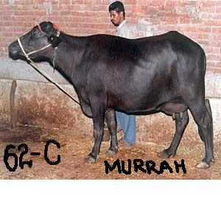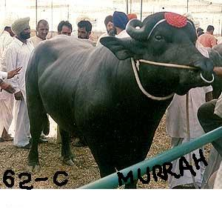
2-NILI/RAVI
The Nili and Ravi are two types of buffaloes there is no essential difference between the two types although for a long time they were treated as different breeds, but closer study indicated that it was a distinction without a difference, and now they are officially treated as one breed. This is considered to be one of the best breeds of buffaloes in India next only to the Murrah. Like the Murrah large number of the animals is exported annually from the breeding areas for milk production in cities.
Home: - found in the valley of the rivers Sutlej and Ravi in districts of Montgomery and Ferozepur (I.C.A.R., 1950).
- Physical characteristics:-
Some of the important characteristics can be described as fallows: -
- Body: medium-sized and massive.
- Head: The head is long and convex bulging at the top depressed between the eyes and ending in a fine muzzle.
- Horns: Horns are small with a high coil.
- Neck: Neck is long, thin and fine.
- Udder: Udder is well developed.
- Tail: Tail is long almost touching the ground.
- Color: The color is usually black but brown is not uncommon.
- Teats: teats are squarely placed and long.
- Milk veins: Milk veins are very prominent.
- Pink markings: Some times there are pink marking on the udder and brisket.
- White markings: One important character of this breed is that, it bears white marks on the forehead, face, muzzle, legs and around the eyes.
- Weight: Live weight of mature animal is 1300 pounds (589.7 kg.) in male and 1000 pounds (453.6 kg.) in female.
- Height: height at withers is 137.2 cm for males and 135.9 cm for females.
- Length: The length from point of shoulder to the pin bone is 158.8 cm in male and 148.6 cm in female.
- Production parameters :-
- Age at maturity: 30 months in male and 36 months in female.
- Lactation length: 250-300 days.
- Milk production: 1800-2000 liters
- Age at first calving: about 3 years.
- Dry period: about 2-3 months.
- Fat percentage: More than 6 %.
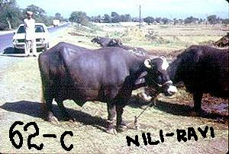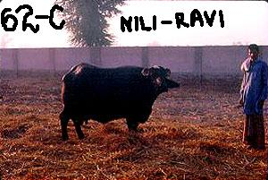

3-SURTI
The Surti breed is considered as an important breed in India. In India, Surti is also known as Charotar, Deccani, Gujarati, Nadiadi, Surati, and Talabda.
- home:-
- the home tract of this breed is Gujarat in Bombay state between the Mahi and Sabarmati rivers.
- Population data:-
:
 | Total population size: | 472000
 | Population figures based on: | census at species level
 | Reliability of population data: | reliable
 | Total number of breeding females: | 260000
 | Total number of males used for breeding: | 1800
 | Population trend: | decreasing
 | Percentage of females being bred pure (mated to males of own breed): | 70
 | Number of males in AI service: | 300

- Physical characteristics:-
- Shape and size: - These are well shaped and medium sized.
- Appearance: general appearance is bright, with prominent, round, rather bulging eyes.
- Horns: The horns are of medium length and are sickle shape.
- Back: No other breed has as much as straight back as this has.
- Collars: These have two white collars, one around the jowl from ear to ear and a second lower down around the brisket.
- Udder and teats: Udder is well developed with pinkish colored skin and medium sized teats, placed squarely.
- Height: height at withers for male is 130.8 cm and for female is 124.5 cm.
- Length: Length for male is 154.2 cm and for female is 138.4 cm.
- Production parameters:-
- Age at first parturition: 35-56 months
- Parturition/clutch interval: 535 days.
- Milk yield per lactation: 1500-1750 kg. With 7.5 % butter fat.
- Lactation length: 340 days.
Breeds of cattle in India
There are approximately 26 different breeds of cattle in India and all of them are Zebu cattle.
1-SAHIWAL
Sahiwal has proved to be the best dairy type breed of Indian-subcontinent and is probably the best tropical dairy breed in the world.
Home:-
Sahiwal cattle also known as Montgomery cattle and Lola (native meaning loose skin). It has been spelt one sanewal. The home tract of this breed is central and southern area of the west Punjab in the neighborhood of the Ravi and Nili Bar Rivers about where the city of Sahiwal now stands.
Spread of breed export:-
- Before partition Sahiwal had been taken for dairy purposes to other parts of the Indian sub-continent. As a result there are four different stud-groups of Sahiwal in the united provinces of India, in addition to that maintained at pusa, New Delhi.
body charecteristics:-
  - Body: These are heavily built, lethargic animals.
  - Color: reddish dun or light brownish red color, sometimes bearing white markings.
  - Skin: The skin is loose and pliable,
  - Hair: The hair are very fine.
  - Udder: The udder is generally large and often pendulous.
  - Legs: they are short legged animals.
Milk production: - Cows average 2270 kg of milk during lactation while suckling a calf and much higher milk yields have been recorded.
These are high yielding animals and are considered as the best milk producers. Ware (1941), in recording the milk production of the cows of one of the best herds of Sahiwal cattle in India, states that of 289 lactations, 117 exceeded 6000 pounds(2722 kg), 66 more than 7000 pounds ( 3175 kg) 30 exceeded more than 8000 pounds ( 3629 kg), 16 more than 9000 pounds (4082 kg) , 6 exceeded 10000 pounds(4536 kg), and one cow produced 12000 pounds (5442 kg) and an other one produced 13000 pounds (5895 kg). The average fat contents of this milk were 3.9 %.
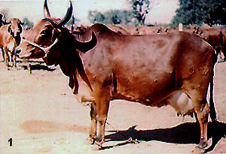

2-GIR
The Gir is one of the principal Zebu or Bos indicus breeds in India and is used for both dairy and beef production. It has been used locally in the improvement of other breeds including the Red Sindhi and the Sahiwal. It was also one of the breeds used in the development of the Brahman breed in North America.
HOME:-
The breed is native to the kathiawar of western India in an are situated between 20-22 degree north in latitude, where the average maximum temperature is 36.7 degrees centigrade.
Origin: - They originated in southwest India in the state of Gujerat and have since spread to neighboring Maharashtra and Rajasthan.
Characteristics:-
- They are the pronouncedly convex
- Head: broad forehead hanging over the eyes so that it gives a heavy eye appearance.
- Ears: ears are very long and pendulous running to a pointed extremity near which there is a notch.
- Horns: horns are peculiarly curved.
- Skin: skin is excessive loose with a large, low-hanging sheath in the males.
- Color: the color is often mottled red of varying intensity but is more generally white with clearly defined patches of red, brown or even black; roaning is not uncommon.
- This is the best beef production breed. It is also used in milk production as well as in draught purposes.
- Height: height of the female is 130 cm and the male is 135 cm.
- Weight: weight of female is 385 kg and the male is 545 kg.

Production parameters:-
  - The average milk production for the Gir is 1590 kg per lactation, with a record production of 3182 kg
  - The fat percentage of the Gir is 4.7 %

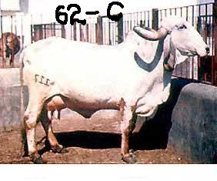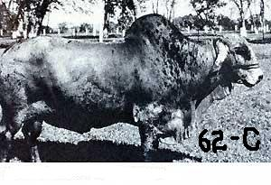

3-ongole
This is a northern Madras breed which is reared on alluvial black cotton soil in a climate where the mean maximum temperature is highest in the month of May at 40.4 degree centigrade.
origin: - Ongole breed, like other breeds of cattle in India, takes its name from the geographical area in which it is produced. It is also called the Nellore breed for the reason that formerly Ongole Taluk, a division of a district, was included in the Nellore district, but now it is included in the Guntur district. The area is part of the Andhra Pradesh in India.
Characteristics:-
- Color: the color of Ongole is white but the hump, neck parts and the head of the bulls is grey.
- Skin: It is fairly thick, loose, elastic, and bears fine hairs on it.
- Neck & Back:-Neck is short and the back is broad and long.
- Dewlaps: - large dewlaps which are fleshy and hang in folds extend to the navel flap, and slightly pendulous sheaths.
- Eyes and Ears: - Eyes are elliptical in shape with black eyelashes and a ring of black skin about 1/4 to 1/2 inch wide around the eyes. Ears are moderately long, measuring on an average for 9 to 12 inches, and slightly drooping.
- Horns: - Horns are short and stumpy, growing outwards and backwards, thick at the base and firm without cracks. In some animals the horns are loose; this is probably due to the horn core not growing well.
- Hump: - The hump in the males is well-developed and erect and filled up on both sides and not concave.
* They have a white switch of the tail, white eyelashes, a flesh colored muzzle, light colored hooves, dark gray marking on the hindquarters and dark mottle appearance on the body.
Production parameters: -
Lactation period: - 313 days.
Inter-calving period: - 479 days.
Milk production: - 3030 pounds (1374 kg.)
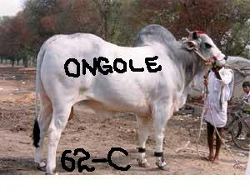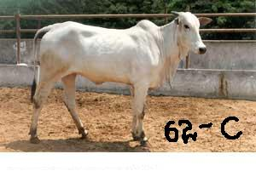
Cross breeds of cattle in India
Karan Swiss
The Karan Swiss were developed in India at the National Dairy Research Institute at Karnal. The breed was developed using Brown Swiss and Sahiwal. The percentage of Brown Swiss in the breed ranges from 1/2 to 3/4 of the breeding. The Karan Swiss is a dual purpose breed with the oxen being well suited for work and the cows giving good quantities of milk.
Characteristics: -
- Color: - The breed is usually light gray to dark brown in color
- Weight: - females weigh 400-500 kg. While male weighs 600-750 kg.
- Height: - female height is about 126 cm. while male height is 136 cm.
Production parameters: -
  - Milk production: - 5000-6000 kg during one lactation
  - Fat percentage: - Fat percentage is about 4.78 %
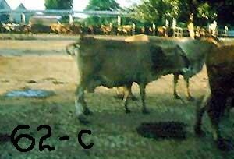
2-sunandni
ORIGIN: - The origins of the Sunandini in India can be traced to the importation of 22 Brown Swiss bulls and 45 cows during the period from 1964 to 1967 (Crettenand and Chacko, 1976, personal communication). The bulls were mated to a nucleus stock of 140 nondescript cows. Subsequently, semen from 11 more bulls was imported.

characteristics: -
While drawing up the characteristics of the breed, importance was given mainly to its economic, rather than phenotypic, characteristics. This was all that was possible because of the mixture of different exotic breeds in this synthetic breed. Before the original Brown Swiss cross - type of animal was mixed with Jersey and later Holstein blood, it had a uniform phenotypic appearance with a short flat head, small ears, short thick horns projecting outwards and curving inwards and a body colour ranging from light grey to black. With the introduction of the Jersey and Holstein inheritance, however, the phenotypic appearance of the Sunandini has become heterogeneous. The only phenotypic characteristic that can now be considered typical to the Sunandini is the straight back and comparatively short flat head. The colour varies from different shades of grey to brown.
• mature body weight of 350 to 400 kg;
Production parameters: -

• age at first calving from 28 to 32 months;
• first lactation milk yield of 2 300 to 2 700 kg;
• overall lactation yield of 3 200 kg;
• milk fat percentage of 4.
The production particulars of the Sunandini cows maintained at the nucleus farm at Mattupatty according to lactation number the overall average number of days milked was 279.8 and the overall lactation milk yield was 2435 kg. Selected areas in the field are controlled under a milk-recording programme. Every year approximately 2 000 cows in their first lactation are milk recorded.

3- Karan Fries

orgin: -

The Karan Fries were developed in India at the National Dairy Research Institute at Karnal. The breed was developed using Holstein (Friesian) and Tharparkar. The percentage of Holstein in the breed ranges from 3/8 to 1/2 of the breeding.

Production parameters:-

Milk production in one day: - 20-25 kg.

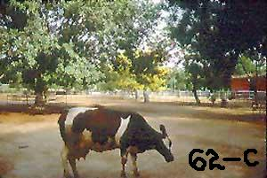

Reference:
Trop agriculturist 109,257 by Anker ladeford 1953 A V .beef cattle breeding and measurement by Pastrol Review pty ltd Melbourne. Bulll 278 by Maccron Brid. Kikul S B 1953 E Afric. Agric 19,86. Lal H K 1948 indian J Veterinarian society 18, 37. Year book of food and agriculture stat 9 room F A O Hammond j 1952. Breeding beef and dairy cattle for unfavorable environments by curson.
- Animal Husbandry by WILLIAMSONS
- Cattle development
- Animal Husbandry and rural development by Nishmani kar
- http://www.ansi.okstate.edu/breeds (Oklahoma State University Board of Regents.)
- http://www.embryoplus.com/cattle_breeds.html
- http://planningcommission.nic.in/aboutus/committee/wrkgrp/wg_anhbndry.pdf
http://www.geocities.com/host_2004just4u
BY:-
- WASEEM SHAUKAT
- ROLL # 62-C
- 1ST YEAR DVM, SEMESTER 1ST.

