Hideyo’s Adventures at Fuller Theological Seminary in Pasadena
“And lead us not into temptation, but deliver us from the evil one.” –Matthew 6:13 (NIV)
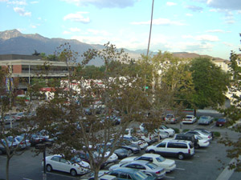
“This chair… it would be good for lovers, yes?”

Andreas is a member of my small group for a class entitled “Foundations of the Ministry.” He is a tall, lanky, Swedish man. He walks into the room where our group of seven is meeting and saunters over to the dish chair. Sitting down in it and feeling quite comfortable, in a room full of M.Div (Masters of Divinity) students, he notes that the chair is indeed, good for lovers.

Starting my seminary education at Fuller has been enriching. I’ve met people who call places other than the U.S. home, and even more people with years of cross-cultural experience. In 10 weeks: China, Korea, India, Saudi Arabia, Sudan, Kenya, Zimbabwe, Colombia, Mexico, and Indian reservations.
Looking out over Pasadena from the Fuller campus.

This fall quarter, I took two classes for 13 units. The aforementioned “Foundations of the Ministry” class for 1 unit and the “Intensive Beginning Greek” class for 12 units. Our class of 25 met three times a week for 10 weeks with each session starting at 8AM and ending at 1PM. Not only are we now finished with the required Greek curriculum, but we also grew closer as classmates and brothers and sisters. We also discovered that the Fuller cafeteria serves a great breakfast for $2.25.
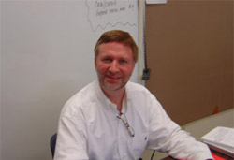
Finding community has been challenging as expected. I’ve visited seven different churches in eleven weeks. I’m currently praying about which church to attend for the remainder of my time in the San Gabriel Valley. I joined Fuller’s intramural Flag Football league and though my team finished dismally, I had a good time.

Exegetical Insight: The verse above, from the Lord’s Prayer, is best translated in the NIV. Traditionally, the verse states “but deliver us from evil.” The presence of the definite article, του, in front of the word for evil, however, indicates that Jesus was not saying that we be protected from evil, the concept, but evil, the being. Thus, “the evil one.”
My Greek teacher, Mark Hall.

Thank you all for your continued love, support, and prayers. Please note my Southern California address listed below in the footer. Merry Christmas.

hideyo@gmail.com http://www.geocities.com/hopping_keroppi (510) 557-4533
2506 Birch St.Alhambra, CA 91801

