SUMMARY OF GRAPHS
Ellipses
+ = 1  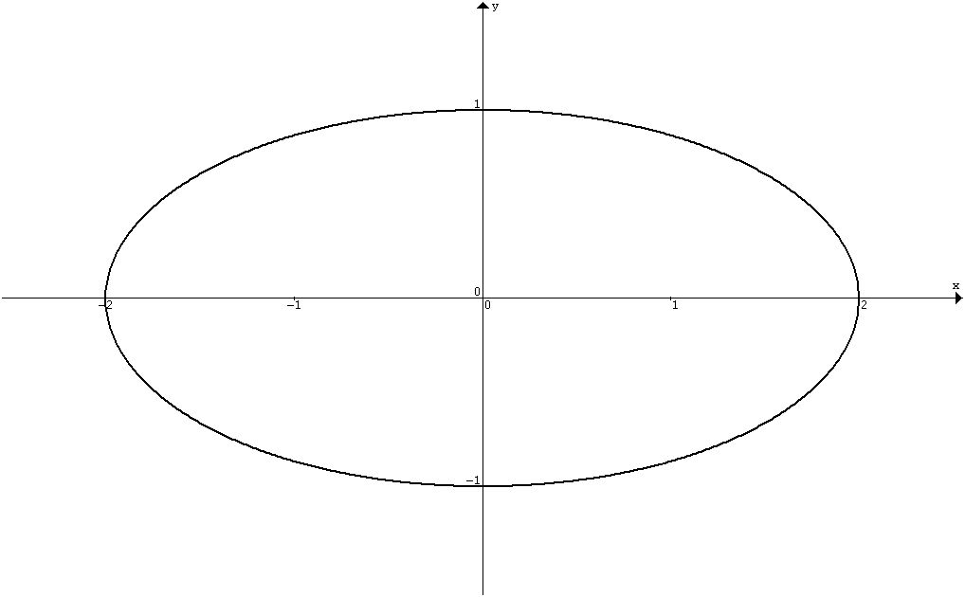  a  b  –b  –a | + = 1  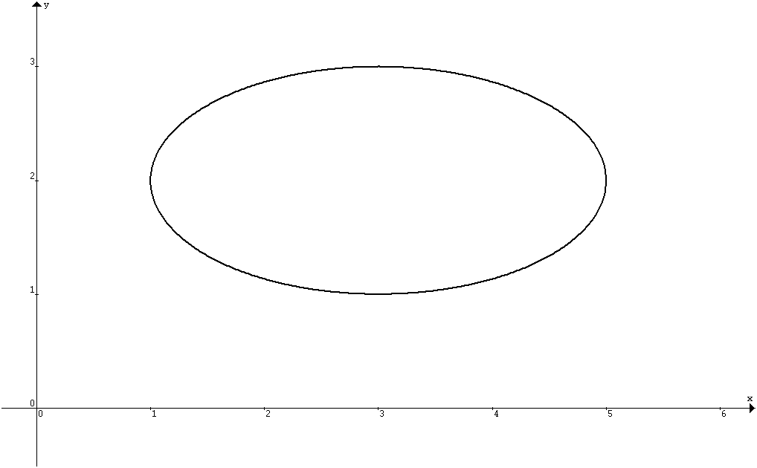  h  k  a  b
Hyperbolas
– = 1  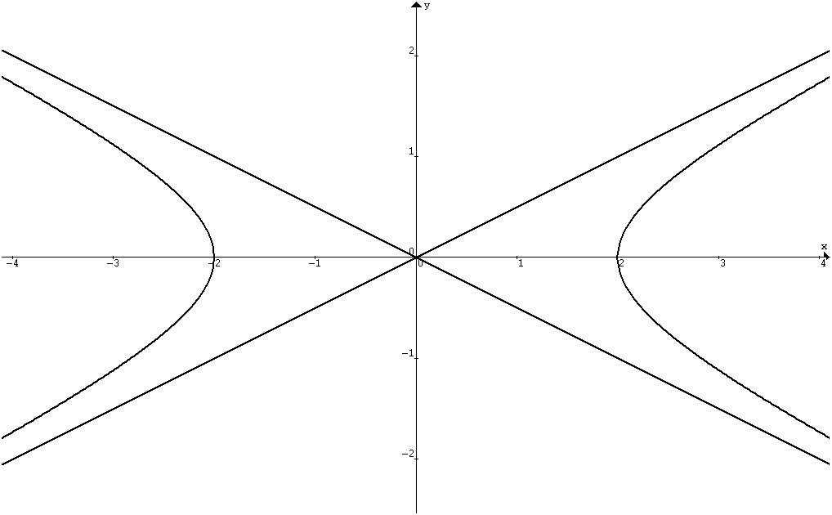  a  –a | – = 1  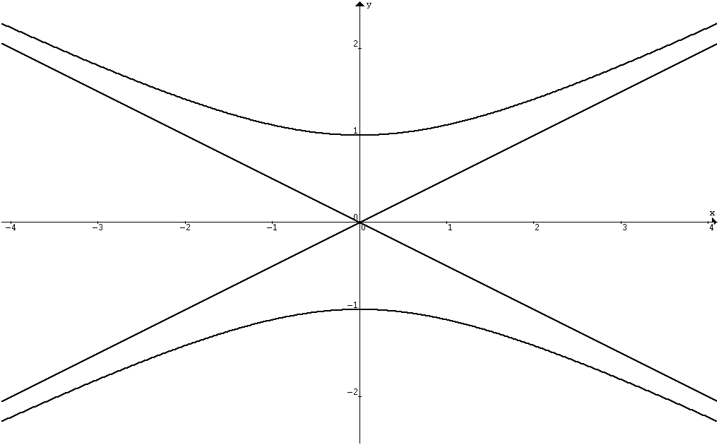  b  –b
The asymptotes are | y = ± x
– = 1  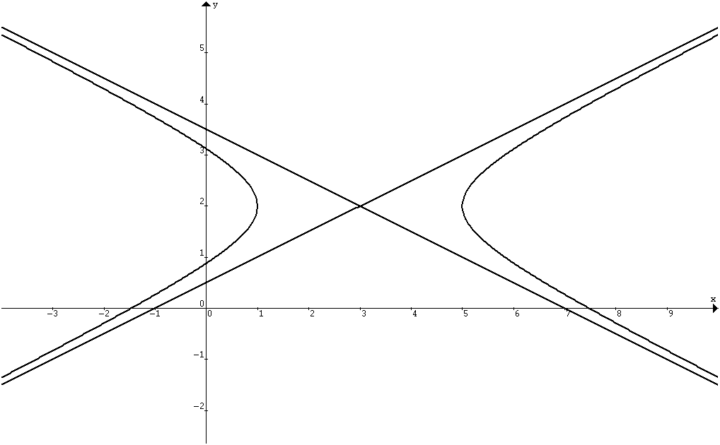 | – = 1  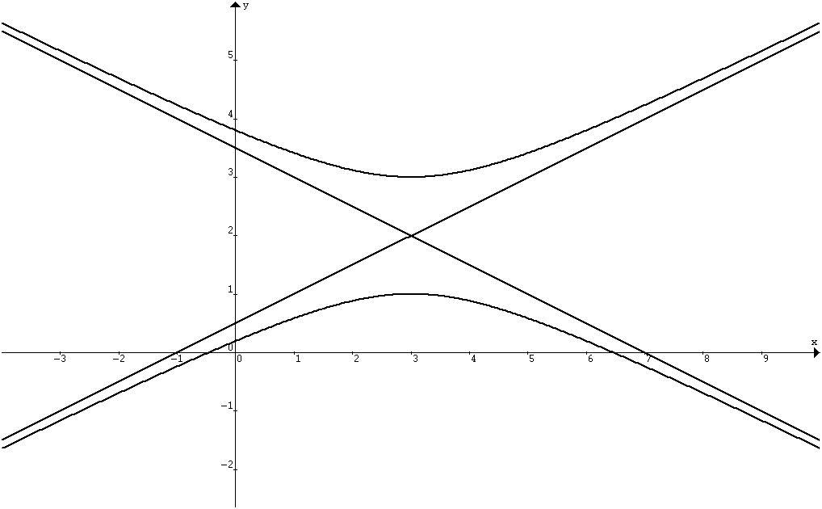
The asymptotes are found by solving | = ±
Graphing Techniques
y =  The vertical asymptote is x = c  The horizontal asymptote is y = a  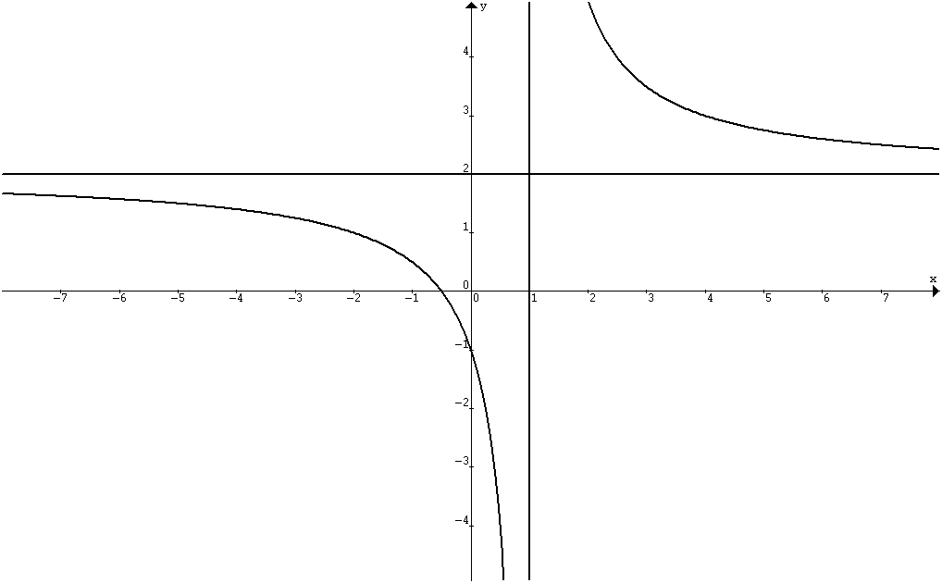 | If degree of numerator is 1 > the degree of the denominator, the graph has an oblique asymptote.  E.g. y = = x – 4 + by long division.  The oblique asymptote is y = x – 4.  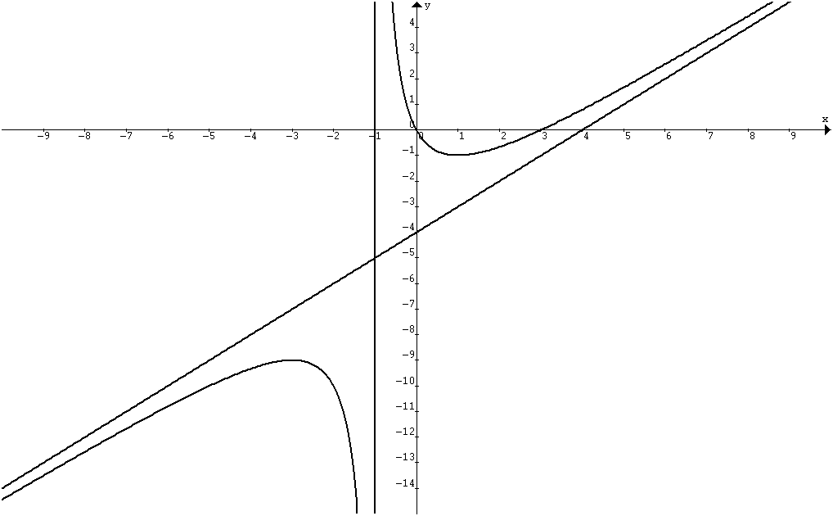
Transformation of Graphs
Translation parallel to y–axis: y = f(x) + a  y = x²  y = x² + 1  y = x² – 1  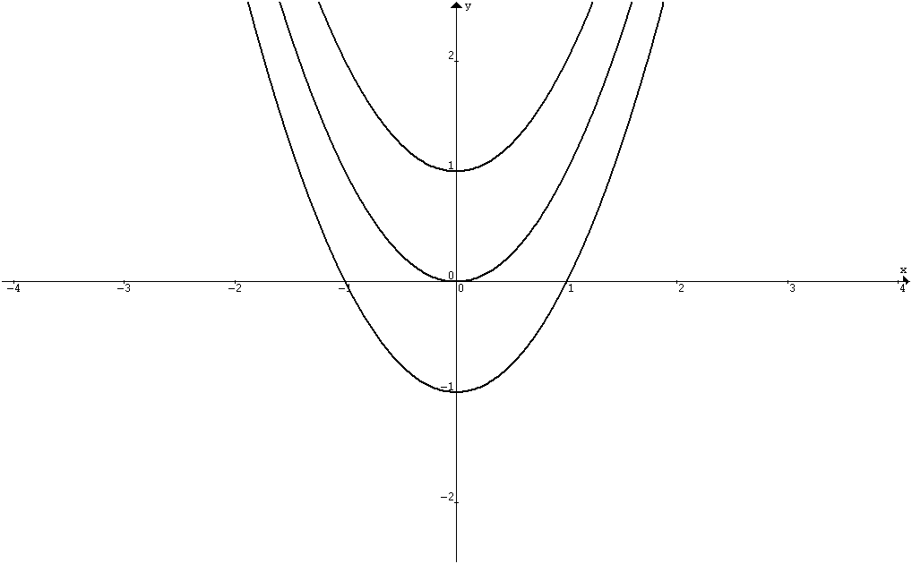  y = x²  y = (x – 1)²  y = (x + 1)² | Translation parallel to x–axis: y = f(x + a)  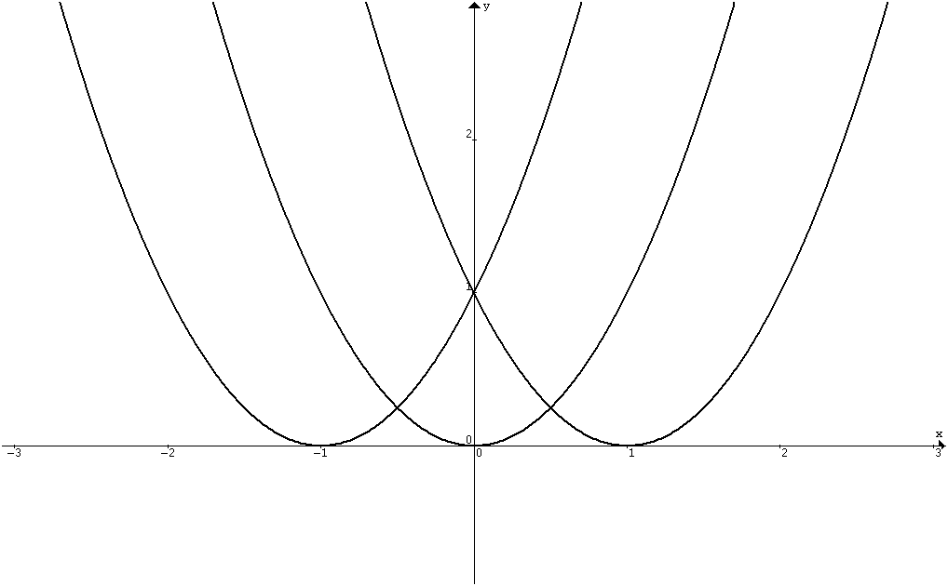
Scaling parallel to y–axis: y = a f(x)  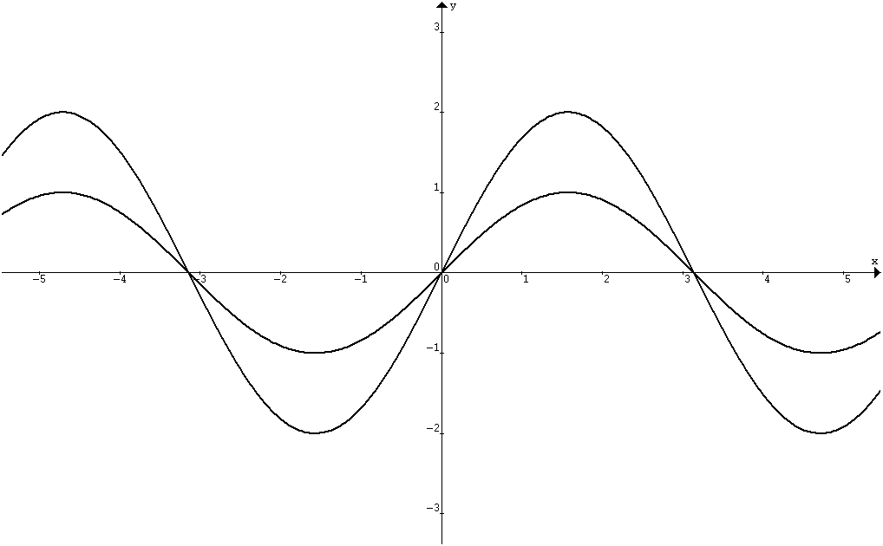  y = sin x  y = 2 sin x | Scaling parallel to x–axis: y = f(ax)  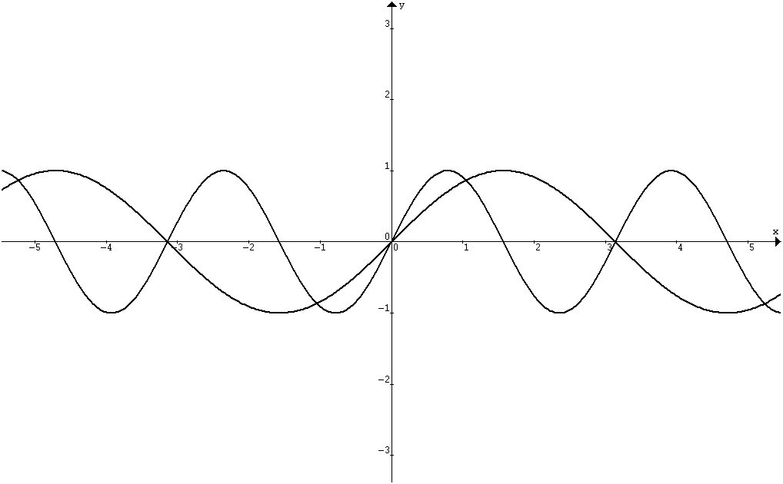  y = sin x  y = sin 2x
Reflection along x–axis: y = – f(x)  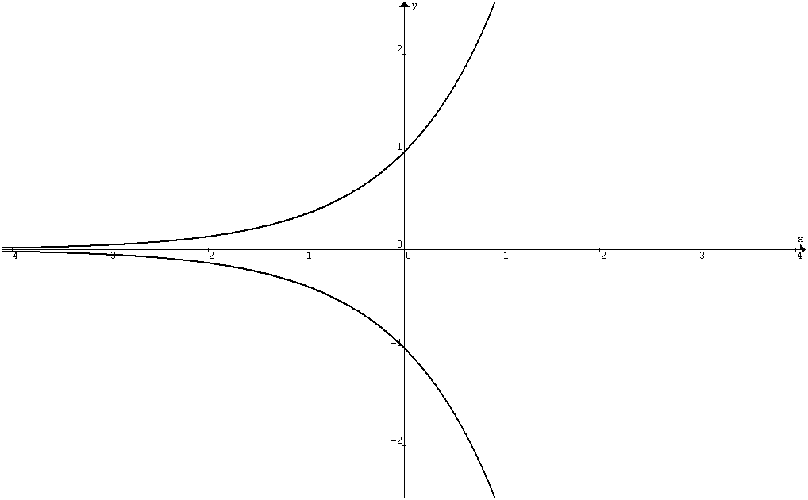  y = – e^{x}  y = e^{x} | Reflection along y–axis: y = f(–x)  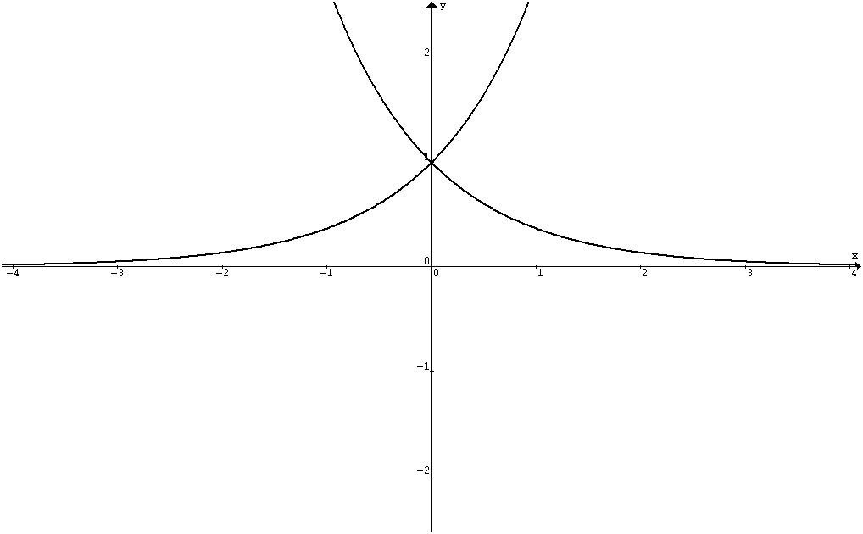  y = e^{x}  y = e^{–x}
Sequence of Transformations: y = f(x) → f(x + c) → f(bx + c) → a f(bx + c) → a f(bx + c) + d

Curve Sketching
y = | f(x) |
y = sin x  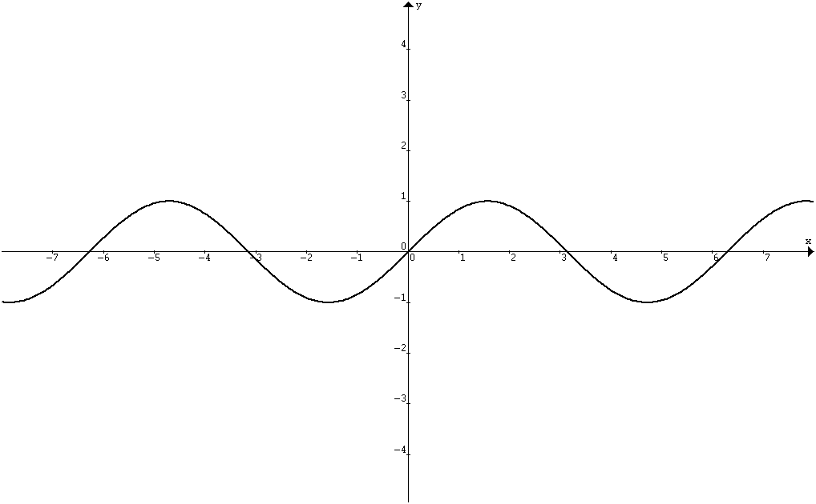 | y = | sin x |  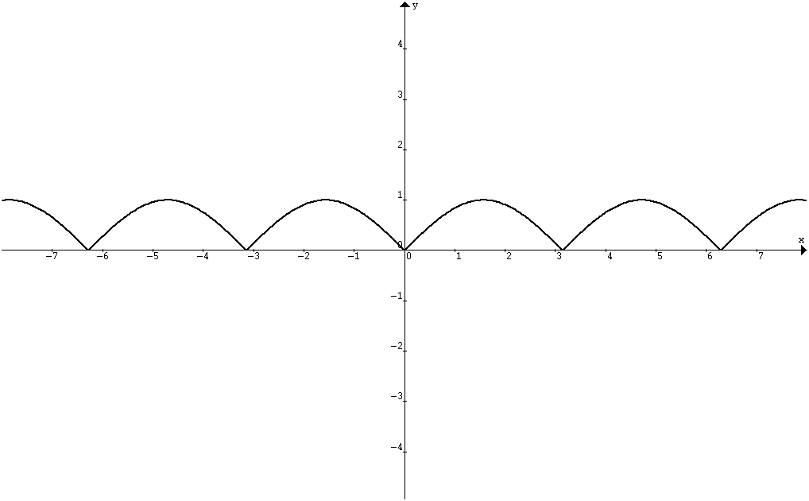
y = f( | x | )  To sketch y = f (| x | ):  Remove the part of the curve y = f(x) on the left of the y–axis.  Draw the reflection of the right hand side of the curve | y = sin | x |  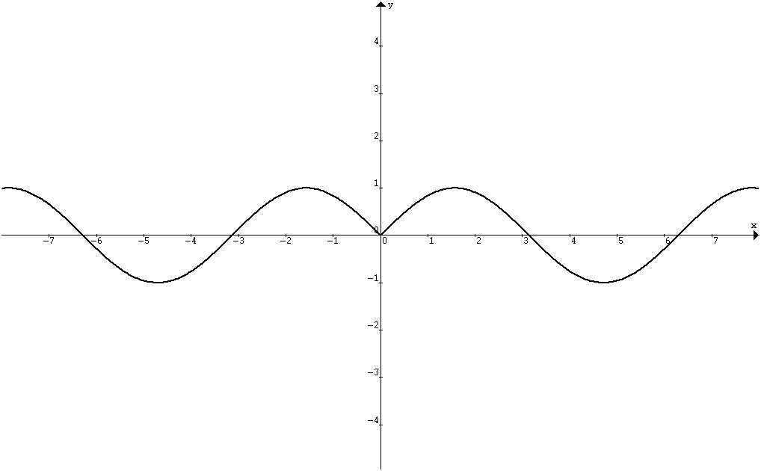

y =  To draw y = :  (1) is undefined when f(x) = 0 ⇒ vertical asymptote.  If y = a is a horizontal asymptote of y = f(x),  then y = is a horizontal asymptote of y = . | y = f(x)  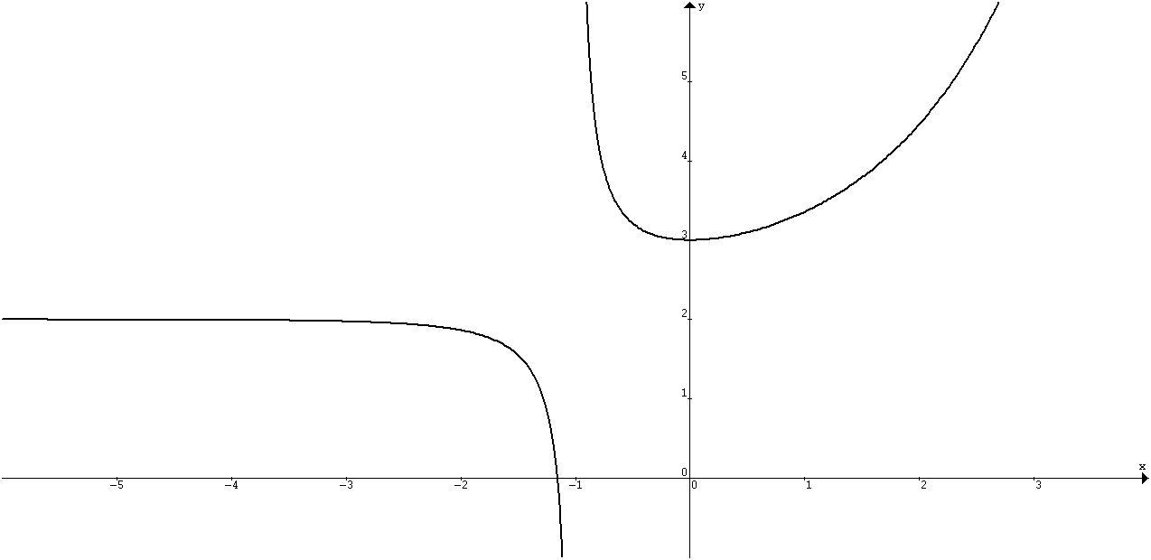  y = 2  (0, 3)  x = –1  (–1.2, 0)
(2) The common points of y = f(x) & y = are the points where y = ±1.  (3) If (a, f(a)) is a maximum point of y = f(x),  then (a, ) is a minimum point of y = , and vice versa.  y =  (0, )  x = –1.2  (–1, 0)  y = 0  (4) As f(x) → 0, → ±∞.  As f(x) → ±∞, → 0. | y =  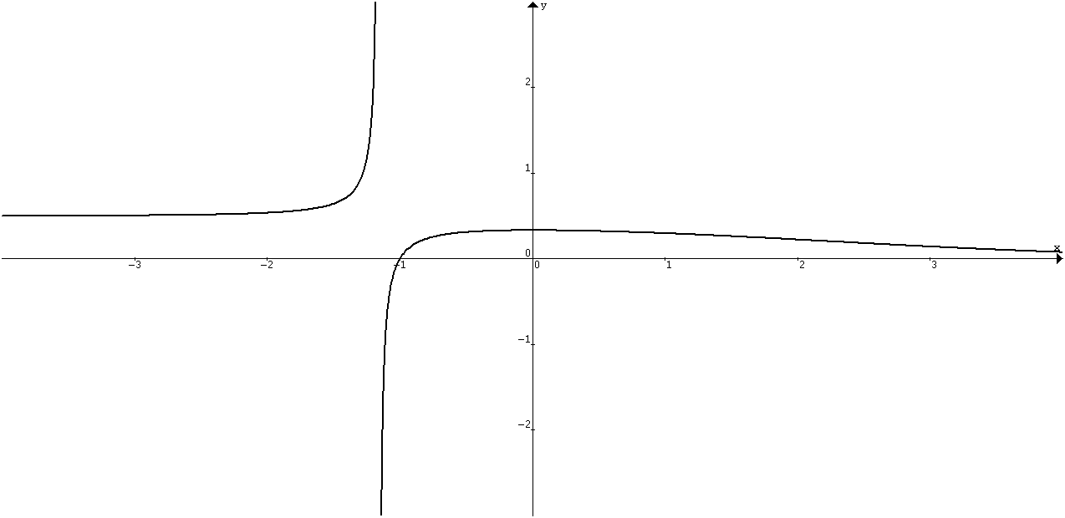

y =  To draw y = :  (1) Remove the part of the curve which is below the x–axis.  (2) The common points of y = f(x) & y = are the points where y = 0 and y = 1. | y = :  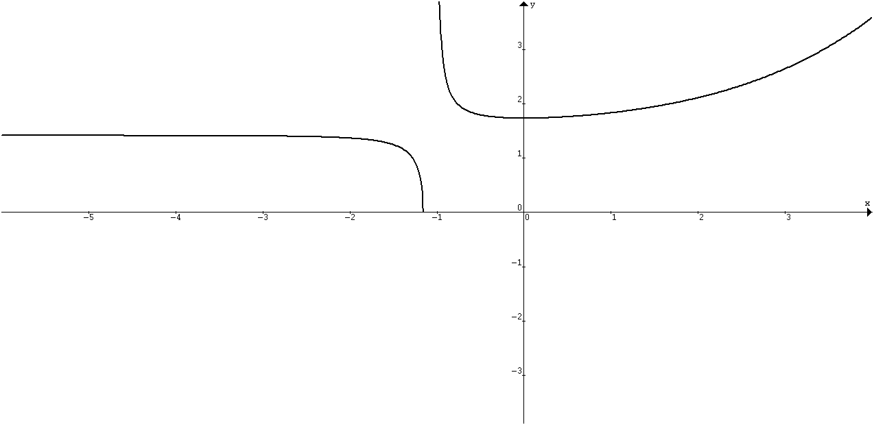
(3) If y = a is a horizontal asymptote of y = f(x), then y = is a horizontal asymptote of y = .  (4) If (a, f(a)) is a turning point of y = f(x), then (a, ) is a turning point of y = .  (5) If 0 < y < 1, then > f(x).  If y > 1, then < f(x). | y² = f(x) ⇒ y = ±  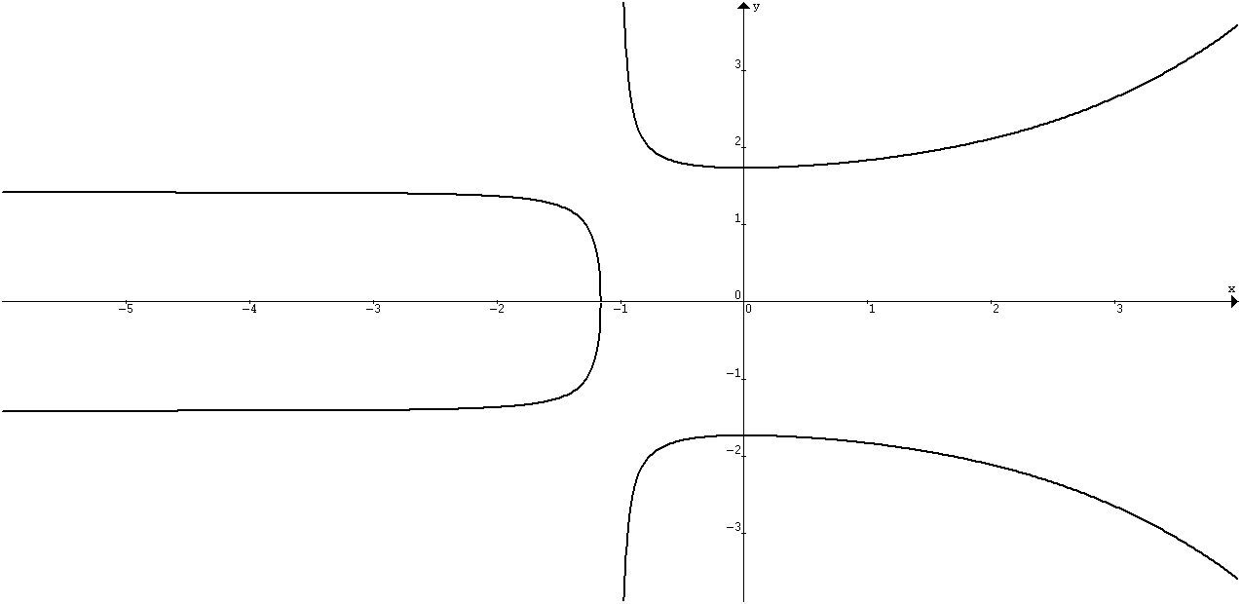

x = –1
y = f ′(x)  (1) If y = f(x) has a stationary point, then f '(x) = 0  (2) If y = f(x) is increasing, then f '(x) > 0  (3) If y = f(x) is decreasing, then f '(x) < 0 | 