How to install downloaded Airplanes, Gauges and sceneries.

After plane is downloaded on you PC, double click on the zip file to open WinZip.
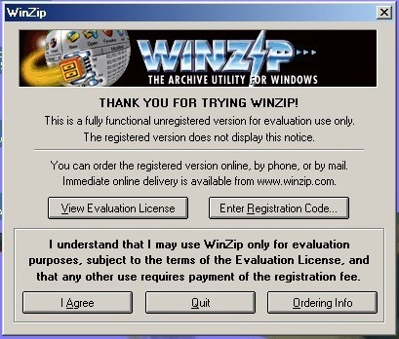

Press I Agree to proceed. All the files will be in the zipped up folder.
Next, press the Extract tab.

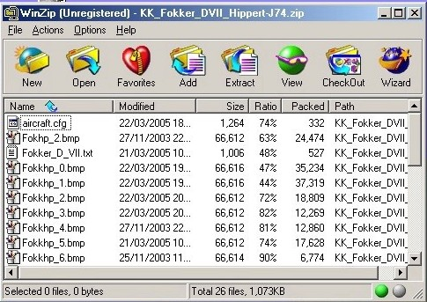

It will now ask you to look for the place you want it to be extracted.

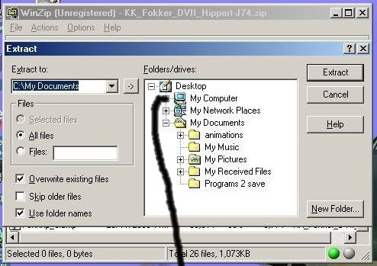

The path to follow is:
My Computer/C:/Program Files/Microsoft Games/ Combat Flight Simulator/Aircraft

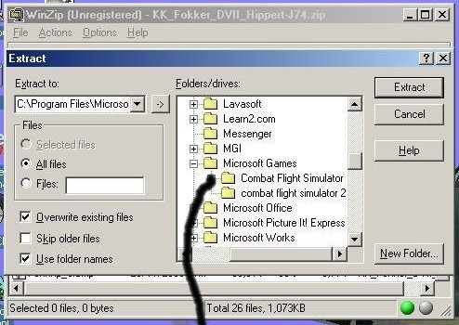

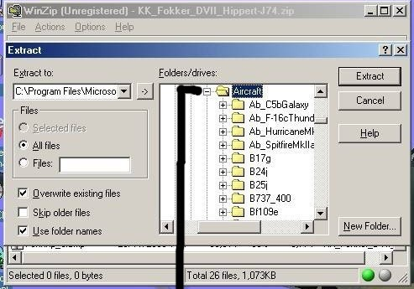

When this folder is found and opened as in above picture, press Extract.

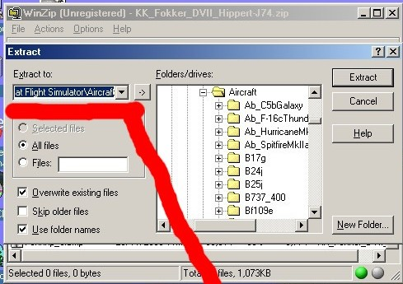

The next time you want to download and install a plane of your choice the aircraft folder will still be there making it even easier to use.
Now you plane should be listed in CFS.
To install gauges, follow the same path to Combat Flight Simulator, but open Gauges folder instead of Aircraft.

To install downloaded sceneries, follow the same path to Combat Flight Simulator, but open the Scenery folder.
Contrary to planes and gauges, sceneries have to be activated.
To activate sceneries:
Using Window Explorer, go into the CFS scenery folder and make sure the scenery you extracted is there, and that if you double click on that folder you see two subfolders. Scenery and Texture.
The example used is doggers_place
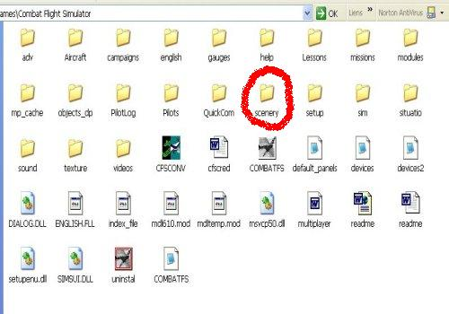
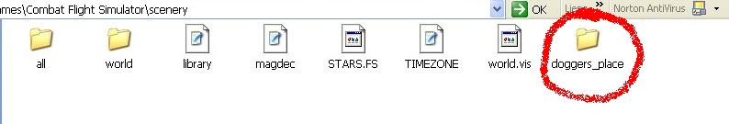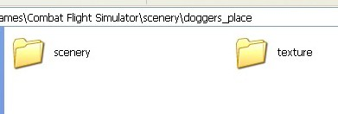
If everything is like this, close, and proceed with activation as follow.
Start you CFS game on Free Flight, using any location and plane. Do not use Full Screen, but Windowed. (You can switch from one to the other by pressing Alt and Enter keys.)

Once the game is started, click on World, then on Scenery Library.
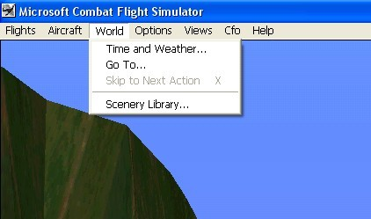

You will receive a warning message, but go ahead and click on OK.
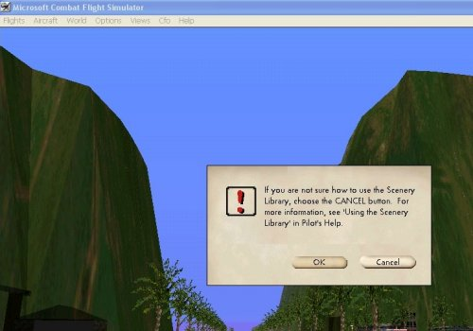

Next, click on files.
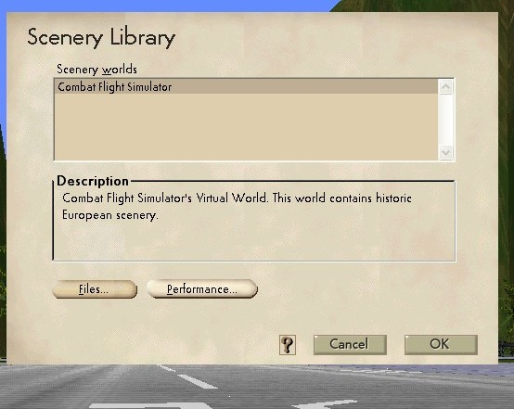

Now click on Add.
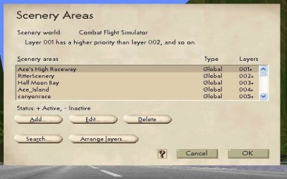

In the next window that appears you will have to fill the Scenery Area Path as shown.
=:\=\scenery\name of scenery being activated\scenery\*.bgl
In this example name of scenery being activated is doggers_place.
Be very careful, one little mistake there will prevent you from completing the process. The next line wont be lit. It is always the same thing for any scenery, except for name of scenery.
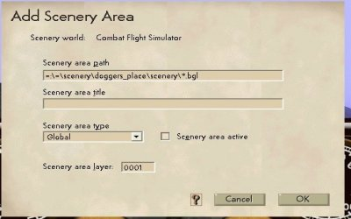

Now write name of scenery being activated in Scenery area title.
Also put an X at Scenery area active.
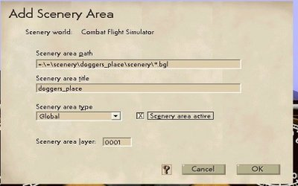

Now click on OK, OK, OK to return to normal game.

The scenery is activated and should appear in Airfield list.

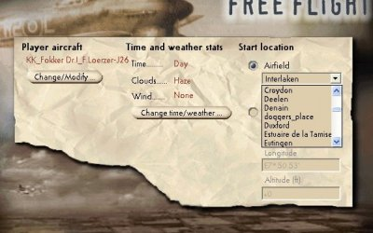

KK_DOGSBODY and KK_de_Deville, May 2005

