'FOR VALOUR'

THE HISTORY OF THE IRON CROSS AND WOUND BADGE
IN GERMAN SOUTH WEST AFRICA 1914 - 1918
Gordon McGregor

This book hopes to fill the much neglected area of both the German and Namibian medallic history and research namely the so called colonial Iron Crosses and Wound Badges that were awarded in the German colony of South West Africa during the 1914 - 15 war. The book will also give the reader the background and events that led to the awarding of the 'Hildegard
Orden', the only official variant of the 1914 Iron Cross, in
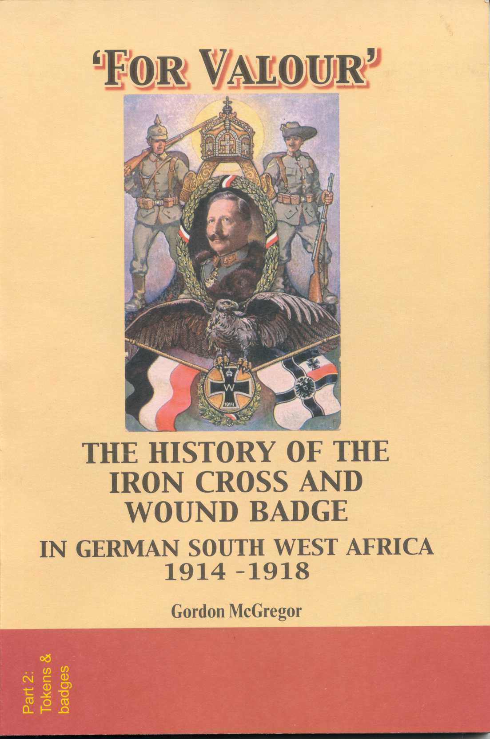
German South West Africa. Also included is the history
of both the Iron Cross and Wound Badge that were
awarded for the 1914 - 15 campaign in German South West
Africa as well as name lists of those that were awarded these
Decorations during the campaign.

A name list of the few persons that were awarded the
'Hildegard Orden' is also included for the very first
time. Of particular interest is the section dealing on
how the former German colonial soldiers, still
residing in the country after the war, got their
awards remembering that the country was now
administered by the Union of South Africa and no
longer by Germany.

The book also contains copies of various interesting documents relating to the 'Hildegard Orden', the Iron Cross and the Wound Badge that have been uncovered by the author during his research work for this publication. This is a book that is a must on the bookshelves of every historian and colonial collector dealing with the former Colony of German South West Africa.

Soft cover
148 x 210 mm
128 pages
20 colour photos
28 black/white photos

The book can be purchased from:-
Namibia Scientific Society
P.O. Box 67
Windhoek
Namibia

 e-mail address for purchasing the book:- nwg@iway.na

