Medals of Burkina Faso

By Jean-Paul LeBlanc
http://www.geocities.com/jleblanc12345

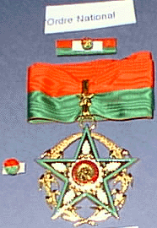 | National Order (L’Ordre National)  This is Burkina Faso’s highest honour, and is awarded to both civilians and military recipients for meritorious service to the Nation. Comes in 5 classes: Grand Cross, Grand Officer, Commander, Officer and Knight. Can be awarded to foreigners. Total number of recipients per year is 100 and 25 to foreigners.
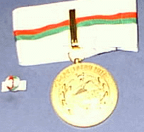 | Burkinabé Order of Merit (L’Ordre du Mérite Burkinabé)  Awarded for long and distinguished devotion. Comes in 5 classes: Grand Cross, Grand Officer, Commander, Officer and Knight. The order also has a series of bronze and silver bars that correspond to national activities as follows: Administration, Agriculture, Social Activity, Friendship, Arts and Culture, Work, Environment, Industrial Economy, Youth and Sports, Security, Health, Scientific Research, Education and Defense. Those receiving the Order for an activity not listed above, are admitted into the “No Bar” Category of the Order. Can be awarded to foreigners. Total number of recipients per year is 300 and 50 to foreigners.
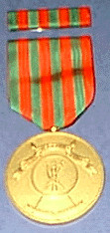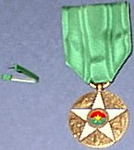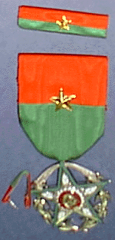 | Specific Orders (Les Ordres Spécifiques)  Awarded to recognize those who, in the public or private sector, have distinguished themselves in a specific National activity, which is determined by Presidential Decree.

Order of Precedence
- National Order (L’Ordre National)
- Military Honour Medal (La Médaille d’Honneur Militaire)
- Military Medal (La Médaille Militaire)
- Burkinabé Order of Merit (L’Ordre du Mérite Burkinabé)
- Commemorative Medal (La Médaille Commémorative)
- Specific Orders (Le (ou les) Médailles spécifiques)

Reference: http://www.primature.gov.bf/republic/finstitutions.htm

