Own Travel to the Grand Canyon

We travelled to the Grand Canyon, Arizona in the summer’s holidays. We are talking on the bus and spent 3 days. We’re staying on an economy hotel to 6 days. We had a lot of things:

- Hiking on your own for 1 day.
- Exploring GC Village for 1 day.
- Going on a 1 day guided hike.
- Going on a 3 day rafting trip.
- Going on a half day jeep tour.
- Going on a half day helicopter tour.

We stayed in an economy hotel for 6 days. Here are some of photos of the travel:

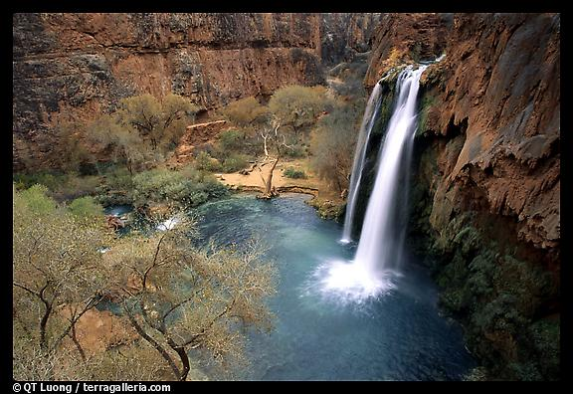

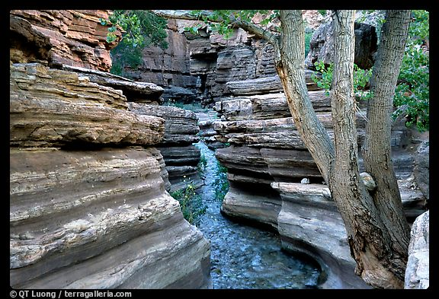
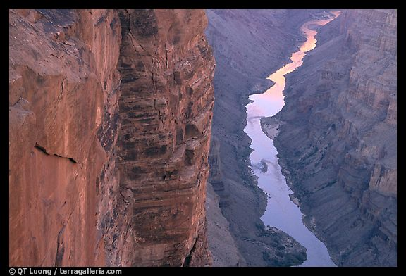

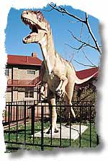
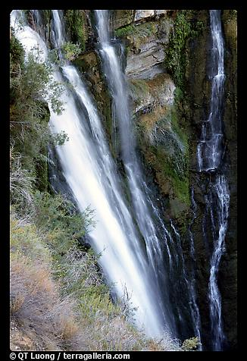
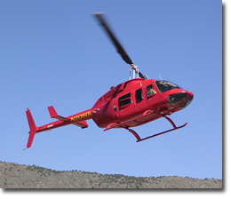
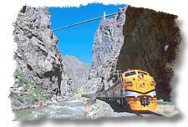

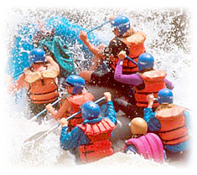

Sergio González Peña Nº 4º A
Luis Manuel Pérez Geraldino Nº 15 4º A

