First week:
We can’t believe it. We are in London.
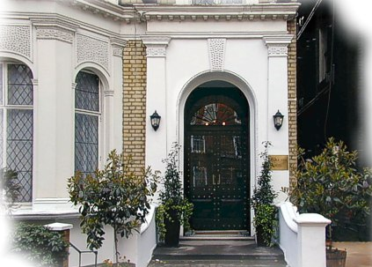
We went there by plane from La Palma airport to Heathrow airport .We chose this city because we thought that this is one of more beautiful city of the world.
We chose a two stars hotel: Chelsea House Hotel (96, Redcliffe Gardens, London, SW10 NN9). The price of double room for night was 55.00 to 78.00 GBP with telephone, TV (English channels only), hair dryer, safety box. Iron and ironing equipment available.

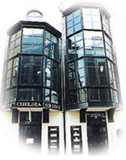
Second week:
We are studying in South Chelsea College (4 Tunstall Road,London SW9 8BNUnited Kingdom).This is a privately owned College, based in an attractive, well-equipped building, with comfortable classrooms, a self-access study centre and free internet access. Founded almost 20 years ago, it attracts students from a wide range of countries, often through personal recommendation.
We take a bus at 5:45 because we took two hours for go to college from the station of Redcliffe Gardens to Lonsdale Avenue.

Third week:
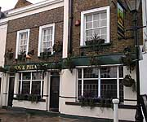
For eat and drink we choose a pub in Chelsea(Fox & Pheasant) in 1 Billing Road, Chelsea to 100 yards from Chelsea football ground and is likely to be packed on match days. It’s open from Monday until Saturday 11.00-23.00 and Sundays 12.00-22.30.
In this week we though” Since we are here because we are not going to see the Chelsea FC”. And we went to see the match (Chelsea FC-Arsenal FC).
Chelsea FC won 1-0 and we spend it to ourselves very well!




Last week
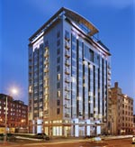
Already it is our last week and we don’t want to go away. We don’t know that to do we have done so many things. We have thought to give a return for the city, visit a museum and buy presents for our family. It’s really a beautiful city. The streets, the people, all is perfect and we can’t forget him.

