OUR TRAVEL TO THE GRAND CANYON

In my summer vacation I went to the Grand Canyon with my friend Omar.
We had 10 days for our travel and we had 2800 $ too.
This travel was really intersecting and we pretend to learn new things and have adventures into the Grand Canyon and saw new species of animals and plants. In this travel we saw a lot of animals and plants. Into the Grand Canyon we walked by the Grand Canyon the first day who we arrived and saw a beautiful pile of landscapes and places.
A hundred of people enter Grand Canyon National Park each day. Grand Canyon is one of the most beautiful places in the world. 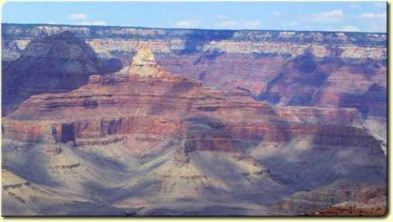

In order to travel to the Grand Canyon we choose the airplane because it is the best and faster means of transport of the existing thing, and in addition we go away the Grand Canyon from an aerial vista.
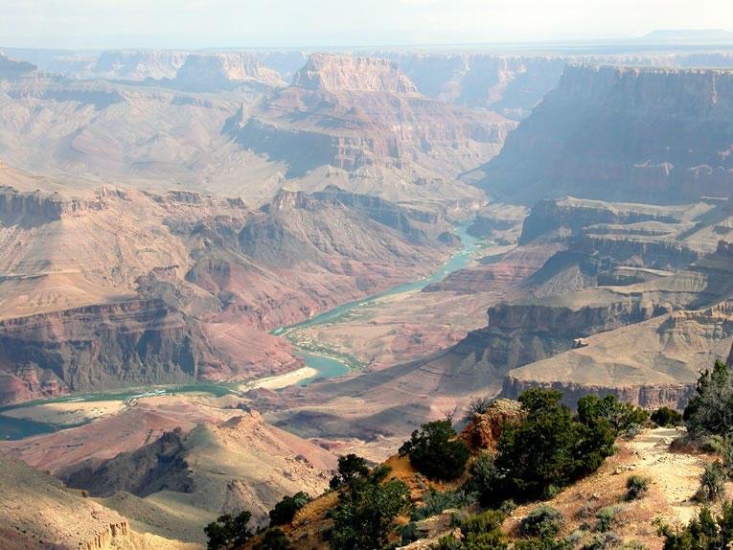

We decided to remain in national park lodge because we spend too much money in travelling in airplane. In addition thus we are more near de place were we make the activities.
One of the activities that we did was give a tour in helicopter during half day. This was one of the activities that we liked more.
In addition we give a tour in jeep and plane too. This was really funny too.
We explore the Grand Canyon with a guide and walked during two hours because the next day we had a day for rest.
I want to invite my friends because this was really beautiful and we learning to much with this visit to the Grand Canyon.

GRAND CANYON INFORMATION
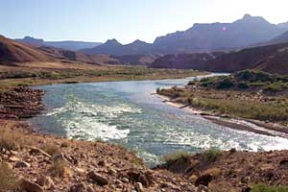
The Grand Canyon is more than a great chasm carved over millennia through the rocks of the Colorado Plateau. It is more than an awe-inspiring view. It is more than a pleasuring ground for those who explore the roads, hike the trails, or float the currents of the turbulent Colorado River.
This canyon is a gift that transcends what we experience. Its beauty and size humble us. Its timelessness provokes a comparison to our short existence. In its vast spaces we may find solace from our hectic lives. The Grand Canyon we visit today is a gift from past generations.
GRAND CANYON HISTORY
Native Americans
More than 11,000 years ago, paleo-hunters wandered the Southwest chasing big game. They left few signs of their passage. In time, these mysterious travellers were followed by hunter-gatherers of the Desert Archaic culture, who inhabited the Grand Canyon region until about 1000 b.c. Evidence of their presence at the Canyon was found in 1932. Small animal hunting fetishes made from willow twigs were discovered secreted away in hard-to-reach crannies in the Redwall Limestone cliffs of the Inner Gorge. Radiocarbon dating has revealed the figurines to be approximately 4,000 years old.
Hunting and gathering predominated until the introduction of agriculture allowed family groups to settle in one place, supplementing game and native plants with cultivated corn. By a.d. 500, a new culture, known as the ancestral Pueblo an (Anasazi) could be found at Grand Canyon. They inhabited dark, smoky, semi subterranean pit houses, hunted deer, rabbits, and bighorn sheep, and made fine baskets, leading archaeologists to name them ancestral Puebloan Basketmakers. The Basketmakers lived peacefully alongside the Cohonina people, who shared many similar cultural traits.
About 2,000 ancestral Pueblo and sites have been found within park boundaries, the most impressive of which is Tusayan Pueblo, which was constructed in a.d. 1185 and occupied by about 30 people. By the time Tusayan Pueblo was built, the ancestral Puebloans were reaching the apex of their culture. The Spanish word pueblo, meaning "town," referred to the apartment-style masonry compounds the ancestral Puebloans now excelled in building. Communal living had led to many new breakthroughs, such as irrigation farming of corn, squash, and bean crops, elaborate ceremonial rituals in underground chambers called kivas, beautiful black-on-white and corrugated utilitarian pottery, and extensive trade with other cultures in the Southwest, in Mesoamerica, and along the Pacific Coast.
It was too good to last. Eventually, a prolonged drought exhausted natural resources, and perhaps internal strife and overpopulation led the Cohonina and the ancestral Puebloans to systematically abandon their homes in the late 1200s. The ancestral Puebloans moved to more reliable water sources beside the Rio Grande and the Little Colorado drainages, where their descendants - the Hopi and the 19 Pueblos of New Mexico - continue many of the traditions of their ancestors.
Native Newcomers
About 150 years later, a new hunter-gatherer tribe, the Cerbat, moved into Grand Canyon in the 1300s. Descendants of these people make up the Hualapai and Havasupai tribes, who occupy reservations in the western Canyon. At the same time, small bands of hunter-gatherer Southern Paiutes began venturing to the Grand Canyon's North Rim. The Southern Paiutes worked closely with the Mormons, who colonized southern Utah and the Arizona Strip in the 1850s.
The last Native Americans to arrive at the Grand Canyon were the Navajo, or the Dine, Athabascan people related to the Apache, who moved here from the northwest around a.d. 1400. The Navajo were hunter-gatherers who learned agriculture from the Pueblos and later obtained horses and sheep from Spanish settlers. Their adaptability allowed them to dominate this region. After centuries of sporadic intertribal conflict, as well as clashes with new Spanish, Mexican, and Anglo arrivals, the Navajo are today the largest, strongest Native American tribe in the United States. Their huge reservation abuts the eastern section of the Canyon. For information on reservations in and around Grand Canyon, see Native American people and their Craft.
America's Westward Expansion
When the Santa Fe Trail linking Missouri to New Mexico opened to east-west trade in 1821, intrepid fur trappers, traders, and fortune hunters travelled through the region en route to California. In 1848, much of the Southwest was ceded to the United States following the U.S. war with Mexico, leading the government to dispatch army surveyors to chart the unknown south western territory. In 1857, a U.S. Army Survey party led by Lieutenant Joseph Ives explored the Grand Canyon region. In his 1858 report, Ives was pessimistic: "The region … is of course altogether valueless …. Ours has been the first, and will doubtless be the last, party of whites to visit this profitless locality." But Ives was soon to be proved wrong.
John Wesley Powell
In 1869, Major John Wesley Powell, a fearless, one-armed Civil War veteran, and his nine companions became the first men to journey 1,000 miles on the Colorado River going through the Grand Canyon. Equipped with four flimsy wooden boats and meager rations, Powell and his party braved dangerous rapids, searing heat, sinking morale, and the loss of three men to complete their remarkable feat. Powell's notes about the trip, and a second in 1871-1872, provided invaluable information about one of the last unexplored parts of the region. Like John Muir, Powell was one of a distinctive 19th-century breed. A self-taught Renaissance man, he travelled extensively, advocated wise use of water in the West, and defended Native American rights. He went on to found the U.S. Geological Survey and the U.S. Bureau of American Ethnology and to negotiate Native American peace treaties with the government.
The Canyon Booms
In the late 1800s, the U.S. government promoted the West as a land of abundant resources waiting to be exploited, and the discovery of zinc, copper, lead, and asbestos in the Grand Canyon in the 1870s and 1880s led many miners to stake claims there. Extraction and transportation of ore from the canyon to the rim proved difficult, though, and some miners abandoned their claims in order to pursue a more lucrative, less dangerous option: tourism. One settler who catered to visitors was Captain Jone Harvey.
As a new century dawned and transportation improved, Americans were changing how they viewed their country. Writers, artists, and photographers led the aesthetic revolution and, along with environmentalists, newspaper magnates, and railroad barons, fought for establishment of protected recreational areas called national parks. At Grand Canyon, writer/geologist Clarence Dutton and painter Thomas Moran produced imaginative works that celebrated the glory of the Canyon; soon, visitors clamored to see for themselves.
Fred Harvey Company
In the early 1900s, the Fred Harvey Company undertook to provide the finest visitor services of any national park. The elegant El Tovar Hotel, designed by Charles Whittlesey, opened in 1905. The forerunner of "rustic architecture," its style was later promoted by architects like Gilbert Stanley Underwood and the National Park Service as a means of surreptitiously blending buildings into park environments. In 1902, Fred Harvey Company hired Mary Elizabeth Colter as company architect. Colter remained with the company until 1948, during which time she was responsible for many of the distinctive buildings at the Grand Canyon. Fred Harvey Company, with its long tradition of fine hospitality and its famous "Harvey Girls," became the principal concessioner at the South Rim in 1920. For more information, see also Fred Harvey
National Park Status
President Theodore Roosevelt visited Grand Canyon in 1903 and was much impressed. The 1906 Act for the Preservation of American Antiquities paved the way for Roosevelt, a devoted outdoorsman and park supporter, to change Grand Canyon's status from national forest and game reserve to national monument in 1908. Congress authorized the expansion and upgrading of the monument to a national park in 1919. An act doubling the size of the park was signed into law by President Gerald Ford in 1975. Grand Canyon was named a World Heritage Site in 1979, in recognition of the universal value of its exceptional natural and cultural features.
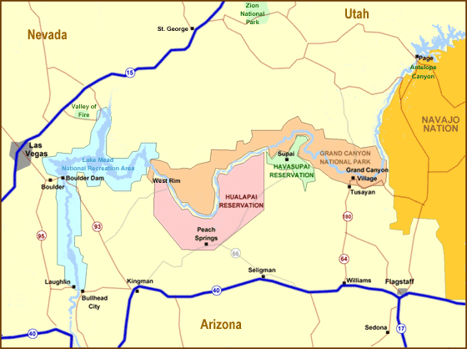

The National Park is situated here.

Daniel Ferraz García
Omar Joaquín García García

