The Grand Canyon is more than a great chasm carved over millennia through the rocks of the Colorado Plateau. It is more than an awe-inspiring view. It is more than a pleasuring ground for those that explore the roads, hike the trails, or float the currents of the turbulent Colorado River.
This canyon is a gift that transcends what we experience. Its beauty and size humbles us. Its timelessness provokes a comparison to our short existence. In its vast spaces we may find solace from our hectic lives.
The Grand Canyon we visit today is a gift from past generations. Take time to enjoy this gift. Sit and watch the changing play of light and shadows. Wander along a trail and feel the sunshine and wind on your face. Attend a ranger program. Follow the antics of ravens soaring above the rim. Listen for the roar of the rapids far below. Savor a sunrise or sunset.
As the shadows lengthen across the spires and buttes, time passing into the depths of the canyon, understand what this great chasm passes to us - a sense of humility born in the interconnections of all that is and a willingness to care for this land. We have the responsibility to ensure that future generations have the opportunity to form their own connections with Grand Canyon National Park. 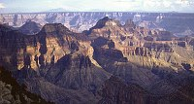 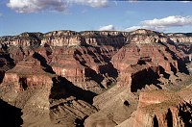 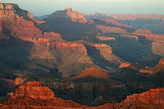

Twenty-three federally listed animal and plant species are known to occur in and adjacent to Grand Canyon National Park:
Species | Classification
Brady pincushion cactus (Pediocactus bradyi) | Endangered
Sentry milk-vetch (Astragalus cremnophylax var. cremnophyla) | Endangered
Arizona cliffrose (Purshia subintegra) | Endangered
Navajo sedge (Carex specuicola) | Threatened
San Francisco peaks groundsel (Senecio franciscaus) | Threatened
Siler pincushion cactus (Pediocactus sileri) | Threatened
Welshs milkweed (Asclepias welshii) | Threatened
Jones' cycladenia (Cycladenia humilis var. jonesii) | Threatened
Kanab ambersnail (Oxyloma haydeni kanabensis) | Endangered
Humpback chub (Gila cypha) | Endangered
Bonytail chub (Gila elegans) | Endangered
Virgin River chub (Gila seminuda) | Endangered
Razorback sucker (Xyrauchen texanus) | Endangered
Woundfin (Plagopterus argentissimus) | Endangered
Little Colorado spinedace (Lepidomeda vittata) | Threatened
Southwestern willow flycatcher (Empidonas traillii extimus) | Endangered
Bald eagle (Haliaeetus leucocephalus) | Threatened
Mexican spotted owl (Strix occidentalis lucida) | Threatened
Yuma clapper rail (Rallus longirostris yumanensis) | Endangered
California condor (Gymnops californianus) | Experimental population (treated as threatened in national parks)
Desert tortoise (Gopherus agassizii - xerobates) | Threatened (Mohave population)
Hualapai Mexican vole (Microtus mexicanus hualpaiensis) | Endangered
Black-footed ferret (Mustela nigripes) | Endangered

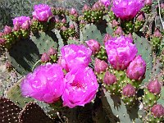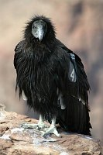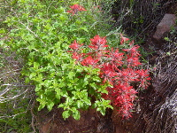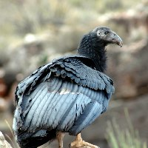

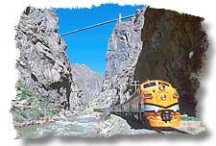
Welcome aboard the Royal Gorge Route Railroad-simply the best way to experience the Royal Gorge and all it has to offer. The railroad tracks were laid over 120 years ago, however, passenger service was cut off in 1967. In 1999, passenger service returned and now provides visitors from around the world 12-miles of unforgettable scenery, coupled with exceptional service and memories to last a lifetime. The 12-miles of track follow the most spectacular section of Denver & Rio Grande Railroad directly through the Gorge. Passengers may choose from First-Class or Coach seating, along with famous Gourmet Lunch and Dinner Trains. The train consists of climate controlled coaches, first-class cars and open-air observation cars to watch the passing scenery. Riders often spot wildlife: ducklings on the river's quieter stretches, mule deer on far meadows, bald eagles, and Rocky Mountain bighorn sheep. The scenery is breathtaking. The journey through the Royal Gorge lasts 2-hours, covering a distance of 24-miles. The train is open year-round. Make advance reservations on-line or call: 1-888-RAILS-4U or 303-569-2403.
Exclusive Raft & Rail Package-The Ultimate Experience!
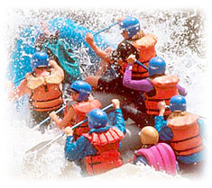
Echo Canyon and the Royal Gorge Route Railroad have teamed up to offer the most unique summer experience available in the state of Colorado. This trip combines the excitement of the river with the Royal Gorge Route's scenic railroad in one continuous excursion. All trips check in at ECHO 45 minutes before scheduled departure and include all transportation, an 12-mile train ride and raft trip . The Parkdale trip also includes lunch. This unique trip is an ECHO exclusive and space is limited. Please us at 800-748-2953 to speak with a reservationist.

The Winery at Holy Cross Abbey
Be sure to visit the Winery at Holy Cross Abbey and taste their award winning Colorado wines. The tasting room and gift shop are first-class and the wines are sure to please. For information, call 719.276.5191 or toll free at: 877.422.9463.
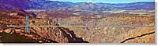
Royal Gorge Bridge
The Royal Gorge Bridge is the world's highest suspension bridge and is open year-round. Give them a ring at: 1-888-333-5597 or visit them on the web at: www.royalgorgebridge.com
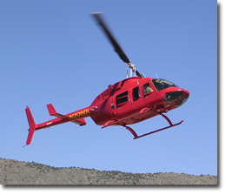
Royal Gorge Helitours
This is the "Must Do" helicopter experience in the world. Come see and experience the Royal Gorge in our turbine powered helicopter. You will see the Royal Gorge from every angle. Mike Pond is a consummate professional with thousands of hours of experience from above it, to down into it. Normal operations are 7 days a week, May26-Sept 6. Call for other dates. 719.276.9038 Visit Royal Gorge Helitours on the web!

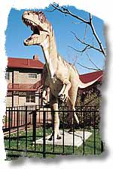
Dinosaur Depot
Maybe not quite "Jurassic Park" but a Jurassic adventure is waiting just around the corner at the Dinosaur Depot.
An educational and interpretive museum. We have two viewable labs with knowledgable guides providing tours of both the museum and Garden Park Fossil Area. Unique gift shop featuring educational and fun items. Open 9-5 daily, June-August and 10-4 Tuesday-Saturday, September-May.
Cañon City has world renowned "dino digs" and an education location to show them off. Paleontologists work right on the premises on fossils from the Garden Park Area. Watch them as they uncover the secrets to our past while learning about the dinosaurs that inhabited Cañon City, long before it was Cañon City. Located across from the Royal Gorge Route Railroad's depot at: 330 Royal Gorge Blvd. Call: 719.269.7150 or toll free at: Toll Free: 800.987.6379
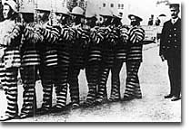
The Museum of Colorado Prisons
Stop and Do Time With Us! They aren't joking either. The Prison Museum brings to life another era where justice was swift and sure. The Cell House of yesteryear allows a peek through the looking glass to see what incarceration was like at the turn of the century. Read about the original "Hannibal the Cannibal", Alferd Packer, who was one of the prison's more notorious guests. Step into actual prison cells and "Do Time With Us"! Located at 1st & Macon. Call: 719.269.3015 Visit our Web-Site
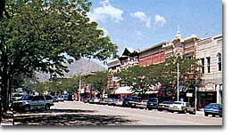
Historic Downtown Cañon City
Cañon City's downtown area is listed on the National Historical Register as it is abundant in early 1900's architecture. The quaint atmosphere of the downtown area warrants a shopping trip to visit the local boutiques and merchants. A downtown walking tour guide of the historical district is available at the local Chamber of Commerce and includes historical information pertinent to each building registered.
Downtown Cañon City has been well preserved over the years, and as such, is the largest historica/commercial district in Colorado, and is designated as such on hte National Historical Register.

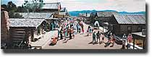
Buckskin Joe Frontier Town
The old west explodes to life as gunfighters hold shootouts on the streets of this authentically restored frontier town where "Cat Ballou" was filmed. Explore with family and friends the 1860's living history that is Buckskin Joe, including the Silver Dollar Saloon, Gold Nugget Restaurant, San isabelle Mine and gold panning which gives everyone a true old west experience. Enhance your wild west encounter with a horseback ride in the Royal Gorge Region. Call: 719.275.5149.
Royal Gorge Riding Stables
Located on the road to the Royal Gorge, we offer 1/2 hour, 1 hour, & 1 1/2 hour horseback rides with a scenic view of the Royal Gorge Bridge. Horses are available for all ages and levels of riding ability. Weight limit 250#. Open year round. Reservations are recommended. Located at: 0303 Co. Rd. 3A. Call: 719.275.4579

