The grand canyon

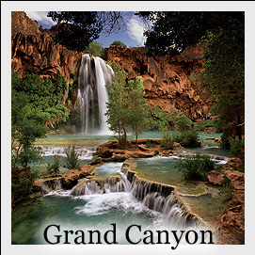

Paula y Atteneri 4ºA

In the summer we went to holidays to the Grand Canyon.
We took the airplane for go. We stayed in a national park lodge for six nights. We did very activities:
- On the own for one day, there we knew the people of the town and we did many friends. We bought many presents: for our family and for ours boyfriends.
- We explored GC village for half a day. There, the old people told us the town’s history.
- We rested for one day.
- We went on a day guided hike. We finished very tired, but it was worth the trouble.
- We went on two days mule trip into the canyon. It was a little disagreeable, because it smelled bad, but…… 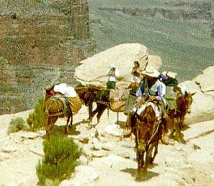¡¡ it was very funny!!
- We went on a half day jeep tour. But it remained without gasoline and we had to awhile hope at that jeep arrived another one.
- We went on a half day plane tour. We fell asleep the passage throughout and we did not find out anything until we arrived.
- We went on a half day helicopter tour, we had much vertigo!.

In total we spent 2700$.

Grand Canyon is unmatched throughout the world for the vistas it offers to visitors on the rim.

Back 3,000 to 4,000 years, the Desert Archaic people lived within the Grand Canyon. The strongest evidence of their having passed here are small willow-twig effigies called "split-twig figurines".

We hope that the next trip is to Paris…………………………

