Dolphin Square Hotel
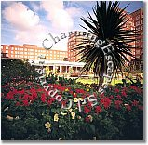
The 4 star Dolphin Square Hotel is set in 3 ½ acres of glorious private gardens situated in the heart of London, bordered by the River Thames and surrounded by the busy streets of Westminster. An all-suite Hotel, each of the 148 suites has a mini kitchen and most have a separate sitting room allowing you the flexibility to be self sufficient, use the extensive Hotel facilities or combine the two.
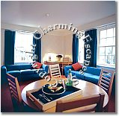

Awarded a Silver Accolade for Quality of Service by the English Tourism Council, Dolphin Square is warm & welcoming, discreet and never stuffy offering service with style and always with a smile.

The 4 star Dolphin Square Hotel is set in 3 ½ acres of glorious private gardens situated in the heart of London.

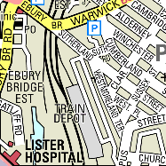 | 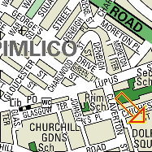 | 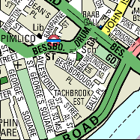
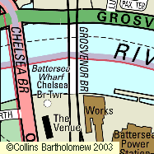 | 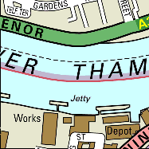 | 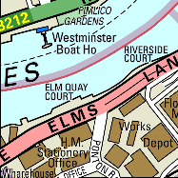

Our stay in the hotel will cost us £180.00

How to reach us?
By Road
By Road From the M4 Motorway, continue to follow signs for central London and then for Earls Court. Follow subsequent signs for the Embankment. Continue along the river passing Battersea, Albert and Chelsea Bridges on your right. After Chelsea Bridge take the second left into Claverton Street. Turn first right into Chichester Street, and Dolphin Square is on the right hand side..
By Air
From Heathrow -Underground line (Piccadilly) to Green Park and change onto the Victoria line to Pimlico, approx. 60 minutes. From Gatwick -express train to Victoria, approx. 30 minutes. From London City Airport -train from Silvertown and City Airport Station, approx. 40 minutes.
By Public Transport
The nearest Underground Station to Dolphin Square is Pimlico, which is on the Victoria line and is a two minute walk from the hotel. At Pimlico Station, take the Bessborough Street South exit. Continue down the road, take the first turning into St Georges Square after the church, then turn first right into Chichester Street and Dolphin Square is on the left. All over London, you are never more than a few minutes’ walk from a bus route and there are a number of bus routes leading to Pimlico, including 24 and C10.

Facilities within the hotel

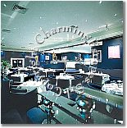
The Hotel has two restaurants, a bar and an extensive room service menu available 24 hours a day.
Restaurant Allium
Contemporary European cooking with depth of flavours and simplicity, from the kitchen of Chef Patron Anton Edelmann, served in the relaxed but sophisticated atmosphere of the restaurant's elegant art-deco dining room.

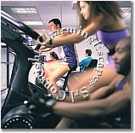
Restaurants: The Hotel s restaurant, the Brasserie, is situated overlooking the swimming pool. Serving breakfast, lunch, dinner and light snacks the Brasserie offers imaginative international cuisine in a relaxed informal atmosphere.
Adjacent to the Brasserie is the art deco style Clipper Bar. The ideal place to enjoy a drink, whether a pre-dinner cocktail, a glass of wine from the Hotel’s superb cellar or an ice cold beer.

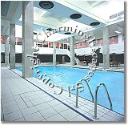
Swimming pool: The 18 metre indoor swimming pool is ideal for a relaxing swim or an aqua workout. Afterwards take time to cleanse and detoxify your skin by relaxing in one of the steam rooms or saunas.
Healthy competition is an option too, either on one of the five squash courts, the outdoor tennis court or on the croquet lawn.

Facilities outside the Hotel

In General: Surrounded by the busy streets of Westminster and bordered by the River Thames Dolphin Square Hotel has the perfect location to make the most of the capital. Just a short walk from the Hotel is the world renowned Tate Britain Art Gallery. Continuing along the banks of the Thames, Parliament Square, home to Westminster Abbey, the Houses of Parliament and Big Ben, is within walking distance. Also within walking distance are Buckingham Palace and the surrounding St James and Hyde Parks.
For those who prefer shopping to sight seeing, Oxford Street is a 10 minute journey by underground from the Hotel. Alternatively, a five minute taxi journey will take you to Knightsbridge and the world famous department stores: Harrods and Harvey Nichols. With Pimlico underground station within minutes from the Hotel and Victoria mainline, bus and coach stations a short walk away, Dolphin Square Hotel is conveniently located for transport in and around London wherever you wish to visit.

First day: We arrived to the airport and took our jet. Our fly cost us 63€. Our flying company is easyJet. We took our jet at 10:05 and we arrived at 14:20.
Once we are in London, we took a bus way to our hotel. We arrived to our hotel and left our equipment in our rooms. As soon as we arrived we started to explore the hotel.

Second day: In the morning: We decided to visit the nearest streets from our hotel.
In the afternoon: we met with some new friends in our hotel. All of us spent the day talking and we planned to do something the next day.

Third day: We and our new friends decided to go out and go for a walk. They guided us and showed us some good pubs and restaurants for eating.
Later: we decided to eat in “Goya Pimlico”. We ate quite well and the dinner cost us £56. Once we left the restaurant, we went back to our hotel.

Fourth day: We decided to enjoy with the facilities that our hotel offer us, so we spent all the day in the gym and in the swimming pool.

Fifth day: We are tired for doing exercise yesterday, so we spent the day in our hotel.

Sixth day: In the morning, we met with our friends in the hotel. They recommend us to visit Byrmington.
In the afternoon: we went to Oxford street and bought a map about the street in London and its pubs.
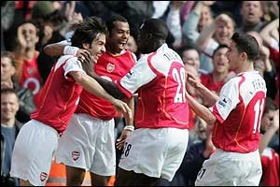
In the evening: we decided to go to Central Park and spend some time walking through the all park.

Seventh day: In the morning: we went to the british museum, the entrance is free and we spent the all the morning in it.
In the afternoon: we went to a football match. The teams that were playing were: the Arsenal and the Liverpool. The Arsenal win 3-1 and we decided to celebrate it so we spent all the night in pubs.

Eighth day: we decided to leave London and spend the day in the country to visit the small towns.

Ninetieth day: we decided to have an exciting day in a theme park so we went to Chessington “World of adventures”. The entrance cost us£27. We spent all the day theme park.

Tenth day: we are tired so we spent all the day in the hotel.
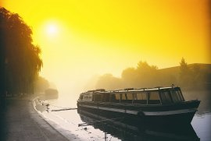
Eleventh day: we decided to leave London and visit another places. We decided to go to the east and visit Cambridgeshire. Once there, we booked in “Da Rosalia” hotel”. The price for a room cost us £49.95.
We are tired so we stood in the hotel.

Twelfth day: we went out the hotel and explored the beautiful streets. We found the Fitzwilliam museum so we decided to visit it and spend some time there.
We are tired so went back to the hotel.

Thirteenth day: we left the hotel and took a bus to go back to London. Once we arrived to our hotel, we stood there and spent the rest the day in it.
´
Fourteenth day: Its winter and the temperature it’s over 5 degrees so we stood in the hotel and wait for a better temperature.

Fifteenth day: In the morning: the time got better so we can leave the hotel now. We decided that its time to go shopping so we went the nearest shopping centre.
In the afternoon: It started raining but anyway we went to a cyber and chatted with our friends at home.
In the evening: we are tired and came back to the hotel.

Sixteenth day: its Rafael’s birthday so we and our British friends went out the hotel and went to a pub. We spent all the day and all the night in the street.
We invited Rafael to eat in a very good restaurant. We invited him to the “Alastair little”. The dinner cost us £75. We came back to the hotel at half past five. We are really tired so we went directly to our beds.

Seventh day: We were very tired and had headache so we didn’t do anything this day.

Eighteenth day: We were better so we decided to go to the Zoo. The zoo that we visited is situated in the Regent’s Park and it opened at 10 am. The entrance cost us £26. Once there we saw animals of all kinds. We left the zoo at 4 o’clock. After the zoo, we had a walk to see new streets. We are tired so we came back to our hotel.

Nineteenth day: We decided to spend the day in a travel over the river thames.
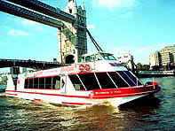
The travel cost us £17.60 and the ship leave at 10 am.
We had a great day seeing London over the cruiser.
We spent all the day in this travel.

Twentieth day: We wanted to go to the “London eye”.
We left the hotel in the afternoon and took a bus.
Once we reached there, there was a terrible crew waiting for a ride so we spent a lot of time waiting for our turn.
The ride cost us £27. Once we are in the top, we had an incredible sight of London. Once we finished the ride, we took a bus back to our hotel.

Twenty-first day: We met with our British friends and went out. We walked through the streets and ate in a Mc Donald’s. We talked and talked until the night.

Twenty-second day: It’s very cold outside the hotel so we stood in the hotel and waited for a better weather.

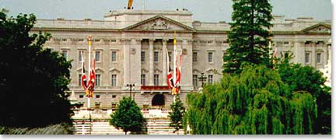
Twenty-third day: There was a better weather than yesterday so we left the hotel and took the metro for visit the Buckingham palace. Once we arrived, we saw that it was bigger than we thought. We bought the entrances and they cost us £18.50. Once we are in, we saw that all the rooms of this building were completely decorated with expensive things like paintings, jewels, etc. Once we left, we came back to our hotel thinking about the things that we never have.

Twenty-fourth day: we met with our friends and took the metro and went to central park. We walked through the all park. We ate in a picnic and stood there until the night.

Twenty-fifth day: We are bored so we stayed in the hotel and did some exercise in the gym.

Twenty-sixth day: We didn’t feel like to do anything and we were starting to get bored of London so we met with our friends the hotel and talked all the day

Twenty-seventh day: we met again with our friends and went to the shopping centre. There was a cinema, so we decided to watch a movie. We left the cinema late and came back to our hotel.

Twenty-eight day: we met with our friends again and spent the day in the swimming pool, after that we relaxed in a bar of the hotel and talked until the night.

Twenty-ninth day: We packed our things in our suitcases. We are leaving London tomorrow so we decided to spend the day with our friends for last time.
We went to a disco and danced all the night until we couldn’t move.

Thirtieth day: we are leaving London today so and our jet leave at 12:00 am so all that we can do is to dismiss our friends and take the metro to the airport.
We took our jet and came back home.

