...GrAnD cAnYoN...

TRAVEL TO GRAND CANYON

I travel to Grand Canyon in airplane. It cost $ 594 round trip per person.
I stay in a national park lodge for two nights. I cost $ 44 for two people per night.
I do the next activities:
- Hike the Canyon on your own three days. It is free.
- Explore Grand Canyon Village and the Visitor´s Center two days. It is free.
- Take a day to rest one day. It is free.
- Guided hike one day. It cost $125 per person.
- Take a 2-3 hour jeep tour on the rim of the Canyon ½ day. It cost $50
per person.
- Take a 50 minute helicopter tour of the Canyon ½ day. It cost $150
per person.

RECREATION
Canon City, Colorado has endless recreational opportunities from fishing and whitewater rafting, to viewing the abundant wildlife, or spending a day in one of our parks. Below are just a few ideas!

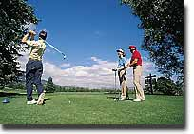

Arkansas Headwaters Recreation Area

The Arkansas River provides other water sports for the ultimate sports enthusiast. Kayaking the rapids through Bighorn Sheep Canyon is a premier place for intermediate kayakers to test their mastery of the sport. Others who prefer to remain grounded can try their luck at fly fishing for rainbow trout.

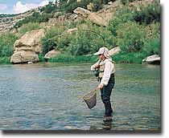

Welcome aboard the Royal Gorge Route Railroad-simply the best way to experience the Royal Gorge and all it has to offer. The railroad tracks were laid over 120 years ago, however, passenger service was cut off in 1967. In 1999, passenger service returned and now provides visitors from around the world 12-miles of unforgettable scenery, coupled with exceptional service and memories to last a lifetime. The 12-miles of track follow the most spectacular section of Denver & Rio Grande Railroad directly through the Gorge. Passengers may choose from First-Class or Coach seating, along with famous Gourmet Lunch and Dinner Trains. The train consists of climate controlled coaches, first-class cars and open-air observation cars to watch the passing scenery. Riders often spot wildlife: ducklings on the river's quieter stretches, mule deer on far meadows, bald eagles, and Rocky Mountain bighorn sheep. The scenery is breathtaking. The journey through the Royal Gorge lasts 2-hours, covering a distance of 24-miles. The train is open year-round. Make advance reservations on-line or call: 1-888-RAILS-4U or 303-569-2403.

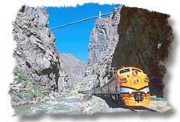

ROYAL GORGE HELITOURS

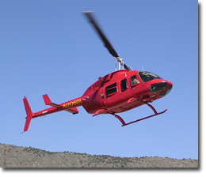
This is the "Must Do" helicopter experience in the world. Come see and experience the Royal Gorge in our turbine powered helicopter. You will see the Royal Gorge from every angle. Mike Pond is a consummate professional with thousands of hours of experience from above it, to down into it. Normal operations are 7 days a week, May26-Sept 6. Call for other dates. 719.276.9038 Visit Royal Gorge Helitours on the web!

DINOSAUR DEPOT

Maybe not quite "Jurassic Park" but a Jurassic adventure is waiting just around the corner at the Dinosaur Depot.
An educational and interpretive museum. We have two viewable labs with knowledgable guides providing tours of both the museum and Garden Park Fossil Area. Unique gift shop featuring educational and fun items. Open 9-5 daily, June-August and 10-4 Tuesday-Saturday, September-May.
Canon City has world renowned "dino digs" and an education location to show them off. Paleontologists work right on the premises on fossils from the Garden Park Area. Watch them as they uncover the secrets to our past while learning about the dinosaurs that inhabited Canon City, long before it was Canon City. Located across from the Royal Gorge Route Railroad's depot at: 330 Royal Gorge Blvd. Call: 719.269.7150 or toll free at: Toll Free: 800.987.6379

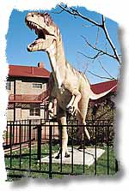

SKYDIVINY

Skydive the Rockies features solo flights and tandem free-falls, and is stationed at the Fremont County Airport on U.S. 50 in Canon City. Tandem free-falls are $160 cash and a solo jump, with ground school, is $250. Hours are from 9 a.m. to 9 p.m. every day. For more information, call (719) 265-9161 or (719) 237-4090.

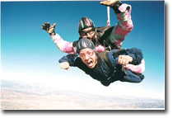

RAFTING
The Royal Gorge regions has a number of outfitters offering rafting trips to fit every ability level. Below is a listing of rafting companies and contact information.

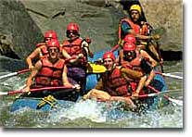

PERSONAL OPINION

This trip very interesting and very was amused...
I believe that I have taken advantage of to the maximum the money and the time, thus, I I would say that he was perfect.
I recommend to them that they make it, and they are going to us to regret.

Alberto 4º ESO - A

