The IYA (International Year of Astronomy) Project
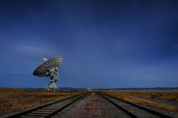 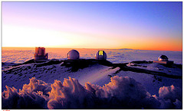 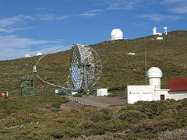 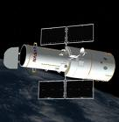
- LINKS:
http://www.iac.es/index.php?lang=en
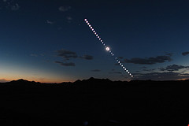
http://www.astronomy2009.org/
http://www.fromearthtotheuniverse.org
http://www.400years.org/index.php
http://www.womenastronomers.com/
http://www.100hoursofastronomy.org/
http://www.gtc.iac.es/en/
http://hubblesite.org/

- RESEARCH AND ANSWER:
- “The International Year of Astronomy 2009 (IYA2009) is a global celebration of astronomy and its contributions to society and culture and marks the 400th anniversary of the first use of an astronomical telescope by Galileo Galilei.”(from astronomy2009 website).
a- What are the objectives of this celebration?
b- And the aims of the tasks proposed?
c- How will the goals be evaluated?
- -How much do you know about women astronomers?
-Who was Hypatia of Egypt?
-Who was Caroline Herschel?
-Who is Maria Rosa Zapatero Osorio?
- Go to http://www.400years.org/index.php . Look up for information in “resources”, “glossary”, and “video” pages. Then answer the following questions:
a- What is the “big bang”?
b-What is a “galaxy”?
c-What are “radio waves”?
d- What is the “redshift”?
e- What is a “Reflecting telescope”?
f- And a “refracting telescope”?
g- What is the “SETI” Project?
h- Why did Taft E. Armandroff become an astronomer?(video)
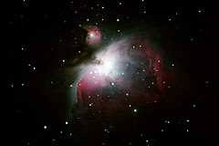
- Go to http://www.fromearthtotheuniverse.org. Do the activity proposed in http://www.fromearthtotheuniverse.org/docs/FETTU_Activity-Guide.pdf ( introduction).
- There´s a wide range of objects in the Universe. Name 5 categories of objects that are found in the Universe.
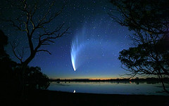

- What is the The Electromagnetic Spectrum?
- Go to http://www.100hoursofastronomy.org and click on “Around the World in 80 Telescopes”.
- Where are the different observatories? Why there?
- Explore one of them and make a brief summary of its characteristics.
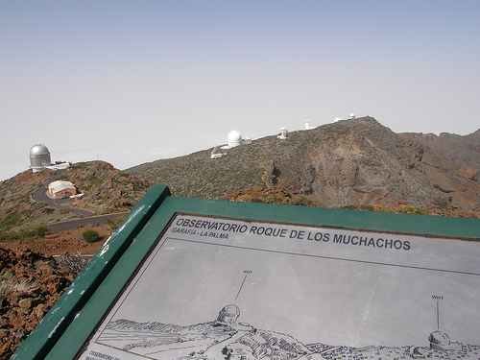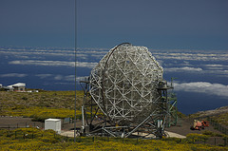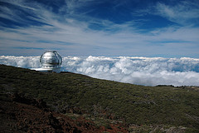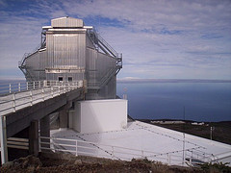

- What is the IAC?
- What is the ENO?
- What is the ORM?
- The “Sky Law”: When was it approved? What for? Which four main areas does it deal with?
- Which features make The Canary Islands be considered of exceptional astronomical quality?
- What is the CCI? Who are its members? What is the Agreement on Cooperation in Astrophysics?
- Name the different kinds of telescopes in the ORM, what are they used for?
- Name the different groups of telescopes in the ORM. Give a general description of each one.
- Main discoveries in the ENO.
- What is the GTC? What will it be used for?

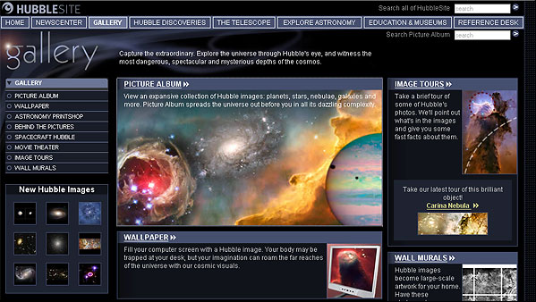
- HUBBLE, the space telescope, how it operates and what it can do. Explain.
- Hubble discoveries.
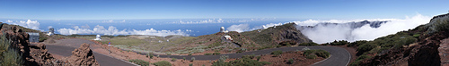

- Write 3 questions you would like to make on a visit to the ORM?

- REPORT:

- Go to http://conchyspot.blogspot.com/ and follow the instructions in “The IYA project” post.
- Your final work should not be a mere list of answers of the questions above, but a work in which all that information must be found.
- The final work can be in digital or paper format, but feel free to show your creativity and imagination.
Conchy Castro http://www.geocities.com/conchy_castro/MY_CORNER.html

