JOSEPH CONRAD

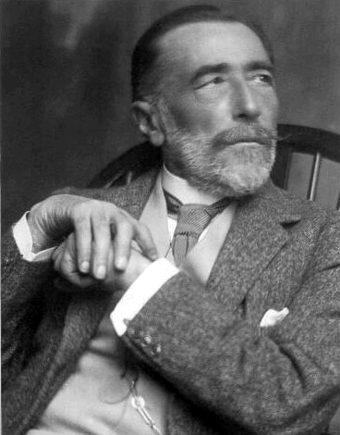

Grupo: Daniel Morera de Paz y Daniel Ferraz García
Teodor Josef Konrad Korzeniowski (1857-1924)
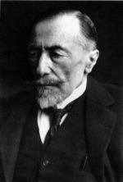

Conrad’s father was a writer best know for patriotic tragedies, and was a translator of Shakespeare and Victor Hugo for English and French.
In 1861, Joseph Conrad’s father was arrested by authorities in Warsaw for helping Russian people and was exiled to Vologda. Conrad’s mother died in 1865 of tuberculosis, and his father died four years later in Krakow. Conrad was leaving to an orphanage at the age of 11.

The parent’s death provoked he was sent to Switzerland to his maternal uncle, Tadeusz Bobrowski. Bobrowski was for Joseph Conrad the figure of his parents. Bobrowski let Conrad to travel to Marseille and begin a career as a seaman at the age of 16. This came after Conrad was rejected for Austro-Hungarian citizenship, leaving for 25 years conscription into the Russian Army. The deeply dept who was involved with the British merchant navy it was a turning point in his life. Conrad rose his rank until getting the masters mariner certificate and commanding his own ship, Otago After that, He changed his name Josef Teodor Konrad Korzeniowski to Joseph Conrad. Although He wasn’t how playwright, he based it for wrote a satirical essay about the obscure civilization.

Literary creation
In spite of thinking people his works were romantics, he believed more in the realism. Mostly of his works are about sailors and the sea. He wrote lots of novels: Almayer´s folly, it was his first novel wrote in English in spite of being French the cultural language for people, an outcast of the islands… but his most famous novel is the hearth of darkness; it is inspired in the environment of Africa when Joseph was in Congo. The principal character is the old sailor Marlow and his meeting with Kurtz remember the old spirit of discover the new world. Francis Ford Coppola based in this brief relate for his film Apocalypse Now where he speak about the spirit of the Conrad relate, the human darkness. His literary work let him get into in the pre-modernist and symbolism world. He also wrote an Outcast, the Nigger of the “Narcissus” and more novels.

England situation
With the death of Carlos IV of France, Eduardo III used to be sure of to get the crown but French people preferred Felipe of Valois (Felipe IV). When Felipe IV confiscated duchy’s Aquitania, it happened the War of hundred years that it finished, after lots of troubles, with the detention of Jack Cade and his death. Enrique IV was a weakling king and the troubles of nobility class it happened the apparition of a new literature “The dances of the Death”. A genre situated in all Europe.

Spain Situation
Amadeo abdicate and the Cortes proclaim a republic, then The First Republic. The Republic has to deal with war in Cuba, the third Carlist war and the canton a list rising of the South and South East of the country. The Moroccan wars enters a disastrous stage, giving rise to a wave of protest all over the country and sparking off the events of the tragic weekend in Barcelona, so the troops fighting in Morocco and suffer the disaster of Annual. Felipe of Anjou got the Spanish crown, and with it, the independence of Americans states, for example Venezuela; however, only rescued Cuba and Filipinas. This loses of territories; it happened the absolutism and the fail of the Constitution of Cadiz. Beginning the century XX, Alfonso XIII got the Spanish crown, but he couldn’t rescue Cuba and Filipinas. These last territories were the Spanish pride. Spain lost his war against USA and so Spain lost Cuba and Filipinas, all the Americans territories. After that, Spain attempted regained its pride with the instauration of the republican regime. Finally, the civil war it provoked the instauration of the Franco’s government. Economy rose, so Franco won more power. Owing to Franco’s dead, Mr. Juan Carlos became the king of Spain.

Situation of the world

The ending of the cold war, it meant an open-minded commerce and a privatization of America. Europe attempted to imitate the model of open-minded commerce of USA. However, failed. Clinton got 20 millions of works for USA and with it the least poorness of the last 20 years. The big richness of USA it contrasted with other American countries. The differences of richness among the population, it provoked the return to the status which followed, before Big Depression. Europe gave a big economy, but there were big differences among countries where Germany was the richest country. In Asia, Japan became the biggest country in richness and the third in the world. It also invented the railroad and the telegraph in India; it happened the succession war in North America… But the most important events were the First World War between Austro-Hungry, German, France and the great navy of England; and the fall of Hitler in Munich.

