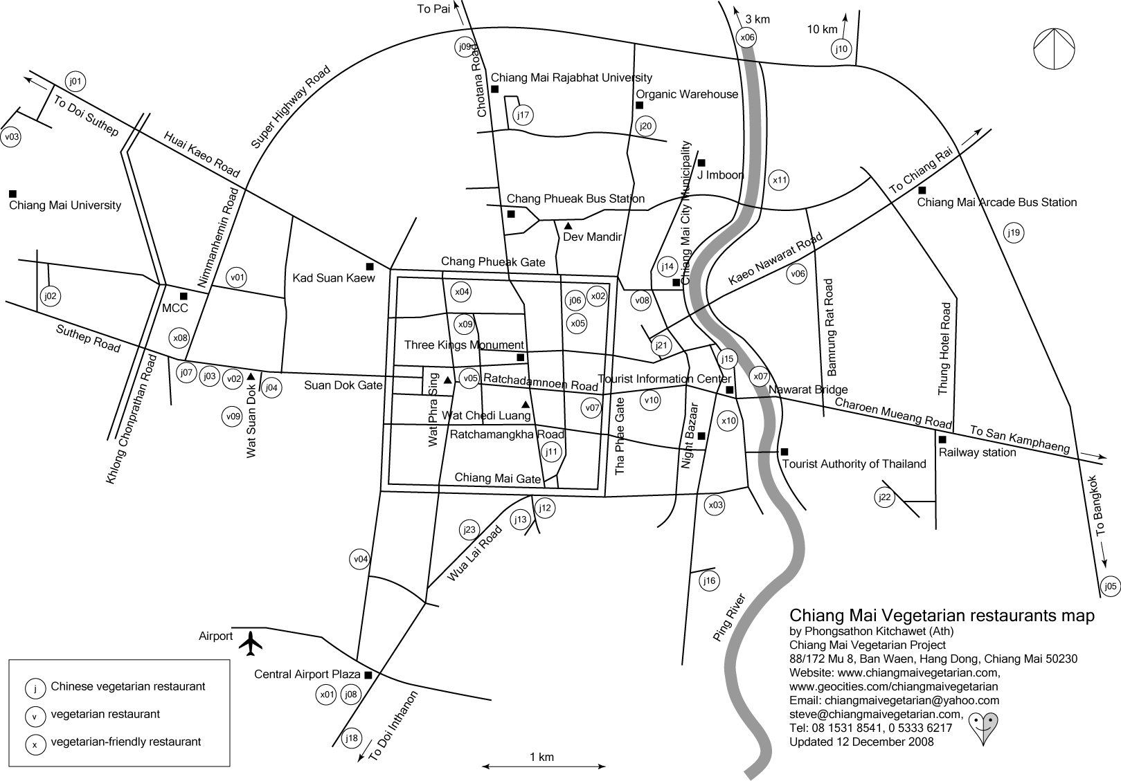
Chinese Vegetarian restaurants
Che: no garlic, onion, Chinese garlic, Chinese chive and tobacco. Perhaps there are eggs, milk, butter or cheese in some restaurants.
j01 Chao Ngo (เจ้าเงาะ) 100/13 Huai Kaeo Road, opposite Chiang Mai University's front gate. Open 9 am - 9 pm, closed on Sunday. Tel: 08 9835 5405
j02 Ahan Che (อาหารเจ) Faculty of Education, Chiang Mai University. Open daily 7 am - 2 pm, closed on holidays and the university vacation (in March-May and October).
j03 J. Krayathip (เจกระยาทิพย์) 193 Suthep Road, near Wat Suan Dok. Open daily 7 am - 8 pm. Tel: 0 5327 9729,
08 1531 9771
j04 Saksit (ศักดิ์สิทธิ์อาหารเจ) 3/2 Suan Dok Road. Open 6.30 am - 7.30 pm, closed on Saturday.* Tel: 0 5390 3855
j05 Ahan Che (อาหารเจ) 2nd floor, Big C, Superhighway Road. Open daily 9 am - 9 pm.
j06 Vegetarian Thai Food (เจ อาหารไทย) 54 Mun Mueang Road, Soi 9. Open daily 7 am - 5 pm. Tel: 0 5341 8978
j07 Che Yaowarat (เจเยาวราช) 257/10 Suthep Road, next to Halong Bay Vietnamese restaurant. Open daily 10 am - 2 pm.
Tel: 0 5390 4441, 08 1837 9310, 08 9635 6965
j08 Che Phatthana (เจพัฒนา) Central Airport Plaza's Food Center at 4th floor. Open daily Monday-Friday 11 am - 9 pm, Saturday-Sunday 10 am - 9.30 pm.
j09 Rassameedhamma Foundation (อาหารเจมูลนิธิรัศมีธรรม) 269/1 Chotana Road. Open 6 am - 4 pm, closed on Sunday.*
Tel: 0 5322 1501
j10 Samphao Thip (สำเภาทิพย์) 251/18 near Maejo University, San Sai. Open 7 am - 5 pm, closed on Sunday.
Tel: 08 6586 9059
j11 Tien Sieng (เทียนเซียง) 54-56 Phra Pok Klao Road.
Open 6.30 am - 5 pm, closed on Sunday.* Tel: 0 5320 6056,
0 5328 1487
j12 Che Ob Oon (เจอบอุ่น) 11 Nantharam Road.
Open 6 am - 6 pm, closed on Saturday.* Tel: 0 5328 4393
j13 Save Thanya (เซฟธัญญา) 12/3 Nantharam Road.
Open daily 8 am - 3.30 pm. Tel: 0 5328 2741
j14 Chan Fong (จันทร์ฟอง) A 7-8, Chao Nuea Market (in Mueang Mai Market). Open daily 3 am - 6 pm.
Tel: 0 5323 2435, 08 9636 0161
j15 Che Cheng (เจ้เจ็งอาหารเจ) in Lamyai Market (opposite Warorot Market). Open daily 6 am - 6 pm, on the monk's day (full, half and new moon) open 3 am - 6 pm. Tel: 0 5323 2144
j16 Che Om Bun (เจ ออมบุญ, พุทธสัมพันธ์) 199/23 Chang Klan Road. Open 7 am - 3 pm, closed on Sunday.
Tel: 0 5382 0361, 0 5381 8094
j17 Che-Mangsawirat (เจ-มังสวิรัติ) Chiang Mai Rajabhat University canteen. Open daily: Monday-Friday 6 am - 6 pm, Saturday-Sunday 6 am - 2 pm. Tel: 08 7114 6679
j18 Che For Health (อาหารเจเพื่อสุขภาพ) Chiang Mai-Hot Road, about 1 km from Central Airport Plaza. Open 6.30 am - 3 pm, closed on Sunday. Tel: 08 1179 5859
j19 Che Phatthana (เจพัฒนา) Carrefour's Food Center at 2nd floor. Open daily Sunday-Thursday 9 am - 9 pm,
Friday-Saturday 9 am - 9.30 pm.
j20 Chuda Che (ชุดาเจ) 23/5 Sri Mongkon Road, near Kham Thiang Intersection. Open daily 8 am - 9 pm.
Tel: 08 6966 6821
j21 DJ Tofu (ดี.เจ.) Sitthiwong Road. Open daily
8 am - 9 pm. Tel: 08 4502 9747, 08 5933 7042
j22 Bun Song (บุญส่ง) 194/5 Kong Sai Road. Open daily
6 am - 6 pm. Tel: 08 1192 5040
j23 Che Tong (เจต๋อง) 148/1-2 Wua Lai Road. Open 7.30 am - 6 pm, closed every first and last Tuesday.
Tel: 0 5327 6196, 08 7177 2862

Vegetarian restaurants
Milk, butter or cheese in some restaurants.
v01 Khun Churn (คุณเชิญ) 120/2 Nimmanhemin Road,
Soi 17. Open 10 am - 10 pm, closed every 16th.
Tel: 0 5322 4124, 08 1881 3032
v02 Mangsawirat Suan Dok (มังสวิรัติสวนดอก) 15 Suthep Road, near Wat Suan Dok. Open 5.30 am - 3 pm, closed on Sunday.* Tel: 0 5380 8337
v03 Long Phisut (ลองพิสูจน์) Faculty of Humanities' canteen, Chiang Mai University. Open 7 am - 2 pm, closed on Saturday-Sunday, holidays and the university vacation (in March-May and October). Tel: 08 6185 3627
v04 Vegetarian Society of Thailand (ชมรมมังสวิรัติแห่งประเทศไทย สาขาเชียงใหม่) Mahidol Road. Open 6 am - 2 pm, closedd on Saturday and Sunday. Tel: 0 5327 1262
v05 Thai Vegetarian Food Restaurant (ร้านอาหารมังสวิรัติ) 65 Inthawarorot Road. Open daily 6 am - 7 pm.
Tel: 08 1289 3163
v06 Khufa Mangsawirat (คู่ฟ้ามังสวิรัติ) 152/6 Kaeo Nawarat Road. Open 7 am - 3 pm, closed on Sunday.
Tel: 08 6924 4884, 08 4172 5213
v07 Aum (โอม) 65 Mun Mueang Road, next to Black Canyon, Thaphae Gate. Open 8.30 am - 2.30 pm, 5 - 9 pm, closed every 1st - 2nd. Tel: 0 5327 8315
v08 Vegetarian Thai Orchid (มังสวิรัติไทยออคิด) 419/24 Witchayanon Road. Open 7.30 am - 4 pm, closed on Sunday.
Tel 0 5387 6232, 08 4177 6032, 08 5037 0307
v09 Pun Pun (พันพรรณ) behind Mahachulalongkornrajavidyalaya University library in Wat Suan Dok. Open daily 9 am -5 pm. Tel: 08 6101 8508
v10 Taste from Heaven 237-239 Thaphae Road. Open daily 8.30 am - 10 pm. Tel: 0 5320 8803

Vegetarian-friendly restaurants
Both meat and vegetarian food
x01 Korean Food (อาหารเกาหลี) in Central Airport Plaza's Food Center, 4th floor. Open Monday-Friday 11 am - 9 pm, Saturday-Sunday 10 am - 9 pm. Tel: 086-192-1551
x02 Bai Porn (ใบพร) or Prego 15/3 Sri Phum Road, Soi 1. Open daily 10 am - 10 pm. Tel: 08 1882 7466
x03 Whole Earth (โฮลเอิร์ท) 88 Sri Don Chai Road.
Open daily 11 am - 10 pm. Tel: 053-282463
x04 Dara Vietnamese Food (ดารา อาหารเวียดนาม) 7 Sriphum Road, next to Monthian Temple. Open 9 am - 9 pm, closed on Sunday, Tel: 0 5321 5849
x05 Blue Diamond (บลูไดมอนด์) 35/1 Mun Mueang Road, Soi 9. Open 7.00 am - 8.30 pm, closed on Sunday.
Tel: 0 5321 7120
x06 Houn Soontaree (เฮือนสุนทรี) 208 Patan Road.
Open daily 10 am - 12 pm. Tel: 0 5387 2707, 0 5387 2708
x07 The Riverside 9-11 Charoen Rat Road. Open daily 4 pm - 1 am. Tel: 053-243239, 053-246323
x08 DinDee (ดินดี), Chiang Mai University Art Museum, Nimmanhemin Road. Open daily 11 am - 9 pm.
Tel: 08 6910 8137
x09 Ek Thip Chok Di (เอกทิพย์โชคดี) 57 Cha Ban Road, near Chiang Mai Technical College. Open daily 10 am - 10 pm.
Tel: 0 5341 7122, 08 6923 6122, 08 1671 6785
X10 Khao Soi Islam (ข้าวซอยอิสลาม) 24 Charoen Prathet Road, Soi 1. Open daily 7 am - 5 pm. Tel: 0 5327 1484
X11 Khao Soi Lamduan Faham (ข้าวซอยลำดวนฟ้าฮ่าม)
352/22 Charoen Rat Road. Open daily 8 am - 4 pm.
Tel: 0 5324 3519, 08 4616 1528

All vegetarian restaurants open daily in Chinese Vegetarian Festival (October). *The restaurants that also open daily in Khao Phansa time (July - October) are j04, j09, j11, j12 and v02.

Updated 12 December 2008

Vegetarianism reduces global warming.

