April Meeting Highlights
This month’s club meeting was held on April 4, 2000 at Lone Cabbage Fish Camp. This month’s meeting had 20 persons in attendance with 2 new people registering. Curt Smith “chaired” the meeting and several topics were covered during the course of this meeting.
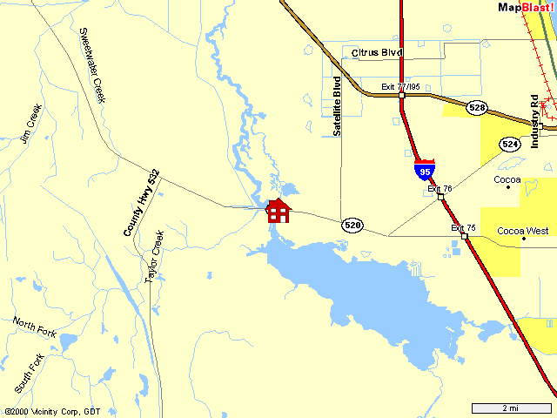
- Nominations for Club Officers was conducted. Elections will be held at the next club meeting to be held on Monday May 1, 2000. Nominations were taken and a ballot is enclosed as the last page of this newsletter. Officer positions and description are identified along with each ballot position.
- Several members have expressed the interest in having T-shirts made up for the club.
- It was announced that effective April 20, 2000 personal watercraft will no longer be permitted in the Cape Canaveral national Seashore.
- Trips and events: We need to get riding events planned. Please help by giving suggestions. We also need to have different people volunteer to help organize and lead rides and ride events.
- The club also would like to receive ideas for charity ride events and ideas for charities or a charity to sponsor. One suggestion was the Red Cross.

Last Months Event(s) Summary
Saturday/Sunday March 11/12 2000 - There was a group event announced at the last meeting to meet at an island just south of Sebastian Inlet on either day.

Upcoming Events:
Saturday April 15, 2000 – Get-together at Sea-Doo Days at the Intracoastal Marina, Melbourne, Florida.
Saturday April 22, 2000 – Group ride on the St. Johns River. Start at Mullet Lake in Sanford, Florida.
Saturday May 13, 2000 – Group get-together at Curts place on the river. The previous planned date for this event was changed
Do you have any ideas for other events or rides? If so, please give your suggestions to Shannon Anderson.
Club Calendar - In the making!

Next Meeting:
Monday May 1, 2000 at 7 p.m.
Lone Cabbage Fish Camp.
8199 State Road 520, Cocoa, Florida
(321) 632-4199
Lone Cabbage is located on SR 520 at the St. John’s River, approximately 5 miles West of I-95.

PLEASE NOTE - All members are encouraged to attend the next two meetings if possible to participate in the election of officers.

Treasurer's Report
No new information this month.

Club Membership Statistics
Total Registered: | 40
Total Members (paid):
IJSBA members: | 19

Web Links
http://www.shannonsworld.com: Shannon's web-site where the Central Florida Jet Riders page(s) are currently hosted.
http://www.geocities.com/cfjr_2000: Online CFJR newsletter, archive and information.
http://www.geocities.com/funonh2o: Peter's web-site with a list of ride location. If you have a place to add, tell him and he will add it.

Club Officer Duty Descriptions
The officers of the club shall be a President, Vice President, Secretary, legislative Chairman, Treasurer and Event Chairman. These officers shall constitute the executive board.
IJSBA requires:
- That all club officers must be IJSBA members.
- Only dues paying club members shall be eligible to hold club office.

Executive Board (duties)
- To act for the club in all matters ordered by the club.
- To make final decisions on expulsion of members.
- To investigate properly and present to the club all business and important activities.
- To have control over all club affairs.

President (duties)
Nominees: Greg Taylor, Curt Smith
- Preside at all club meetings
- General supervision of club affairs
- Appoint any person or committee not otherwise ordered by the club
- Represent the club personally on appropriate occasions and in business contacts.
- Assist all other officers of the club in their records, correspondence and other duties.
- Promote interest on the part of each member in club life and activities.
- Vote only when necessary to break a tie.

Vice President (duties)
Nominees: Cindy Gentile
- Performs the duties of the President in his or her absence.

Secretary (duties)

BALLOT
President  Greg Taylor  Curt Smith | Treasurer  Trixi Stone | Legislative Chairman  Curt Smith
Vice President  Cindy Gentile | Secretary  Peter Came  Jonell Pope | Event Chairman

Nominees: Peter Came, Jonell Pope
- To send out the notices of regular or special meetings.
- To handle all club correspondence.
- To perform such other duties as generally fall into that office.
- To keep a record of the club meetings.

Legislative Chairman (duties)
Nominees: Curt Smith
- To monitor local and state legislative activities affecting PWC.
- To communicate with the IJSBA Government Affairs Department and legislative activities defined.
- To work with the IJSBA Government Affairs Department, and the legislative chairmen of other clubs, to promote programs and legislation that will benefit PWC users.

Treasurer (duties)
Nominees: Trixi Stone
- To collect the dues from all members
- To collect all the money due the club.
- To maintain club financial records and deliver reports on a timely basis.

Event Chairman (duties)
Nominees: None
- To plan all club rides, activities, etc.
- To stimulate interest in activities.
- To assist in handling club socials, parties and other functions.
- To enforce all rules of group riding.
- To appoint members of Activities Committee to assist with event planning.

