March Meeting Highlights
This month’s club meeting was held on March 7, 2000 at Kay’s Bar-B-Q. This month’s meeting had 27 persons in attendance with 9 new people registering. Curt Smith “chaired” the meeting and several topics were covered during the course of this meeting.
- The necessity to have nominations and elections for Club Officers was discussed. The current “interim” officers are intended to get us going. A suggested date to hold elections will be the club meeting to be held in May. Nominations are currently being accepted. Officer positions and description are identified on page 3.
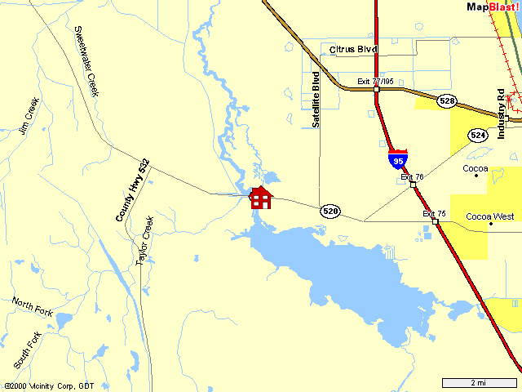
- In an effort to have the newsletter distribute information, and to also serve as a meeting reminder, the newsletter will be mailed approximately one to two weeks before the next meeting.
- Several members have expressed the interest in having T-shirts made up for the club.
- Topics of interest to several (if not all) members is PWC insurance.
- Curt will attempt to provide some information at the April meeting on having an annual event similar to the Tennessee 600.
- Trips and events: Shannon (acting Event Chairman) has not received any inputs or suggestions on events to plan locally. Please help by giving him suggestions.

Last Months Event(s) Summary
Saturday/Sunday March 11/12 2000 - There was a group event announced at the last meeting to meet at an island just south of Sebastian Inlet on either day. The original plan was for a 2-day campout. Unfortunately the "support" boat had a last-minute problem that resulted with a plan change.
A second group planned to depart Front Street Park in Melbourne at 9:00 am. John Kerekes and Marc Schrader arrived and waited until 9:30. No one else showed up. The weather was not looking too good. They decided to drive south to Grant and launch from there, weather permitting. After waiting about one hour, it was decided to give it a try. They took off and rode to the middle of the channel. The wind was too much to continue, so they returned back to the ramp, loaded up and went home.

Upcoming Events:
Saturday April 8, 2000 – Group get-together at Curts place on the river.
Do you have any ideas for other events or rides? If so, please give your suggestions to Shannon Anderson.

Next Meeting:
Tuesday April 4, 2000 at 7 p.m.
Lone Cabbage Fish Camp.
8199 State Road 520, Cocoa, Florida
(321) 632-4199
On SR 520 at the St. John’s River. West of I-95.

PLEASE NOTE - All members are encouraged to attend the next two meetings if possible to participate in the nomination and election of officers.

Treasurer's Report
Establish Bank Account - After looking into opening a bank account for the club, several issues arose. Items such as monthly service fee, having a registered name, and a club address were some of these issues. At this time, a "lock-box" has been obtained and the club funds will be maintained from there. At a future date, this practice will be reviewed and establishing a bank account will be re-visited.

Club Membership Statistics
Total Registered: | 38
Total Members (paid):
IJSBA members: | 18

Web Links
http://www.shannonsworld.com: Shannon's web-site where the Central Florida Jet Riders page(s) are currently hosted.
http://www.geocities.com/cfjr_2000: Online CFJR newsletter and archive.
http://www.geocities.com/funonh2o: Peter's web-site with a list of ride location. If you have a place to add, tell him and he will add it.

Club Officer Duty Descriptions
The officers of the club shall be a President, Vice President, Secretary, legislative Chairman, Treasurer and Event Chairman. These officers shall constitute the executive board.
IJSBA requires:
- That all club officers must be IJSBA members.
- Only dues paying club members shall be eligible to hold club office.

Executive Board (duties)
- To act for the club in all matters ordered by the club.
- To make final decisions on expulsion of members.
- To investigate properly and present to the club all business and important activities.
- To have control over all club affairs.

President (duties)
Interim President: Greg Taylor
- Preside at all club meetings
- General supervision of club affairs
- Appoint any person or committee not otherwise ordered by the club
- Represent the club personally on appropriate occasions and in business contacts.
- Assist all other officers of the club in their records, correspondence and other duties.
- Promote interest on the part of each member in club life and activities.
- Vote only when necessary to break a tie.

Vice President (duties)
Interim Vice President: Cindy Gentile
- Performs the duties of the President in his or her absence.

Secretary (duties)
Interim Secretary: Peter Came
- To keep a record of the club meetings.
- To send out the notices of regular or special meetings.
- To handle all club correspondence.
- To perform such other duties as generally fall into that office.

Legislative Chairman (duties)
Interim Legislative Chairman: Curt Smith
- To monitor local and state legislative activities affecting PWC.
- To communicate with the IJSBA Government Affairs Department and legislative activities defined.
- To work with the IJSBA Government Affairs Department, and the legislative chairmen of other clubs, to promote programs and legislation that will benefit PWC users.

Treasurer (duties)
Interim Treasurer: Trixi Stone
- To collect the dues from all members
- To collect all the money due the club.
- To maintain club financial records and deliver reports on a timely basis.

Event Chairman (duties)
Interim Event Chairman: Shannon Anderson
- To plan all club rides, activities, etc.
- To stimulate interest in activities.
- To assist in handling club socials, parties and other functions.
- To enforce all rules of group riding.
- To appoint members of Activities Committee to assist with event planning.

