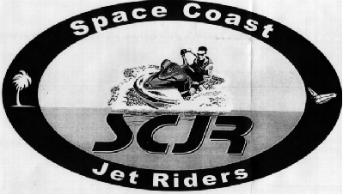

Central Florida/Space Coast only personal watercraft club, invites you to become a member of SPACE COAST JET RIDERS. As a member you can participate in events that include weekend outings, camaraderie and FUN ... FUN ... FUN.

Come have fun and help to protect your right to have fun. Also receive member discounts at participating dealers.

For more information, contact any of the club officers listed below:
Curt: (321) 242-2054 | Todd or Trixi: (321) 455-6388
Jonell: (321) 639-1776 | Peter: (321) 453-0495

Central Florida/Space Coast only personal watercraft club, invites you to become a member of SPACE COAST JET RIDERS. As a member you can participate in events that include weekend outings, camaraderie and FUN ... FUN ... FUN.

Come have fun and help to protect your right to have fun. Also receive member discounts at participating dealers.

For more information, contact any of the club officers listed below:
Curt: (321) 242-2054 | Todd or Trixi: (321) 455-6388
Jonell: (321) 639-1776 | Peter: (321) 453-0495

