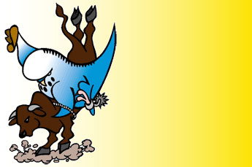
Australian National
Budgerigar Council

36th Annual Show

Hosted by:
Queensland North and Central Zone Budgerigar Council

Rockhampton 28th May to 3rd June 2010

Website: www.geocities.com/capbuds

Contact point:
Show co-ordinator: Scott Eriksen
Mobile: 0419776837
Email: Scott.A.Eriksen@nab.com.au

Expression of interest form

Please send me further information regarding the upcoming 2010 ANBC Championships.

Name:
Mailing Address:
Zoning: (Please circle your zone.) | N&C/QLD S/QLD WA SA VIC TAS NSW
Phone No:
Home club:
Email:

