HINDUPPARA MISSION

Hinduppara Colony is situated on the border of two states in India on a rock. More than 300 Hindu consisting of approximately 60 families live in this colony. It is not a slum; but almost the same.

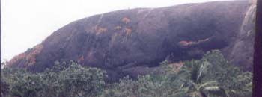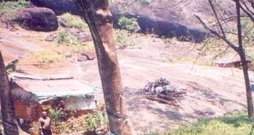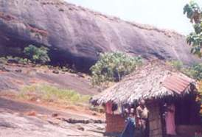
Hinduppara rock begins There are about 60 houses like this Pastor Ciniraj with a familyat their shelter
All people are very very poor. They earn daily for their life. Usually, they are jobless or without income for more than 15 days of a month. Most are illiterate. The living conditions are not hygienic. There is no electricity, no telephone and not even purified water to drink - their drinking water comes from a local well. They use tin bottle lamps and lanterns with Kerosene oil for their lighting.

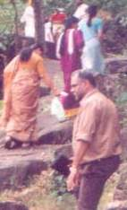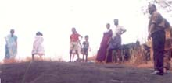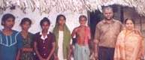
going up to the colony missionaries reaching on the rock another family with Pastor & Mrs. Ciniraj
There was not even a single Christian within 20 kilometers of the colony. Transporting facilities are very rare to travel. By the grace of God, the Salem Voice reached that interior remote area about five years ago. We started a Bible class as well as adult education. Many were interested and are attending the classes. We provide medicine, clothes, and children's education.

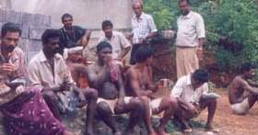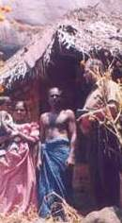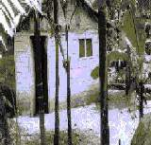
Pastor with the villagers Pastor with a family another house
When Pastor Paul Ciniraj and family were tortured by terrorists sometimes ago, they were hidden in this colony for few days. During those days we conducted a fasting prayer. Almost everybody participated and accepted Jesus as their Saviour.

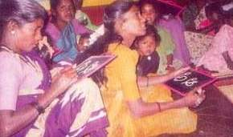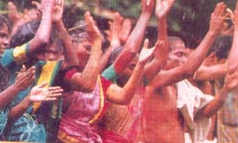
Adults learn to read and write, for they want to read the Bible Worshipping the Lord in the Spirit and the Truth
We prayed together for a Gospel Assembly Hall. Praise the Lord! One handicapped poor Hindu woman of the same colony named Indira contributed a plot to build an assembly hall. We are praying to the Lord to provide them funds for constructing the Assembly hall as well as a Bible School and a residence wing for the local minister.

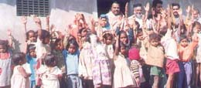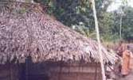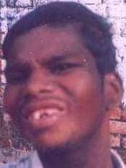
Village school of the Salem Voice another house He was attacked by a Bear.By prayers he lives.
If God permits, we'd like to build 60 proper houses for each families with latrine facilities, a common water tank, solar electricity, a school for the children, a stitching school for young ladies, a computer centre for the youths, an adult literacy centre for adults.

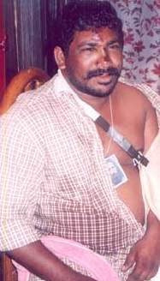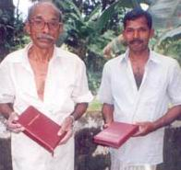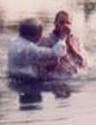
He was a terrorist, now servant of Lord Jesus. Bible has been donated by Salem Voice Witnessing Christ in the water

If God inspires, help this mission (Contacting address given below):

Pastor Paul Ciniraj,
SALEM VOICE, Devalokam (P.O),
Kottayam, Kerala-686038, INDIA.
(mailto:ciniraj@asianetindia.com)

