S’mores

Any Which Way
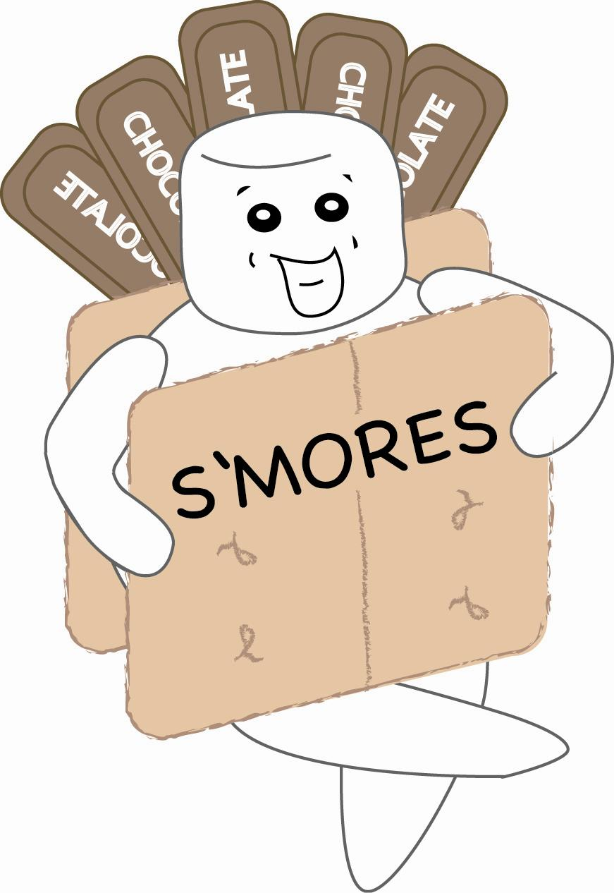
SPECIAL: Buy 4 and get the 5th FREE!!!

Girl Scouts of Mid-Continent Council – 2007 Australia Patrol of Senior Girl Scout Troop 1262 has developed this special limited edition S’mores – Any Which Way cookbook. No need to have the same S’mores time after time. With over 140 recipes from which to choose, you can treat yourself to a new recipe for months! Try S’mores ice cream, cocoa, appetizers, brownies, cereal, cheesecake, pie, pudding, and so much more! Other features of this unique cookbook include a unique measurement index.

This one-of-a-kind cookbook makes a perfect gift for a special Scouting leader, camp staff, camping enthusiasts, outdoor specialist or novice, family members, and … YOU! So just complete this form and mail with your check for $10.50 (includes $2.50 for shipping). A copy of S’mores – Any Which Way cookbook will be yours!

Name |  |  |  |  |  | Phone Number
Address |  |  |  |  |  | Email Address
City |  |  |  |  |  | State |  |  |  |  |  | Zip
 |  |  |  | Quantity |  |  | Price |  |  |  | Total Cost
 | S’mores – Any Which Way |  |  |  |  |  | $8.00 |  |  |  | $
 | Shipping each item |  |  |  |  |  | $2.50 |  |  |  | $
 | Total |  |  |  |  |  | $10.50 |  |  |  | $

Please make checks payable to: Girl Scouts.
Mail form & check to: Judy Brennan, 11313 Riley, Overland Park, KS 66210-2655
Questions: Email at jbrennan2@kc.rr.com
Thank you for your support!!

