PRACTICAL MINISTRY OPPORTUNITIES
WITH BOUNTIFUL HARVEST
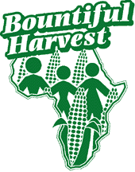 | We Minister to the Villages We Serve Through:  - Training in Agricultural and Economic Development  - Literacy Education and Empowerment of Women  - The True Vine Ministry:  - Reaching Youth for Christ  - Health Care  - Helping Families Achieve Self-Reliance

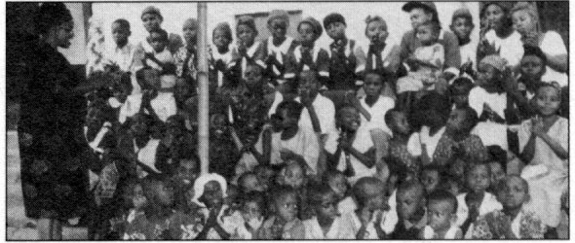

- YES, Grace, count me in:

I want to Participate in Practical Ministry with Bountiful Harvest
- I will commit to 6 months’ donations of: __ $10 __ $20 __ $50 __ $100
___ Other $___ per month to help Bountiful Harvest continue its work.
- I am enclosing a gift of $______ to be used for:
- The True Vine Minstry
- Literacy education and empowerment of women
- Training in agricultural and economic development
- Support of Short-Term Missionaries
- I would like to sponsor a family with $23 per month. Please send me a photo and information about a family.

Name________________________________ Phone ( )_________________

Address___________________________________________________________________

City________________________________________ State_______ Zip_______________

Please make checks payable to

BOUNTIFUL HARVEST
P.O. Box 785, Duarte, CA 91109-0785 USA • (626) 305-9020
FAX (626) 303-2856 • www.bountifulharvest.org

Contributions to support Bountiful Harvest are tax-deductible
as a dba of National Christian Fellowship, under Section 501(c)(3) of the Internal Revenue Code.

