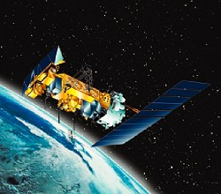
Argos
(Advanced Research Global Observation System)
Problem Statement:
Build a distributed and integrated system, which gather reliable statistics from real environments (earth, space etc) and these statistics use for knowledge processing to protect and monitor the environments with mobility feature. i.e. “Argos is a solution”.
Argos System Definition:
Argos is a distributed satellite-based data location and collection system dedicated to monitoring and protecting the environment. It can determine the location of any ARGOS transmitter, anywhere in the world, and collect data from sensors on fixed or mobile platforms.
Argos is a satellite-based system, which collects environmental data from autonomous platforms and delivers it to users worldwide. Argos has truly global service and is fully integrated - providing data from the source to the User's desktop.
Brief History:
Since it began in the late-1970, Argos use continues to expand. The system has proven to be simple to use and highly reliable. Currently, approximately 6,000 transmitters are operating in a variety of applications involving either study of the earth or protection of the environment.
Argos was developed under a Memorandum of Understanding (MOU) between the CNES (the French space agency), the National Aeronautics and Space Administration (NASA, USA) and the National Oceanic and Atmospheric Administration (NOAA, USA).
Argos is operated by CLS, based in Toulouse, France. CLS has subsidiaries in the U.S., namely, Service Argos, Inc. and North American CLS, Inc.. These companies together operate the system and promote its use.
The Basic Goal:
The basic goal of the system is to optimize both the quantity and the quality of Argos data distributed onto the GTS (The Global Telecommunication System) without interfering with Principal Investigators' requirements.
How it Works?
The system utilizes both ground and satellite-based resources to accomplish its mission. This includes instruments carried aboard the NOAA polar orbiting environmental satellites (POES), receiving stations around the world and major processing facilities in France and the United States. This fully integrated system works to conveniently locate and deliver data from the most remote platforms to the user's desktop, often in near real-time.
The Argos system involves three interactive subsystems:
1) Platform Transmitter Terminals (PTTs)
2) The Space Segment
3) The Ground Segment
1) Platform Transmitter Terminals (PTTs)
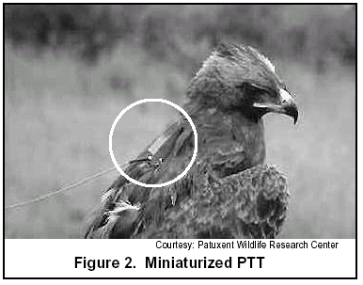
Argos operation begins with transmissions from PTTs attached to sensor equipment and the platform from which data is collected. PTTs have been Adapted for applications as diverse as tracking Migratory birds (ie.,miniaturized, Figure 2) to monitoring ice floes in harsh environments. Typically, they are built rugged to withstand punishment, both expected and unexpected (Figure 3). Transmitters are interfaced with sensors on moored or drifting buoys (Figure 4), animals, ships, containers, balloons, and many other platforms. They are configured by size, weight, power consumption, and housing according to application.The smallest PTTs, used to track birds, weigh as little as 17 grams. Power consumption on all PTTs is low due to the satellite’s low-earth orbit and highly sensitive receiver equipment. This enables extended operation —a year or more— on battery power alone.
Terminals (PTT) Properties
Uplink Frequency: 401.65
Message Length: up to 32 bytes
Repetition Period: 45 to 200 seconds
Messages/pass: varies depending on
latitude and type of service (see figure 8)
Transmission time: 360 - 920 ms
Duty Cycle: Varies
Power: battery, solar, external
2) The Space Segment
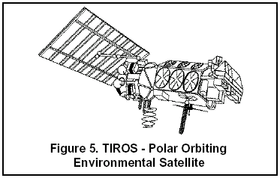
Argos instruments are flown on board the National Oceanic and Atmospheric Administration (NOAA) Polar Orbiting Environmental Satellites (POES). The satellites receive Argos messages from PTTs and relay them to the ground in realtime. They also store them on tape recorders and read out (“dump”) the messages to one of three main system ground stations:
- Wallops Island, Virginia, USA
- Fairbanks, Alaska, USA,
- Lannion, France.
At least two satellites are operational at any time and launches are scheduled well into the 21st century. Data from additional satellites is processed on an
As available basis. The duration of transmitter visibility by the satellite (pass duration over the transmitter) is the “window” during which the satellite can receive messages from the transmitter. It lasts between 8 and 15 minutes (10 minutes on average).
3) The Ground Segment
Figure 9 shows the Argos System Configuration for receiving and processing facilities. Upgrades to computer equipment and communications links are made throughout the segment. Argos Global Processing Centers (GPC) are fully redundant.
Receiving Stations
- GPCs
- RPCs
GPCs
The Global Processing Centers (GPCs) in Largo, MD, USA and Toulouse, France process all data received from the receiving stations. They archive the results and make them available to users on line.
The work of a GPC includes:
Quality control, including checking of message time tagging, signal level, transmitter ID number.
RPCs
Regional Processing Centers (RPCs) provide users in a region with local access to results. For example, Japanese users can connect to the Argos RPC in Tokyo to access locations and sensor data from transmitters around the world. Some RPCs, such as Melbourne, are connected to one or more regional receiving stations. This means they can process data received in real time from transmitters in visibility of the receiving stations.
Each RPC is also connected to a GPC so that it can provide its users with global coverage, i.e. data received in other parts of the world.
The data from each sensor on a given transmitter is processed separately. Users can therefore choose different processing options:
• A - which outputs the raw sensor data as numerical values
• B - which converts raw sensor data into physical values using a different calibration curve for each sensor.
The three main ground stations (Wallops Island, Fairbanks, and Lannion) receive all messages recorded by the satellite during an orbital revolution, providing complete global coverage. Regional receiving stations receive transmitter data from the satellites in real-time whenever a satellite is within station visibility. The
main ground stations also act as regional receiving stations.
ARGOS LOCATION PROCESSING (Argos plus GPS )
Global Positioning System (GPS) positions are processed along with Argos locations through the Argos system. Since GPS receivers continuously recalculate position fixes, higher temporal resolution is possible. For example, samples taken every 30 minutes can be associated with a location. Results are integrated with Argos data, and GPS and Argos locations appear in the same format (a flag indicates whether Argos or GPS). Of course, use of a GPS receiver impacts on the platform's power requirements and costs.
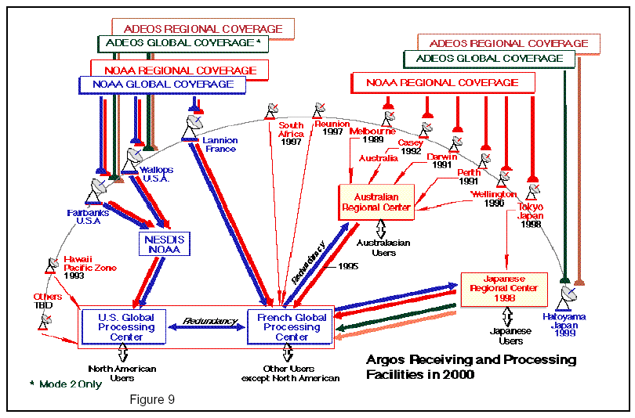
2 150 m < accuracy < 350 m
1 350 m < accuracy < 1000 m
0* > 1000 m
A no estimate of location accuracy
DATA DISTRIBUTION
Argos data is distributed by a variety of methods
(Figure 11). The most commonly used involve
automatic delivery of the data to users via networks
such as the Internet. Archived data is available on
floppy diskette or CDRom.

Argos DATA DISTRIBUTION Cycle:
Argos data is distributed by a variety of methods (Figure 11). The most commonly used involve automatic delivery of the data to users via networks such as the Internet. Archived data is available on floppy diskette or CD Rom.

GTS Subsystem
One of the fundamental reasons for developing the Argos system was to provide buoy data—drift tracks and sensor data such as atmospheric pressure and temperature—for meteorologists and oceanographers. These data are usually relayed onto the Global Telecommunications System (GTS), a world-wide operational system for the sharing of meteorological and climate data. Argos established a powerful Argos/GTS processing subsystem to simplify the transmission of data directly onto the GTS. The system provides maximum flexibility in processing sensor data. This has resulted in increased quantity and quality of Argos data on the GTS.
Automatic Distribution Service (ADS)
ADS supplies results automatically, either at fixed times, which are User-defined, or whenever new data become available. The User specifies the most appropriate distribution network. For example, in the US, many users are taking advantage of the Internet to receive their data via FTP or email. There is no need to interrogate Argos on-line since data is delivered automatically to the User's system.

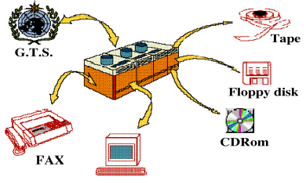

Basic Application of Argos System:
Argos Phenomenon explains as:
”Advance earth system science worldwide by application and enhancement of space based data collection and location technologies.”

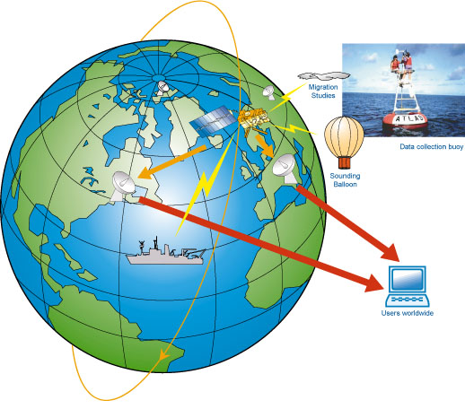
Which Distributed OS works here??

ARGOS OS (a research GMMP operating system) is a distributed message-based operating system for studying the ramifications of the Virtual Port Memory Architecture (VPM). In the VPM architecture individual processing elements reference a global memory using system-wide virtual addresses translated at the memory. There is a separate message bus used for all inter-processor messages. The processing elements have large caches with no coherency support. ARGUS provides each process a private process space, performing message-based communication and synchronization via messages. ARGOS uses the global memory to implement rapid message passing and copy-on-write between processes. The object manager, file manager, and pager all utilize the global memory for rapid communication and the message bus for the synchronization.

Developed by: New Mexico State University, USA Eric E. Johnson
Model: Global Memory Message Passing Multiprocessor, shared memory
Properties: message passing, UNIX-compatible, real-time support

Transparency: Achieved
Running on: VMP machine consisting of MC 68020 processors (embedded)
Deployment Date: 1989

Features:
- Sensor data processing
- Time of observation
- Multiplexing
- Quality Control
- Encoding
- Statistics are automatically updated by the system.
- Real-time data are stored in a relational database to facilitate monitoring activities and trace possible problems with individual platforms.
- Raw data simulation
- Transparency
- Fault Tolerance & Reliability (Multiple PPTs, Space Segments, GPCs, RPCs)
- Global Resource Sharing
------------------------------------------------------------------------------------------------------------

Better Approach To Experience Real-time Distributed System

