- Course Name:
Computers In Science (KOS 1110)

- Assignment Number: FIVE (5)
Maple graphics and maplets

- Submission Date: 11. 10. 2005
- Name Of Student:
Ayesha Hafsa Hafeel
- Degree Programme:
Biotechnology
- Student ID No. (Matric No.) : 0424148
- Section No: TWO (2)

- E-mail address:
ayeshafsa@gmail.com
- Web Site Address:
www.geocities.com/ayeshafsa
- Instructor’s Name:
Dr. Ibrahim Ali Noorbatcha

1. Multiplot: During your laboratory class, you have created multiplots (one figure containing several plots) and animations using these multiplots. Using your own function, create at least one set of multiplot (static) and animation. Use as many options as possible to make your plot look like textbook quality plots
>
> with(plots);

> q:=z*cos(f*beta);
> graph1:=plot(subs(z=2,f=2,q),beta=0..3*Pi,colour=blue,legend="f=2",title="Waves 1"):
graph1;
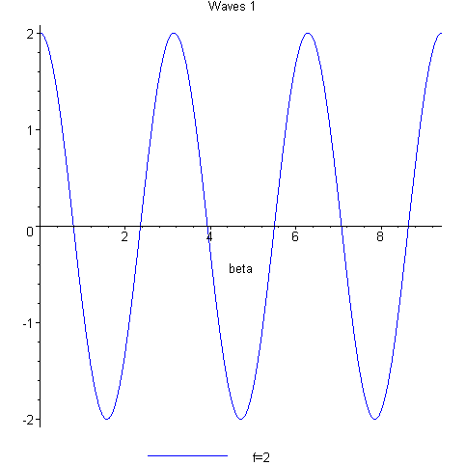
> graph2:=plot(subs(z=2,f=4,q),beta=0..3*Pi,colour=green,legend="f=4",title="Waves 2"):graph2;
>
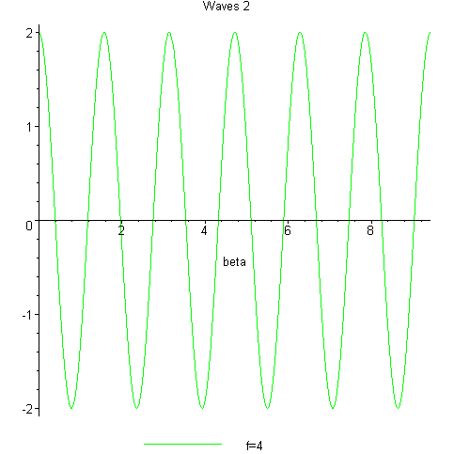
> graph3:=plot(subs(z=2,f=6,q),beta=0..3*Pi,colour=red,legend="f=6",title="waves 3 "):graph3;
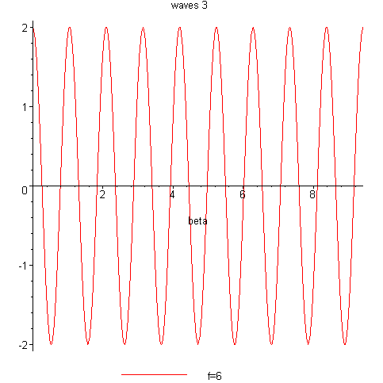
> display({graph1,graph2,graph3});
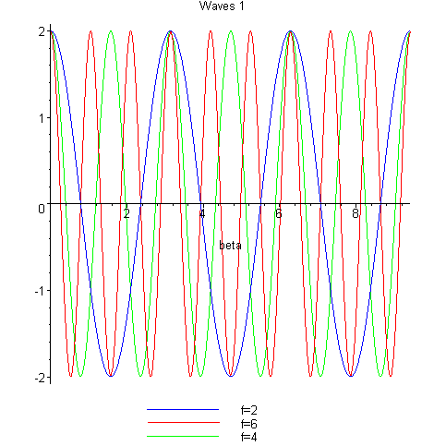
> animate(subs(z=2,q),beta=0..3*Pi,f=2..6);
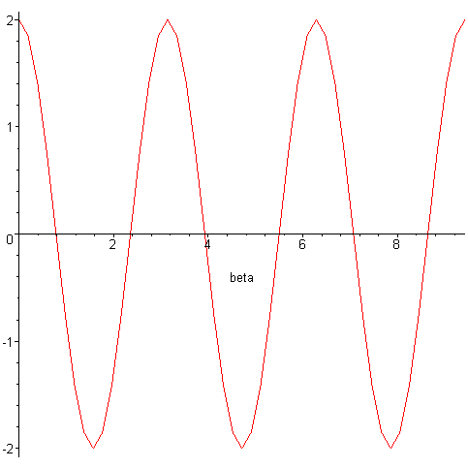
> restart;

2. Scientific graph: Select any one graph and the corresponding equation used to create this graph from your text/reference books. Plot this graph using maple. Use as many options as possible to make your plot look like textbook quality plots.
> restart;
> P:=m*v;
> m:=10;
> plot(P,v=-5..5,labels=["Velocity(m/s)","P(Momentum)"], title="Variation of momentum with increase in velocity");
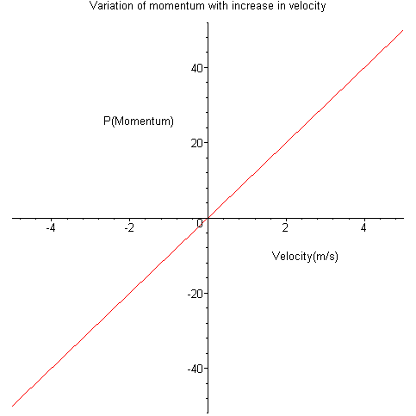
3. Your artistic skills: Draw at least one unique picture each in 2D and 3D using Maple. Convert the 3D picture into VRML format and visualise using Cortona player.
> restart;
> with(plots);with(plottools);
Warning, the name changecoords has been redefined

Warning, the name arrow has been redefined

> plot([1.2^x*sin(4*x)+cos(x),cos(x*2)*sin(5*x),x=-3*Pi..3*Pi],colour=violet,axes=none,title="Scribbles");
>
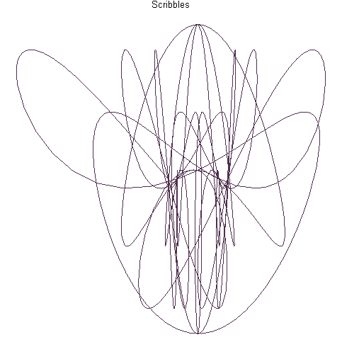

> plot3d(tan(h)*9*k/sin(h)*h^2,h=-2..2,k=-Pi..Pi,title="A Suspension Bridge");
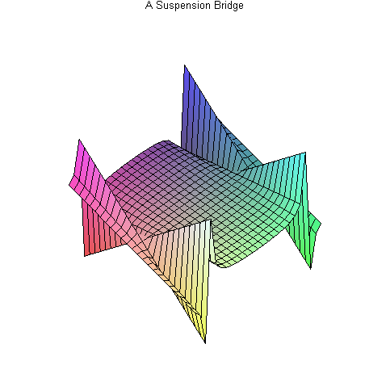
> vrml(plot3d(sin(d^2)/(5*d+2*b),d=-10..10,b=-10..10),`vrmlplot.wrl`,background_color=COLOR(RGB,1,1,1));

4. 3D animation: Make at least one unique animation in 3D.
> restart;
> with(plots);with(plottools);
Warning, the name changecoords has been redefined

Warning, the name arrow has been redefined

> animate3d(sqrt(2*t^3/3*r^2)/7*p^4,r=-10..10,t=-3*Pi..3*Pi,p=-5*Pi..5*Pi,style=patch,frames=66,title="Butterfly Wings");
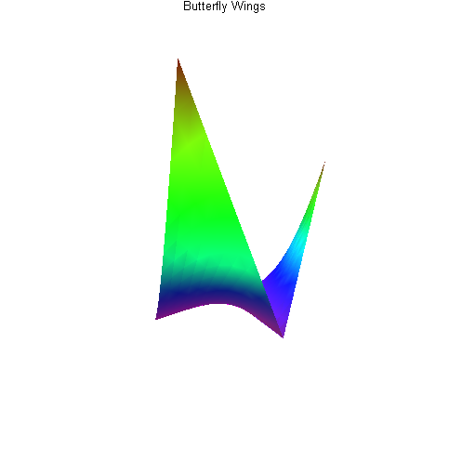

Q5) Write a Maple procedure (proc) called function(x), which will accept the value of a and x to calculate a function which has a value of in the range of and a value of x+5 in the range of . The value of this function is zero everywhere else. Check your procedure by calling this proc using different values of x and a.

> restart;

> a:=5;
> y:=proc(x)
local z:
if x>=-a and x<=a then
if x>=0 and x<=a then
z:=x+5:
else
z:=7*exp(x)+x+5
fi:
else
z:=0
fi:
end:
> y(6);
> y(5);
>
> y(-10.4);
>
> y(2);
> y(-2);

6. Write a Maple procedure (proc) called Grade(marks), which will accept a student's exam mark and returns his grade.
> Grade:=proc(x)
local m:
if x>=85 then
m:=A:
elif
x>=70 then
m:=B:
elif
x>=65 then
m:=C:
elif
x>=55 then
m:=D:
elif
x>=50 then
m:=E:
else
m:=FAIL
fi:
end:
> Grade(67);
> Grade(99.9);
> Grade(49.9);
> Grade(75);
> Grade(56);
> Grade(54.5);

Q7) Write the commands necessary to produce the following maplets:

a) Grader maplet which will accept a student's exam mark and returns his grade.
b) Eqsolver maplet which will accept any equation in one variable and give its solutions.
c) 3Dplotter maplet which accept any equation in two variables and draw a 3D plot.

Include necessary titles, comments and buttons in all the above maplets.
a) Grader maplet which will accept a student's exam mark and returns his grades.
> with(Maplets[Elements]):
> GraderMaplet:=Maplet([
["Determine Student's Grades"],
["Student's Marks:",TextField['marks']()],
TextBox['TB1'](not editable, width='2',height='3'),
[Button("Grade Obtained",Evaluate('TB1'='Grade(marks)')),
Button("Finished",Shutdown(['marks']))]
]):
Maplets[Display](GraderMaplet);#The command 'Grade' is linked to the procedure in Q6
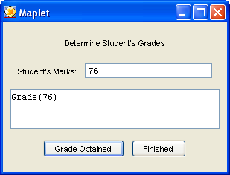

b) Eqsolver maplet which will accept any equation in one variable and give its solutions.
> restart;
> with(Maplets[Elements]):
> IntMaplet:=Maplet([
["Equation Solver!"],
["Type Equation here:",TextField['eqn']()],
["Enter Variable to be solved here:",TextField['var'](3)],
TextBox['TB1'](not editable,width='20',height='3'),
[Button("Solve!",Evaluate('TB1'='solve(eqn,var)')),
Button("Close",Shutdown(['var','TB1']))]
]):
Maplets[Display](IntMaplet);
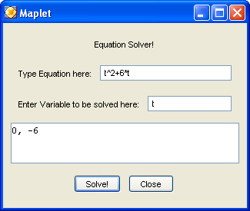

c) 3Dplotter maplet which accept any equation in two variables and draw a 3D plot.
> restart;
> with(Maplets[Elements]):
> maplet3d:=Maplet([
["Type the equation here in the form(2*m+3*n):",TextField['eqn2']()],
Plotter['plot'](),
[Button("View 3D-Plot",Evaluate('plot'='plot3d(eqn2,m=0..Pi,n=0..Pi)')),
Button("Done",Shutdown(['eqn2']))]
]):
result:=Maplets[Display](maplet3d);
