1. Computer Algebra System: What is computer algebra system (symbolic computing)?

Symbolic computing involves computation with symbols representing mathematical objects including integers, real and complex numbers as well as polynomials, derivatives, integrals, etc. The objective of this system is to obtain a closed form and this is able to provide exact solutions. It has thousands of built in functions and also contains many options that are able to simplify expressions.
________________________________________________________________________

2. What are the differences between symbolic computing and numerical computing?

Numerical computing involves operation on numbers as well as on computation of numerical values such as finding out the roots of equations, mathematical functions, integrals and derivatives. These calculations are on numbers alone. Whereas, Symbolic computation is a method of computation which uses symbols instead. These symbols represent mathematical objects that include integers, real and complex numbers.

The results obtained through Numerical computing are not exact because floating point approximations are used. The floating point computation leads to truncation errors and propagation errors. However in Symbolic computation, closed forms are used and this provides exact solutions. The errors of propagation are overcome.

________________________________________________________________________

3. What are the advantages of symbolic computing compared to the numerical computing?

When using Symbolic computation, the number of significant figures exceeds the typical floating point representations and so the errors encountered in numerical computation such as those involving truncation error and propagation errors are reduced.
In addition to this, Symbolic computation is able to overcome the word length problem encountered in Numerical computation as it allows close to half a million digits being displayed in a an answer.
________________________________________________________________________

4. Hierarchy of arithmetic operations: Use your own examples (at least three examples and execute them in maple) to prove which arithmetic operations are carried out first in Maple and if they are of equal priority, in which directions they are carried?

The order of mathematical operations generally follow this order:
Brackets, Multiplicaion, Division, Addition and finally Subtraction

Example 1:
This can be explained with the help of an example such as: 3+5x2 In this case,the multiplication operation is carried out first followed by addition.If it were to take place in the direct manner then the answer would not be 13 but: 3+5= 8, 8x2=16.

> 3+5*2;
> 20+7;

Example 2:
20-3*8+7
In this example, the multiplication of 3 and 8 (3x8) takes palce first to form the eqaution: 20-24+7. Next, 20 is added to 7 to give a total of 27 from which 24 is subtracted to give: 3

> 20-3*8+7;
Example 3:
(15/60) x 5+ 41
In this mathematical operation, the brackets are worked out first. The result of the division of 15/60 is 1/4. this value is then multiplied by 5 to give 5/4 which is added to 41 to result in 169/4.

> (15/60)*5+41;
________________________________________________________________________

5. Using your own examples (one example each and execute them in maple) clearly bring out all the differences between the following maple symbols and commands:

a) ; and :
b) = and :=
c) ? and ???
d) expression and function
e) sum and add

a) ; and :
The semi-colon ; is used in Maple to end an expression .Without it an error message will be generated and the calculation will not be completed.For instance:
> 4+3-2;
> 4+3-2
Warning, premature end of input

However, when a colon is typed at the end of the equation, the equation remains as it is and the operation is not executed and when pressing the Enter key, the cursor moves into the next line.
> 4+3-2:

b) = and :=
The Equal to= sign when used alone does not assign a function to a symbol.Therefore when the symbol is used in another calculation,the numerical value of it is not taken into consideration. Example:

> p=4+7;
> 5+p;
The colon: is used in conjuction with the equal to= sign to denote an expression name. This allows the user to enter the equation once and use the denotion to refer to it further calculations.The numerical value of the symbol is used for the further calculations. Example:

> p:=4+7;
> 5+p;
c) ? and ???
When the single question mark(?) in entered in the calcuation mode, it opens out the just the help topic. It is used in front of the topic we want displayed. For instance:
[> ?sum
However when the triple question mark(???) is typed in then the topic opens with the examples (if any) expanded and all the other sections contracted. The format for this is;
[> ???sum

d) expression and function
In Maple, symbols can be used be included in expressions ( symbols represent objects that have no assigned values). In expressions, for the symbolic manipulation of an expression, the expression must first be assigned or re-assigned from the numerical to the symbolic value.
Functions can also be used to define expressions and they follow mathematical representations more closely.However, when a valie is assigned to a avriable, it does not change the definition of the function, unlike in the case of expressions.
For instance:
Expression
> k:=a^3+7*a;
> a:=3;
> k;
> m:=1/2*k;
> a:='a';

> g:=1/2*k;
As seen from above, for the symbolic representation of 'g', the value of 'a' has to be re-assigned.

Function
> k:=a->a^3+7*a;
> k(3);a:=3;
>

Functions and expressions also differ in their manner of display. in the case of functions, the general form of expression is:
[> name:=variable->expression;

However in expressions, the form is as the mathematical form,i.e.
Mathematical form: 385+827-10x54
Expression form: [>385+827-10*54;

e) sum and add

The sum function is used to add up an infinite number of terms. it is used for a series that may have a regular pattern or for a long range of numbers.

The add function is used in the addition of a fewer number of digits and it cannot be used for the addition of an infinite number of values.

> add( d^4, d=2..7 );
> sum('d^5', 'd'=-3..7);

6. Use of Help facilties in Maple: Use the help commands in Maple and explain the use of three Maple commands (not discussed in the class) with your own examples.

1.Square Root (sqrt):
In Maple it is possible to obtain the square root of a value by typing in the command: [>sqrt(x) where x is the value whose square root is to be computed.
If x is a real number or a floating point constant, the value of x is computed in floating point arithmentic.

Examples:
> sqrt(4);
> sqrt(4.5);
> sqrt(10);

> sqrt(43.24);
> sqrt(3672);

2. Exponential (exp):
When the exponential function is used in Maple, the value of E ( the base of the natural logarithm,2.718281828...) is calculated to the power of the variable, e.g. x. the exponential function is in the form:
[>exp(x) where x is the expression.

Examples:
> exp(8);
> evalf(%);
> exp(-2);
> evalf(%);
> exp(10);
> evalf(%);

3. Multiplication (mul):
The mul function in Maple can be used to mutliply a sequence of values. It is able to compute products of a definite sequence of values. It is represented as: [>mul(p,q=a..b); where p is any expression, q is the name and a,b are the range of numerical values.

Examples:

> mul( p, p=2..10 );
> mul(d,d=10..50);
> mul(t,t=4..8);
>
________________________________________________________________________

7. Use of units and Scientific Constants: Select any three problems involving different types of units from your textbooks and carry out the complete calculations including the units using Maple. State the problem fully and comment whether Maple gives the correct final answer along with appropriate units. (Refer, but don't reuse the examples discussed in the class or in the help menu)

Example 1: Calculate the Work done when an object of mass 400grams is moved a distance of 6km. The acceleration due to gravity is taken as 10m/s^2

> weight:=400*Unit(grams);
> convert(weight,units,kg);
> distance:=6*Unit(km);
> convert(distance,units,m);
> Workdone:=weight*10*Unit(m/s^2)*distance;

Example 2: Calculate the force exerted by an object of mass 50grams traveling at a speed of 14km/s^2
> Weight:=40*Unit(grams);
> Acceleration:=14*Unit(km/s^2);
> Force:=Weight*Acceleration;
Example 3:
Calculate the time taken for the earth to revolve around the sun in hours and seconds.
> Time:=365*Unit(day);
> convert(Time,units,s);
> convert(Time,units,hour);
________________________________________________________________________

8. Find out the dimensions of three different physical properties using Maple.
> GetDimension(power);
> GetDimension(angular_flow);
> GetDimension(acceleration);
________________________________________________________________________

9. Calculate the volume occupied by 1 kg of mercury at 25 C.

> restart;
>
> with(ScientificConstants);
> GetElement(Hg,density);
> maass:=1*unit(kg);
> convert(1,units,kg,g);
> volume:=1000*g/density;
> eval(volume,[mass=1000*g,density=(13.5336*g/cm^3)]);
> convert(73.89016965,units,m);
>
________________________________________________________________________

10. Use Maple to calculate the number of water molecules in 1 g of liquid water.
> with(ScientificConstants);
> GetElement(H,atomicweight);
> GetElement(O,atomicweight);
> Watermolecule:=2*Element(H,atomicweight)+1*Element(O,atomicweight);
> evalf(Watermolecule);
> convert(%,units,kg,amu);
> 1/%;
> %*evalf(Constant(N['A']));
11. Determine whether (y+8)/(x-2)=(x+6) is linear nor not? (Hint: solve for y, and comment)

> (y+8)/(x-2)=(x+6);
> solve(%,y);
> plot([-20+x^2+4*x],x,-5..5);
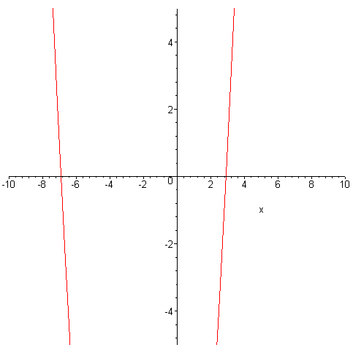

12. Show that z=1, y=2, x=3 are the solutions for x+2y-3z = 4. (Hint: use subs)
> f1:= x+2*y-3*z=4;
> subs(z=1,y=2,x=3,[x+2*y-3*z=4]);
From the above solution we can see that substituting the vales of x,y and z in the equation leads to the same answer as that given in the equation.
________________________________________________________________________

13. a) Solve the equations: x - y = -3 and x + 2y = 3. Plot these equations in the same graph. Do these graphs cross each other? What is the meaning of the point of intersection?

> solve(x-y=-3,{y});
> solve(x+2*y=3,{y});
> plot({ x+3, -1/2*x+3/2},x=-5..5);
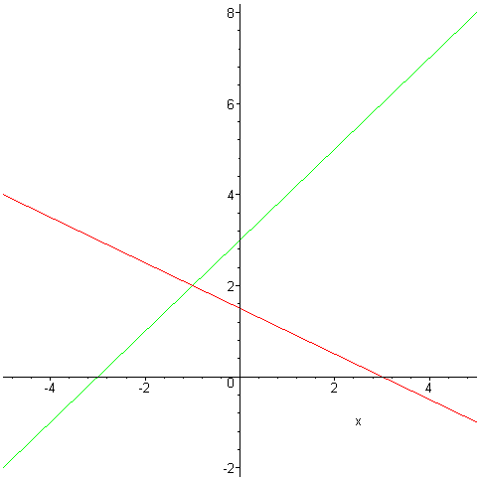

The point of intersection can be obtained by solving both equations.
> solve({x+3=(-1/2*x)+(3/2)},{x});
________________________________________________________________________

b) Plot the equations: y = -x - 3 and y = -x + 2. From the graphs what can you say about the existence of solutions for this set of equation?
> plot({-x-3,-x+2},x=-5..5);
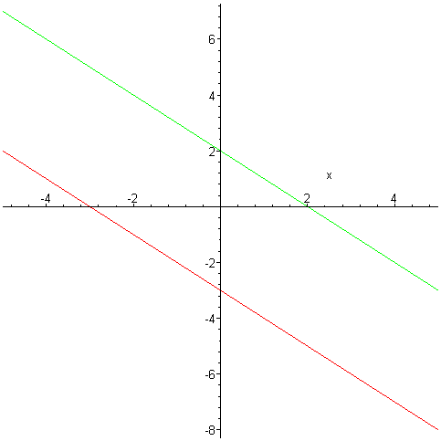
The solutions for these graphs will not be the same but similar because both graphs are parallel to each other and they have the same slope as well.
________________________________________________________________________

c) Plot the equations: x + y = 1 and 2x + 2y = 2. From the graphs what can you say about the existence of solutions for this set of equation?

> solve(x+y=1,{y});
> solve(2*x+2*y=2,{y});
> plot({-x+1,-x+1},x=-5..5);
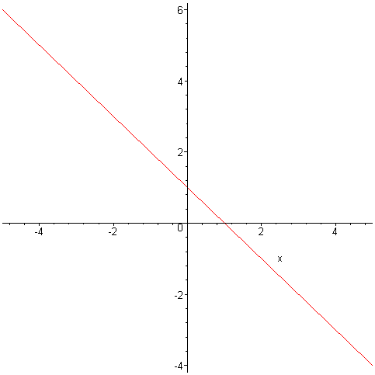
The solutions for these equations will be the same as they both have the same graph.
________________________________________________________________________

14. Solve the equations: 2x + y - 2z = 8, 3x + 2y - 4z = 15 and 5x + 4y - z = 1.

> a1:= 2*x+y-2*z=8;
> a2:= 3*x+2*y-4*z=15;
> a3:= 5*x+4*y-z=1;
> solve({a1,a2,a3},{x,y,z});
________________________________________________________________________

15. Write any equation of your own and expand it using Maple. Factorize and simply the result and show that it gives back the starting equation.

> b1:=(3*x+4*y-7*z)*(z+9*x-2*y)*(y+2*z+3*x);
> expand(b1);
> factor(%);
As seen from above, the same equation is obtained when the equation is expanded and factorized again.
________________________________________________________________________

16. Write any equation with three variables (x, y and z) and solve it using Maple.

> c1:= (3*x+5*y-7*z=10);
> c2:=(z+9*x-2*y=5);
> c3:=(y+2*z+3*x=17);
> solve({c1,c2,c3},{x,y,z});

