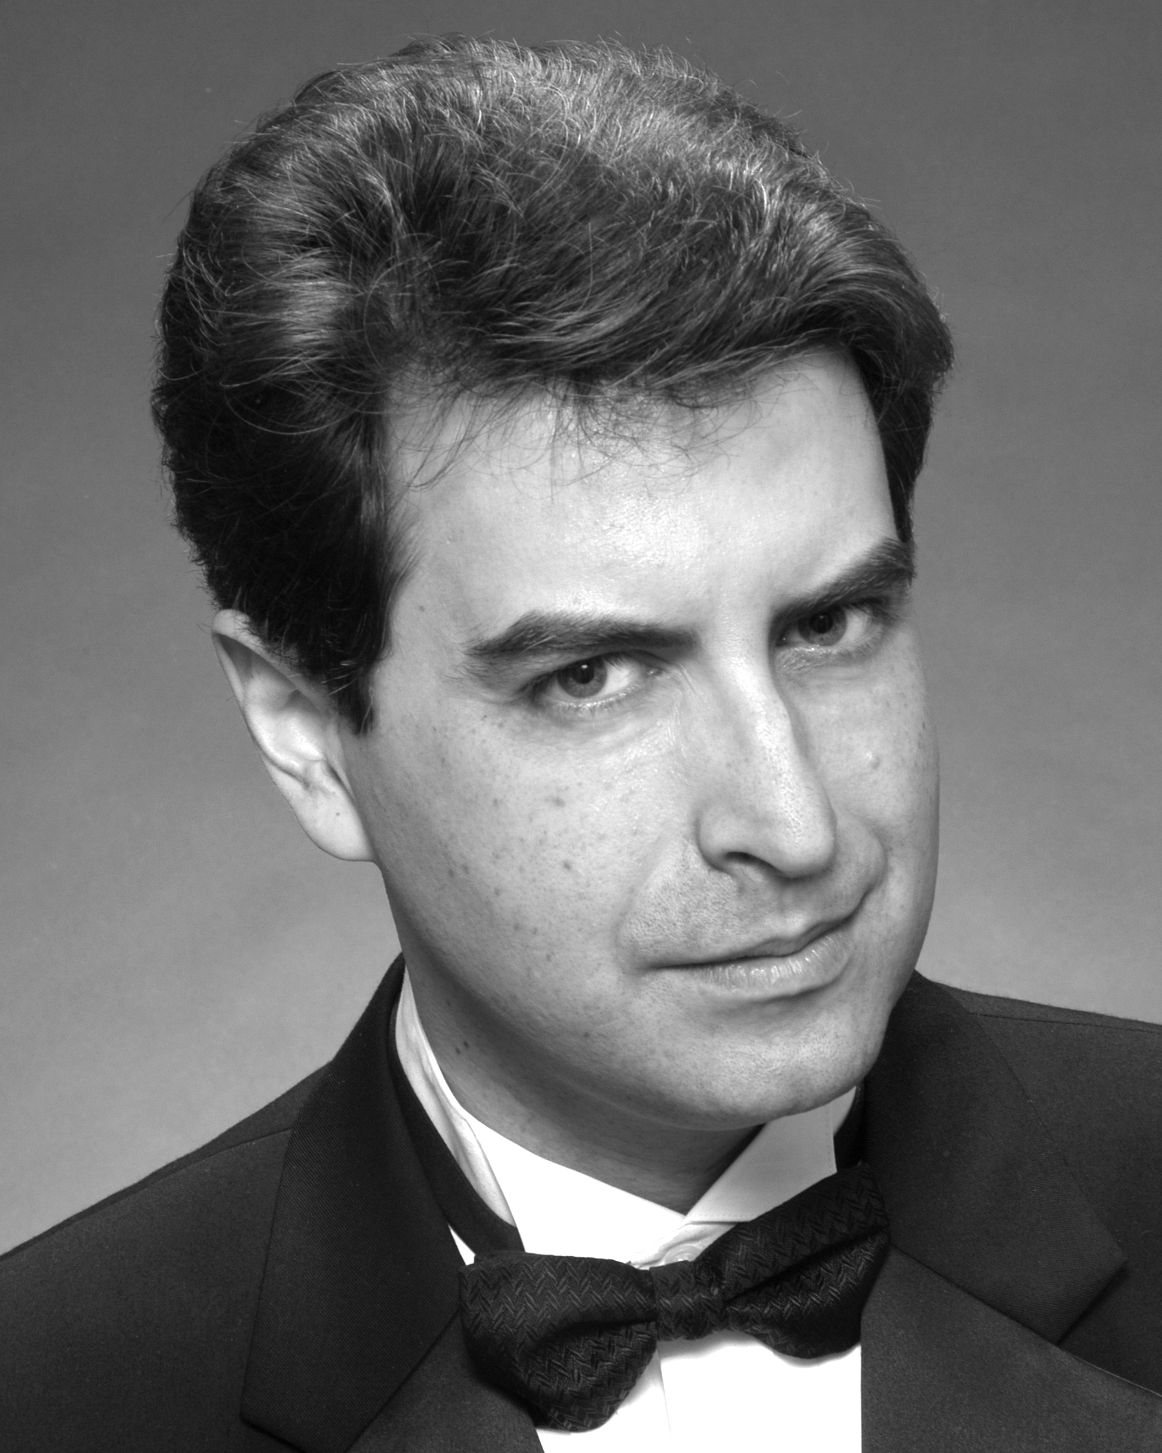
Andrew Solovay
2221 Village Court, #9
Belmont, CA 94002-3440

Day: (650) 581-2681 Evening: (408) 216-7572
EMail: <asolovay@rubberducky.com>

• Vocal Type: Baritone (G flat → F) • Height: 6’2”
• Read Music: Yes • Weight: 188 lb.
• Suit Size: 42 Long

Awards, Training, etc:

Date
Feb-Sept. 2003 Studied intermediate Lindy Hop with Paul Overton & Sharon Ashe (int. al.)
March 2003 Received 2002 “Outstanding Character Actor: Musical” award from Stage 1 Theatre (for Miles Gloriosus)
Oct. 1998 “Swashbuckling” stage combat class with (SF) Academy of the Sword: 16 hrs. w/ broadsword, rapier, etc.
Sept. 1996 Recipient of Michael Multer Scholarship from Lyric Theatre San José
1995-2006 Studied voice and Alexander Technique with Susan Nance, San Francisco

Stage Experience:

Date Theater Director Production Role
2006 April Lyric Theatre San José Cheryl Blalock Die Fledermaus Falke
2005 October Lyric Theatre San José Barbara Murray Ruddigore Sir Roderick
2005 April Lyric Theatre San José Don Tull The Mikado Pish-tush
2004 October Lyric Theatre San José Barbara Murray The Gondoliers Don Alhambra
2004 February Foothill College Jay Manley Candide Lion, et al.
2003 November Foothill College Jay Manley The Trojan Women Poseidon
2003 March Bethany Theatre Project (SF) Dexter Fidler A Funny Thing Happened… Forum Miles Gloriosus
2002 December Stage 1 Rep. (Newark) Dave Sikula A Funny Thing Happened… Forum Miles Gloriosus
2002 October West Bay Opera Kenneth Tigar Tosca Sciarrone
2002 August (concert production) Frank Coppola Barbary Coast (original musical) McLarty
2002 May Hillbarn Theatre Dave Sikula Dirty Work at the Crossroads Munro Murgatroyd
2001 June Hillbarn Theatre Toni Tomei 1776 Rutledge
2000 September Stage 1 Rep. (Newark) Donna Foley A Midsummer Night’s Dream Oberon/Theseus
1999 October Livermore Valley Opera T. Morningstar The Barber of Seville Basilio
1999 August Lamplighters Frank Coppola My Fair Lady Zoltan Karpathy
1999 April Opera San José Daniel Helfgot The Merry Widow Baron Zeta
1999 January Theatreworks Robert Kelley Amadeus Baritone (swing)
1998 September Stage 1 Rep. (Newark) Dennis Gleason Noises Off Frederick/Philip
1998 June Pocket Opera Marissa Pugliano La Belle Hélène Agamemnon

1998 March Lyric Theatre San José Russell Blackwood H.M.S. Pinafore Capt. Corcoran
1997 October Lamplighters Orva Hoskinson Yeomen of the Guard Lieutenant
1997 June Lyric Theatre San José Brien Mahoney Naughty Marietta Governor
1997 February Northside Theatre Richard Orlando Much Ado About Nothing Don Pedro

1996 June Lyric Theatre San José Ruth Stein The Merry Widow Pritschitch
1996 February Lyric Theatre San José Brien Mahoney Iolanthe Pvt. Willis
1995 November Menlo Players’ Guild Dylan Rhodes Artist Descending a Staircase Young Beauchamp

1994 March Masquers’ Playhouse Tim Hart You Can’t Take It With You Tony

1993 October Lamplighters Orva Hoskinson The Gondoliers Giorgio

1989 Spring Yale Gilbert & Sullivan Soc’y Mark Myers Patience Major

1987 Spring Saybrook Dramat (Yale) Jim Lockman The Real Inspector Hound Moon
1985 Fall Trumbull Dramat (Yale) Marty Frame The Skin Of Our Teeth Various

Other Musical Experience:

Date Group Director
1996-7 Poor Wandering Ones (Lyric Theatre San José touring quartet) Kay Kleinerman
1986-8 The Yale Glee Club Fenno Heath

