A Report
on
Evolving Internet Routing Technology

-Ashish Vyas-

Contents

- Introduction………………………………………….… 3
- IP Routing…………………………………………….... 3
- Types of Routing…………………………………….….3
3.1. Static Routing…………………………………………….……..3
3.2. Dynamic Routing……………………………………….………4
- IP Switching…………………………………….……….5
4.1. Routing versus Switching………………………………………5
4.2. IP Switch…………...……………………………………………5
4.3. Tag Switching…………………………………………………...7
4.4. Multi-protocol Label Switching………………………………..8
- Conclusion……………………………………………….9
- Acronyms and Definitions……………………………...10
- References……………………………………………….11

- Introduction

The purpose of this report is to give an overview of different IP routing algorithms and advancements in IP routing technologies.

- IP Routing

IP routing is mainly concerned with routing packets from the source machine to the destination machine. The path from source to destination may contain many hops and there can be many possible paths from a source machine to destination machine. Therefore the network elements (i.e. routers) must have knowledge of network topology and should be able to choose appropriate path through it.

The rapid growth of Internet and increase in real-time and multimedia applications have created a need to improve “routing” technology in terms of speed, bandwidth, performance, scalability and Quality of Service. Because of its fast switching capabilities ATM is considered as a promising technology for fast networking. However most of the current applications are based on IP and hence the success of ATM in Internet world depends on its capabilities to support IP and other higher layer protocols.

Many companies have developed different techniques to improve IP routing. Noticeable efforts in this direction are Ipsilon’s IP Switching, Cisco’s Tag Switching, IBM’s ARIS (Aggregate Route based IP Switching), Toshiba’s CSR (Cell Switched Router). The latest standard defined by IETF is MPLS.

- Types of Routing

Routing algorithms can be grouped into two major classes

  - Static Routing

The route from one node to another node is computed in advance, off-line, and downloaded to the nodes (e.g. routers) at the time of initialization (e.g. network bootup). The routing decision is not based on measurements or estimates of the current traffic and topology. This procedure is also referred as “Non-adaptive Routing”. Statically programmed routers can not discover routes, they can only forward packets using routes defined by a network administrator.

Static routing is good for small networks that have a single path to any given destination. In such cases static routing can be the most efficient because routers does not require to exchange information for discovering paths and building routing database. But static routing is not feasible solution for large networks. One drawback of static routing is that a link failure in the network can disrupt the communication.

  - Dynamic Routing

The routes are not computed statically. The routing decision changes whenever there is a change in “Network Topology” and/or change in the traffic. This is also known as “Adaptive Routing”. In modern networks dynamic routing is more widely used than static routing. Following two dynamic algorithms are most popular.

    - Distance Vector Algorithm

In “Distance Vector” routing each router maintains a routing table indexed by, and containing one entry (i.e. distance vector) for each router in the subnet. This entry contains two parts: the preferred outgoing line to use for that destination (i.e. next hop), and an estimate of the time or distance to that destination. The metric used might be number of hops, time delay or something similar.

Initially each router finds out the distance to each of its neighbor and they send this information (i.e. routing table) to each neighbor. Each recipient adds its own “distance vector” and forwards it to its own neighbors. This step-by-step process results in each router learning an estimate of distance to each destination.

It is also known as the “Distributed Bellman-Ford” routing algorithm and “Ford-Fulkerson” algorithm, after the researchers who developed it. It was the original ARPANET routing algorithm and in Internet the “Routing Information Protocol (RIP)” is also based on this algorithm.

    - Link State Algorithm

Link State routing algorithms requires routers to maintain a complex database of the network topology. Unlike “Distance Vector” algorithm, link state algorithms develop and maintain a full knowledge of the network routers as well as how they are interconnected. This is achieved via the exchange of “Link State Advertisements (LSAs)” with other routers in a network.

Initially each router discovers neighbors and learns their network addresses and then measures the delay or cost to each of its neighbor. Each router forms a packet containing the information and sends it to all other routers. In effect, the complete network topology and all delays are measured and distributed to every router. Then “Dijkstra” shortest path algorithm is used to find the shortest path to every other router.

- IP Switching

  - Routing versus Switching

Routing is based on address lookup. In IP to route a packet the router looks into the IP header and then performs “Search Operation” on routing tables to find out the max address prefix match. Routing requires “Search Operation”, which generally has complexity of the order O (log n). Thus increase in the number of entries in the table (e.g. increase in “n”) also affects the performance of routing. It is generally considered as costlier operation that is done by layer-3 software.

In ATM switch the VPI/VCI field of the ATM cell is used as an index in the table to find out the outgoing path. Switching is based on “indexing”, which is a “O (1)” (e.g. order one) operation. Thus increase in the number of table entries does not affect the switching operation. Generally this functionality is implemented in the hardware and is faster than the routing.

Therefore if packets can be forwarded by using the “Indexing” rather than performing the “Search” operation and without looking into the complete IP header or layer-3 header then the performance of a network can be improved significantly. This can be achieved by having a “circuit value” in the header that is sufficient for performing “indexing” operation in the routing table.

  - IP Switch

This technique for “Fast Forwarding” is developed by a company called Ipsilon. The goal was to make IP faster and offer Quality of Service support. In this technique a ATM switch is upgraded by putting routing software in it. A separate virtual circuit is setup for “long term” flow (e.g. FTP, telnet, and HTTP traffic) but for a short-term traffic no virtual circuit is established. All the packets pertaining to short-term flows (e.g. SNMP, SMTP, DNS query etc.) are forwarded at layer-3.

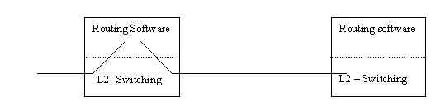

Figure 1 - IP Switching

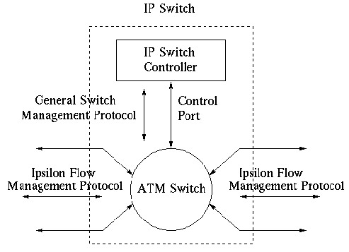

Figure 2 - IP Switch

To construct an IP Switch, a standard ATM switch is taken, the hardware is left untouched but all the control software above AAL5 is replaced by standard IP routing software.

Following are the disadvantages of this technique

- Routing software has to run on each node.
- Too many “virtual circuits” are required.
- This solution is applicable only for ATM switch not for IP routers or for other link layers like PPP, Ethernet etc.
- It does not support virtual LANs

  - Tag Switching

This technology has been developed by Cisco. A circuit number is put in the packet header, this circuit number is called “Tag”. This “tag” is attached above the layer-2 header. This technology is independent of link layer. The ingress node is responsible for looking into the IP header and then putting the “tag”. The intermediate nodes simply switch the packet by looking into the “tag”. The “tag” is removed at the egress node.

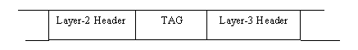
Figure 3 - TAG Position

When a tag-switch receives a packet with tag, it uses the tag as an index to lookup information in TIB. On finding an entry with incoming tag equal to the tag of the packet, for every subentry of the entry, the switch replaces the tag and the link level information in the packet by the outgoing tag and link information in the subentry and sends the packet to the outgoing interface. Since the forwarding procedure involves fixed length matching of tag entries, it can be implemented in hardware and thereby increasing the packet forwarding performance. Secondly, the forwarding procedure is independent of routing functionality (unicast/multicast, routing protocol used, etc). As such the forwarding component is independent of the Network Layer.

  - Multi-protocol label switching

The IETF has developed this standard for switched IP forwarding. Initially the focus is on supporting Ipv4 and Ipv6, but this technique can support any kind of layer-3 protocol. It is also independent of link layer technology.

Whenever a packet enters the MPLS domain, a label is put on the “label stack” and the label on the top is popped off at the exit point of the MPLS domain. A label is defined as a short fixed length locally significant identifier, which is used to identify a stream.

Unlike the “Tag” switching MPLS also support multiple hierarchical level.

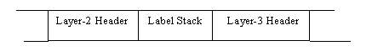
Figure 4 - Label Stack Position

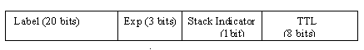
Figure 5 - Label Stack Entry Format

The “Exp” field can be used for “Class of service (CoS)” which will indicate the QoS class. The “Stack Indicator” field indicates the last entry in the label stack and the TTL field is used to carry the value of “Time To Live” field.

The basic forwarding operation involves label swapping as follows. When a packet is received by a label switch, its label is used for index lookup in LIB and information like encapsulation, outgoing interface and outgoing label is retrieved. When a packet first enters an MPLS domain, a label is inserted along-with normal packet forwarding, the process being called "Label Push". When a packet leaves an MPLS domain, the label is removed from the packet, the process being called "Label Pop". In general, a packet can carry a stack of labels, with the label on the top of stack being relevant at any instance.

- Conclusion

Rapid growth in size of Internet, increase in number of real-time and multimedia applications, and some other changes in network traffic pattern have motivated several companies and organizations like ATM Forum and IETF to use label swapping technology for network layer forwarding.

- Acronyms and Definitions

Table1: Acronyms and Definitions
Term | Description
AAL5 | ATM Adaptation Layer – 5
ATM | Asynchronous Transfer Mode
COS | Class of Service
CSR | Cell Switched Router
HTTP | Hyper Text Transfer Protocol
IETF | Internet Engineering Task Force
IP | Internet Protocol
LAN | Local Area Network
LSA | Link State Advertisement
MPLS | Multi-protocol Label Switching
PPP | Point-to-Point Protocol
QOS | Quality Of Service
RIP | Routing Information Protocol
SMTP | Simple Mail Transfer Protocol
SNMP | Simple Network Management Protocol
TTL | Time-To-Live
VCI | Virtual Circuit Identifier
VPI | Virtual Path Identifier

- References

- Computer Networks by Tanenbaum
- RFC 3031 – MPLS Architecture
- http://www.cis.ohio-state.edu/~jain/

