______________________________________________
Important Historical Figure
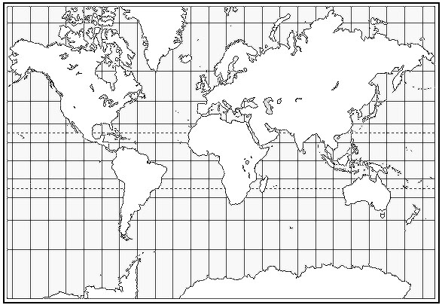
Date of Birth: ____________________
Date of Death: ___________________

Continent: __________________
City: _________________________

Ethnic Origin: ________________
Religion: ________________________

We should remember this person because:
________________________________________________________________________________________________________________________________________________________________________________________________________________________________________________________________________________________________________

Family
Mother: ________________________
Father: ________________________
Spouse: _________________________
Children: ________________________
______________________________________________________________

Picture or drawing of this person:
Name two important people in this person’s life:
- ____________________________________________________
- ____________________________________________________
What was the most important event in this person’s life?
____________________________________________________________________________________________________________________________
Name one other important event:
______________________________________________________________

