Module 1
Introduction to MATLAB

The objective of this module is to recall the basic commands and functions in MATLAB (for those who have been familiar with it) and to offer a fair introduction to MATLAB (for those who are new to it). This module will serve as a tutorial. After this tutorial, you are expected to be able to:

a. encode matrices
b. carry out matrix operations
c. do graphs
d. utilize MATLAB functions
e. write simple m-files

The module is divided into the following major sections:

1.1 Brief Background
1.2 How to Use this Tutorial
1.3 Encoding Matrices
1.4 Description of the MATLAB Workspace
1.5 Variables Used for Complex Numbers
1.6 Operations on Matrices
1.7 Graphing in MATLAB
1.8 Additional Notes on Matrices
1.9 Loop and Decision in MATLAB
1.10 MATLAB m-files
1.11 The MATLAB Diary
1.12 MATLAB Toolboxes
1.13 Rundown of Frequently-Used MATLAB Commands

1.1 Brief Background

MATLAB originated as a FORTRAN code for MATrix LABoratory designed primarily to perform numerical calculations towards the solution of linear algebra problems. From its somehow routine functions, MATLAB evolved into very powerful code-based mathematical and engineering calculation software. It is now capable of solving nonlinear equations and offers intricate graphing features. One beauty of MATLAB is its ability to perform complex operations very fast in just few commands, task that will require a rather time-consuming computer programming.

1.2 How to Use this Tutorial

This tutorial is interactive. It is best utilized if you open-up your MATLAB program and follow through the instructions and examples given. To distinguish a MATLAB command from the tutorial text, a different font is used. An Arial Black font will be used to represent a MATLAB command while an Arial font will be used to represent MATLAB output. Below is how the fonts look like:

Arial Black
Arial

A double arrow pointing to the right will be used to represent user input:

>>

To aid you if you need assistance, MATLAB offers wide-ranging help features. To access this facility, you simply type the help command followed by a specific item you want to have a help on. An example would be a help tan command. This is done by typing the command immediately after the user prompt (the double arrow). The following is the result of typing the command:

>> help tan

TAN Tangent.
TAN(X) is the tangent of the elements of X.

See also ATAN, ATAN2.

Overloaded methods
help sym/tan.m

As you noticed, MATLAB offers a See Also feature on its help facility which lists down related topics. You can try for yourself other help commands. Feel free to experiment. If you don’t have any idea what MATLAB command to get help from, you can just simply type help and MATLAB will display a list of available commands (as well as m-files which will be tackled later). Below is the first few portions of the output when you issue the help command.
>> help
HELP topics:

matlab\general - General purpose commands.
matlab\ops - Operators and special characters.
matlab\lang - Programming language constructs.

The end of the help command gives you this notice:

For more help on directory/topic, type "help topic".
For command syntax information, type "help syntax".

If you are unsure of the exact command to get help from, you can also try MATLAB’s “index” style help feature. This is accomplished by issuing the lookfor command. For example if you do not know the exact MATLAB command to get the derivative, you can do a lookfor derivative command which results in the following partial output:

>> lookfor derivative
DIFF Difference and approximate derivative.
PDEVAL Evaluate the solution computed by PDEPE and its spatial derivative.
DERIVGET Get derivatives Options parameters.

The lookfor command needs to have a single word (two words or more can give you an error message) argument to follow it. You cannot issue a plain lookfor command because it will give you an error. The lookfor command can also result in a very long output because of a number of topics containing the keyword argument. Be patient.

1.3 Encoding Matrices

Each entity in MATLAB is basically a rectangular matrix. The elements of the matrix can either be real or complex. To separate the elements, you can either use a comma or put a space between elements. Let’s have a look at this example:

>>x = [10, 20, 30, 40, 50]
x =

10 20 30 40 50

The above result is likewise achieved by issuing the command:

>>x = [10 20 30 40 50]
x =

10 20 30 40 50

In the example, x is called a row vector which is the default in MATLAB. Remember that a vector is a matrix comprising a single row or column.

MATLAB offers an alternative to input a matrix whose elements follow a certain pattern. Our example can be entered using the command:

>>x=10:10:50
x =

10 20 30 40 50

The command simply means: “x is equal to a row vector with first element equals 10, the next elements of which are in increments of 10, with the last element equals 50”.

The transpose of a matrix is generated by putting a single quote (‘) at the end of the matrix variable. Below is an example:

>> y=x'
y =

10
20
30
40
50

Recall that a transpose of a matrix is done by interchanging its rows and columns. Since MATLAB’s default is a row vector, we can have an alternative to enter a column vector without using the transpose operation. Here is how:

>> y= [10; 20; 30; 40; 50]
y =

10
20
30
40
50

By default, MATLAB displays the value of an expression from a user input. If you want to suppress the output, you can place a semicolon (;) immediately after the complete command like this one:

>>z=3:7:38;

MATLAB silently generates the matrix z internally without displaying its elements because there is a semicolon at the end of the user input. To get the fourth element of the row vector z, you can input:

>>z(4)
ans =

24

If there is no assigned variable to contain a given MATLAB expression such as z(4), a variable ans is automatically created to store its value.

1.4 Description of the MATLAB Workspace

The MATLAB workspace contains all the variables that are defined by the user or automatically created by MATLAB (the ans variable). To list the variables that are found on the workspace, we type the who command:

>>who

Your variables are:

ans x y z

So far you have only four (4) variables created. As discussed earlier, each of the variables is actually a matrix. To view a detailed description of the variables including the matrix size, among others, you input the whos command:

>>whos
Name Size Bytes Class

ans 1x1 8 double array
x 1x5 40 double array
y 5x1 40 double array
z 1x6 48 double array

Grand total is 17 elements using 136 bytes

Alternatively, you can also determine the size of a matrix by issuing a command like this:

>>size (x)

ans =

1 5

The first column of the row vector ans represents the number of rows (in this case is equal to 1) of matrix x and the second column gives you the number of columns, that is, 5. You can also assign a variable to hold the corresponding number of rows and columns by using the following command:

>>[m,n]=size(x)

m =

1

n =

5

Thus, in the example, m = number of rows and n= number of columns.
Also, since x is a row vector, we can apply the length command:

>>length(x)

ans =

5

MATLAB variables are case-sensitive which implies that a variable z is different from Z and both of these variables can both exist in the MATLAB workspace without any conflict.

Sometimes, it is necessary to save the values of your variables because you may want to continue working with them later and you don’t want to type them again or repeat your calculation. To do so, you can enter the save command followed by the desired name of the file (say mod1vars) you want the variables to be stored.

>>save mod1vars

The variables are now saved in a file called mod1vars located at your default work directory. This is usually found at C:\MATLAB6p1\work or its equivalent depending on where you install MATLAB and what version of MATLAB you have.

Once a set of variables is stored in a file, it can be recalled by using the load command. The form of the command is similar to the save command like this:

>>load mod1vars

You can also just select certain variables to save in a file called selectvars for example and specify them in the save command:

>> save selectvars x y z

If you desire to cleanup your workspace by erasing all variables, you can input:

>>clear

A variable once cleared is undefined and will generate an error if you use it.

>>x
??? Undefined function or variable 'x'.

You can also opt to clear only a particular variable. You just type the name of the variables after the clear command:

>>clear x y

Note: Saving the variables in a file does not automatically erase them from the MATLAB workspace. You have to use the clear command to erase them.

1.5 Variables Used for Complex Numbers

MATLAB uses the variables i and j for an imaginary number $\sqrt{−1}$.

>>i

ans =

0 + 1.0000i

>>j

ans =

0 + 1.0000i

Note however, that, the variables i and j can also be used as index in a FOR loop (to be discussed later). In MATLAB we can combine the matrix elements to be both real and complex:

>>a = [sqrt(16), 5; sqrt(-25), -7]

a =

4.0000 5.0000
0 + 5.0000i -7.0000

1.6 Operations on Matrices

In MATLAB it is straightforward to do matrix multiplication.
For example we have this matrix:

>> b=[2 3 4; 1 5 10]

b =

2 3 4
1 5 10

You can use matrix a created in the previous section and multiply it with matrix b.

>>c =a*b

c =

13.0000 37.0000 66.0000
-7.0000 +10.0000i -35.0000 +15.0000i -70.0000 +20.0000i

MATLAB can also do element-by-element multiplication instead of matrix multiplication. This is achieved by using .* (a dot followed by an asterisk instead of just an asterisk).

>>d=c.*b

d =

1.0e+002 *

0.2600 1.1100 2.6400
-0.0700 + 0.1000i -1.7500 + 0.7500i - 7.0000 + 2.0000i

The actual result is each element multiplied by 100 which means the element at row 1 column 1 is actually 26.000. This process of factoring out a common factor out of the elements of the matrix is called scaling.

You can also perform element-by-element division in MATLAB:

>>e=b./c

e =

0.1538 0.0811 0.0606
-0.0470 - 0.0671i -0.1207 - 0.0517i -0.1321 - 0.0377i

Other matrix operations are performed on a square matrix such as taking it to a power and the exponential of a matrix:

>> f=a^2

f =

16.0000 +25.0000i -15.0000
0 -15.0000i 49.0000 +25.0000i

>>g =expm(a)

g =

-28.3854 +69.3625i -6.5638 +31.6582i
-31.6582 - 6.5638i -13.9451 - 0.2856i

1.7 Graphing in MATLAB

Graphing is simple in MATLAB. You just issue a plot command. For instance you have created the following row vectors:

>> x=1:2:11;
>> z=5:5:30;

You can use this command to do a default solid line plot:

>> plot(x,z)

MATLAB responds by generating the graph in a new window. Figure No. 1 is shown here with the x and y axes being labeled accordingly by the use of the xlabel and ylabel commands:

>> xlabel('x')
>> ylabel('z')

The effects of the xlabel and ylabel commands are implemented on the graph itself and are not shown on the command window but in Figure No. 1.

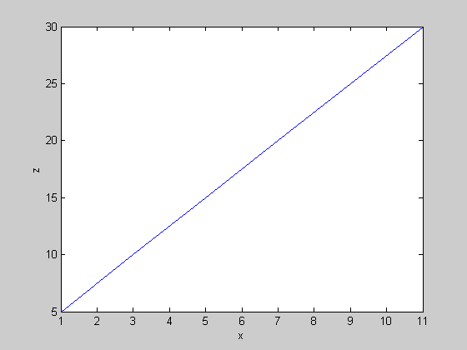
Figure No. 1 A graph that results from plot (x,z) command.

To find out more about plotting options feel free to enter the help plot command. Below is the result with some portions of the text.

>>help plot

PLOT Linear plot.
PLOT(X,Y) plots vector Y versus vector X. If X or Y is a matrix,
then the vector is plotted versus the rows or columns of the matrix,
whichever line up. If X is a scalar and Y is a vector, length(Y)
disconnected points are plotted.

Some portions of the text are found below with options on lines and colors:

PLOT(X,Y,S) where S is a character string made from one element
from any or all the following 3 columns:

b blue . point - solid
g green o circle : dotted
r red x x-mark -. dashdot

Instead of a solid line, you can also plot discrete points employing a different symbol, for instance, a ‘+’.

>>plot (x, z, ‘+’)

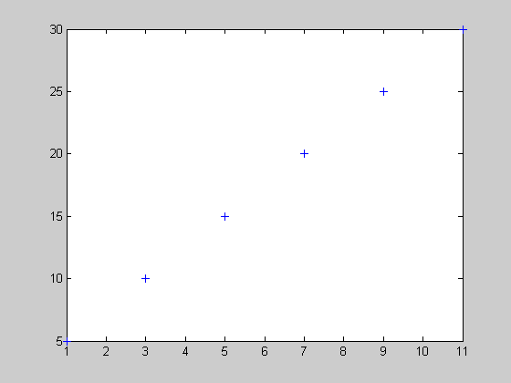

One interesting command that you can do is to put a text on a graph by using the gtext command. Type the command in the format gtext (‘string’). MATLAB waits for you to position your mouse on the graph. MATLAB writes the text on that area once it detects a mouse click or a press of any key.
The equation $y\left(t\right) = 5e^{−0\text{.}2t}$can be graphed using the following commands:

>>t=0:1:50;
>>y=5*exp(-0.2*t);
>>plot(t,y)

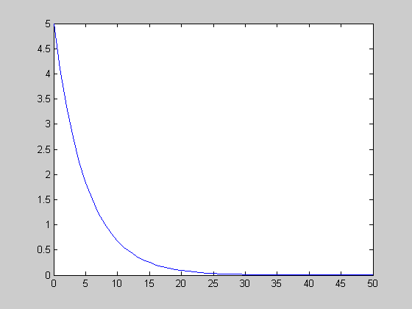

The previous two commands can be lumped together into a single command:

>>plot(t, 5*exp(-0.2*t))

To graph $y\left(t\right) = t e^{−0\text{.}2t}$input the following commands:

>>y = t.*exp(-0.2*t);
>>plot(t,y)

We can also put some labels:

>>gtext (‘This is the peak of the curve.’)
>>xlabel (‘t’)
>>ylabel (‘y’)

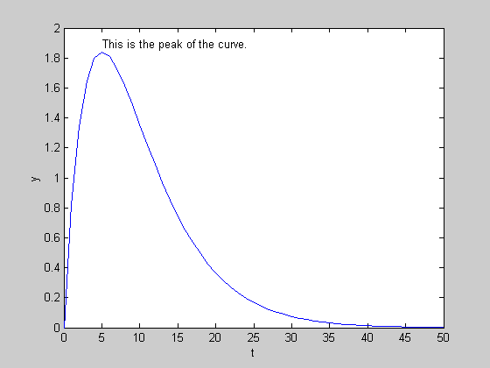

The command axis (‘square’) will put the graph in a square box. On the other hand, the command axis (‘normal’) will revert back to the usual aspect ratio.

Another interesting feature is to specify the upper and lower limits on the extent of the graph window using the command axis (x_left x_right y_down y_up). For instance we can assign a row vector to hold the argument of the axis command:

>>v = [0 50 0 4];
>>axis(v);

The plot command can also process multiple curves like this:

>>plot (t,5*exp(-0.2*t), t, t.* exp(-0.2*t), ‘--‘)

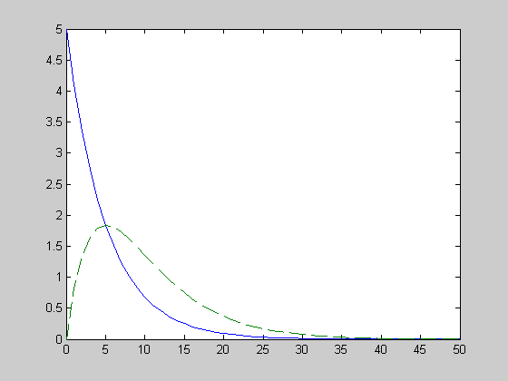

Notice how MATLAB automatically implements a change in the color of the plot to distinguish one from the other? The dashed curve is actually colored green.

MATLAB can also display multiple plots in one window using the subplot command. The idea is to specify the number of rows of figures (n_row), the number of columns of figures (n_column), and number of the figure (number), then followed by the plot command: subplot(n_row, n_column, number), plot (x,y). The numbering of the figure is assigned by counting from right to left and top to bottom.

>>subplot (2,1,1), plot (t,5*exp(-0.2*t))
>>subplot (2,1,2), plot (t,t.* exp(-0.2*t))

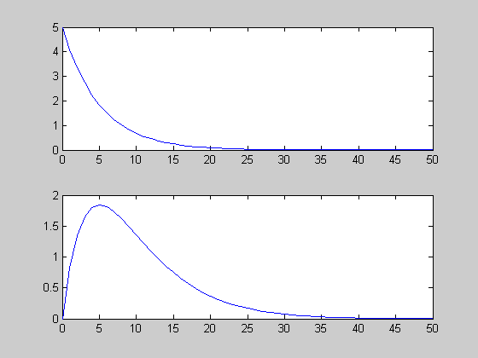

To go back to the default single plotting, you can just type subplot (1,1,1).
When you do that, MATLAB displays a blank graph window with the normal axis. You can then continue with your other plot commands.

1.8 Additional Notes on Matrices

You can combine two vectors to form a new matrix. For example, you create a row vector x with elements from 3 to 21 in increments of 3 and a row vector z with elements from 4 to 16 in increments of 2. Thus, you type the following commands:

>>x=3:3:21;
>>z=4:2:16;

You can now create a matrix v containing the transpose of x as the first column and the transpose of y as the second column.

>>v=[x’ z’]

v =

3 4
6 6
9 8
12 10
15 12
18 14
21 16

To view only the elements of the first column of v, you can enter this command:
>>v(:,1)

ans =

3
6
9
12
15
18
21

Similarly, you can also use v(:,2) to take a look at the second column of matrix v.
Furthermore, you can also issue a plot command using the first and second columns of the matrix v.
>>plot(v(:,1),v(:,2),’--')

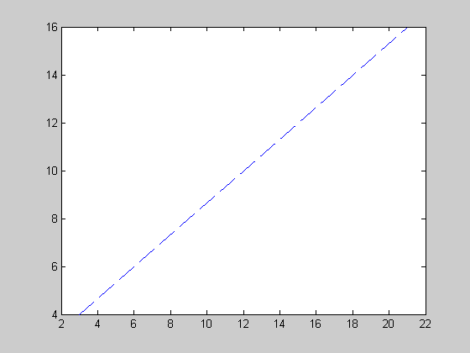

1.9 Loop and Decision in MATLAB

MATLAB features a for loop as one way to do a repeated process a number of times. For instance, if you want to get the factorial of 5, that is, 1*2*3*4*5 using loop you can do so:

>> p=1;
>> for i=1:5,
p=p*i;
end

First, you assign the value of 1 to p. Next, you type the beginning of a for loop. The variable i is taken here in a different context. It serves as an index variable. Read “for i equals 1 to 5”. MATLAB then gives you a chance to enter the statements without a user input, >>. The for loop is terminated by issuing an end command. MATLAB immediately puts back the user prompt. You can check the value of p.
>>p
p =

120

Obviously, you can alternatively find the factorial of 5:
>>factorial(5)
ans =

120

To learn more about the for loop, you can input the help for command.

Conditional statements in MATLAB are checked by using the if statement. For example, you want to check if 23 is one of the elements of a row vector x.

>> x=3:2:29;
>> c=0;
>> n=23;
>> for k= 1:length(x),
if x(k) == n
c=1;
break;
end
end
>>c

c =

1

The analyses of the above statements are left to you.

1.10 MATLAB m-files

The MATLAB command window lets you input commands interactively. However, there may be times that you will be performing the same sets of interactive commands repeatedly. In such scenario, you can opt to create a text file that contains these MATLAB commands and statements so that later you can just recall it. Such a text file or m-file is called a script file. To call back the script file you have saved, you just type its filename and all the commands stored in it are performed.

If you want to write a script that allows you to output a Fibonacci series containing a certain number of terms, then you can probably use write the following script file.

% fibonacci.m
% A script to generate a fibonacci series containing n terms.
% A sample script file prepared by Allan S. Hugo 11/14/2005

clear x
a = input ('First value = ?');
b = input ('Second value = ?');
n = input ('No. of terms (greater than 2)? ');

x(1)=1;
x(2)=1;
for k = 3:n,
c = a + b;
x(k)=c;
a=b;
b=c;
end
x
% end of the fibonacci script file

To write a script file, you can use any text editor and save it as All Files type with an extension of .m or you can just use the MATLAB menu File/New/M-file.
>> fibonacci
First value = ?1
Second value = ?1
No. of terms (greater than 2)? 6

x =

1 1 2 3 5 8

The numbers 1, 1, and 6 after the question mark (?) are inputs from the user. You can run the script again and try another set of inputs.

As an alternative to a script file, you can probably create an m-file that allows you to just include the values of the first two terms and the number of terms as part of the command like fibo(a,b,n). You can do so by writing another type of m-file called a function routine. The sample file is found on the next page. The name of your file should be the same as the name of the function like fibo.m. The first line of the file (at the top) is called the syntax definition. It tells you how to use the function. In other words it offers you the format of the command to call your function. In this case, a variable x (or actually any variable for that matter) is assigned to a function. If no variable is assigned to hold the function value, MATLAB allocates the default variable ans to hold it.

function x = fibo(a, b, n)
% fibo.m
% A function to generate a fibonacci series containing n terms.
% A sample function routine file prepared by Allan S. Hugo 11/14/2005

clear x;
x(1)=a;
x(2)=b;

for k = 3:n,
c = a + b;
x(k)=c;
a=b;
b=c;
end
% end of the fibo function routine file

>>y = fibo (1, 1, 6)

y =

1 1 2 3 5 8

1.11 The MATLAB Diary

MATLAB offers a way for you to keep track of your commands as well as most of the outputs. This is done by the use of the diary command. You do this by inputting diary filename. This will instruct MATLAB to keep a record to your inputs and most of the corresponding outputs in the command window, and then write it in a text file which you can view later using your favorite word processor. This is essential when you want to review what you have in the previous sessions. This will also help you locate a possible error while in the interactive command window. The command diary only is a toggle between on and off. If you want MATLAB to stop recording, type diary off.

1.12 MATLAB Toolboxes

To perform various tasks from simple to complex, MATLAB has an extensive collection of related function routine files (m-files) that are called toolboxes. Some of these toolboxes are the Symbolic Math Toolbox, Control System Toolbox, and Fuzzy Logic Toolbox. You can see the MATLAB demo to get the feel of these toolboxes.

1.13 Rundown of Frequently-Used MATLAB Commands

Here you will find the list of commonly used MATLAB commands and functions.

Summary of Frequently-Used Commands

Command | Description
axis | sets the limits for the x and y axes in plots
clear | deletes all variables from the MATLAB workspace
clc | cleans up the command window area
diary | records inputs and outs at the command window
end | terminates a loop
exp | exponential function “e to the xth”
for | creates a loop sequence
format | specifies output display
function | allows to create a user-defined routines
gtext | places a text on the graph
help | requests for MATLAB’s assistance on command syntax
hold | keeps the current plot intact and allows a new plot to be placed on it
if | MATLAB’s test for a condition
length | gives the number of elements in a vector
lookfor | index style help alternative
plot | performs graphing of vectors
size | returns the number of rows and columns of the array/matrix.
subplot | enables plotting of various figures in one plot window
who | takes a look at the variables used in the workspace
whos | variable view with details like size of the matrix, etc.
* | multiplies a matrix
‘ | gives the transpose of a matrix
; | disables display of output of a command
.* | multiplies matrices element-by-element
./ | divides matrices element-by-element
: | represents a column or row in a matrix; also creates a vector
% | indicates a comment

Summary of Frequently-Used Functions

Function | Description
eig | eigenvalues or eigenvectors
fsolve | gives the solutions to algebraic equations
fzero | finds the solutions to a single algebraic equation
impulse | the impulse response
ode45 | does numerical integration on systems of ordinary differential equations (ODEs)
polyfit | fits a set of data to a polynomial using the least squares
ss2tf | converts a state space model to a transfer function model
step | the step response
tf2ss | converts a transfer function model to state space model

