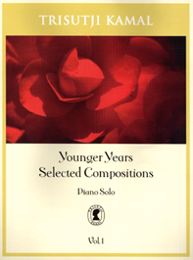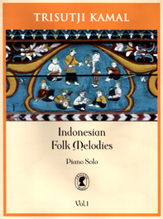

Three books written by Trisutji Kamal
- Younger Years Selected Compositions
- Indonesia Folk Melodies.
- Sunda Seascapes

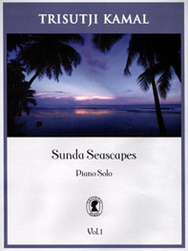

I started composing my first at the age of 7, not long after I was able to play the piano and read the notes.
My first compositions were definitely in Javanese pentatonic and were synthesis.

My passion in arranging folk melodies for solo piano started in the year 1953. For 50 years, it has benefited the development of my overall musical language.

I wrote the 7 pieces of the Sunda Seascapes for piano solo in 1990, inspired by the incredible beauty of the nature.
During that period I spent my time at my villa in Anyer, West Java.

