System Specification
Of
Disc Management System
(DMS)

For
Visual Studio Company

V 1.0
6 March 2007

Copyright © 2007 by
Electronic Software House

Distribution of Controlled Copy

Copy No. | Holder
1 | On File
2 | Visual Studio Company

Prepared by :
To Oi Chu, Tobee (036133633), Email: tobeetoc@yahoo.com.hk
Lai Fung Ying, Florence(036255009), Email: bellecurtain@yahoo.com.hk
Lee Pui Chee, Christine(036267727), Email: christinelee01@netvigator.com
Yip Lai Ming, Lily (036250235), Email: lilyylm@yahoo.com.hk

Submission Date: 6th March, 2007

TABLE OF CONTENTS
1. OVERVIEW 4
1.1 Background 4
1.2 Goals and Objectives 4
1.3 System Requirement 5
1.3.1 Hardware Requirement 5
1.3.2 Software Requirement 5
1.3.3 Generic Workflow 5
1.3.4 Program Requirements 5
1.3.5 Extended Enhancement 9
1.4 Major Constraints 9

2. USAGE SCENARIO 10
2.1 User Profiles 10
2.2 User-cases 10

3. DATA STRUCTURE AND DESCRIPTION 12
3.1 Logical Data Structure 12
3.1.1 Data Description 12
3.1.2 Data Objects and Dictionary 13
3.1.3 Data Relationships 15

4. FUNCTIONAL MODEL AND DESCRIPTION 16
4.1 Description for functions 16
4.1.1 Add new member 16
4.1.2 Update member record 16
4.1.3 Delete member record 18
4.1.4 Search member 19
4.1.5 Sales transaction 20
4.1.6 Generate report 20
4.1.7 Add inventory item 21
4.1.8 Add new staff 21
4.2 Software Interface Description 22
4.2.1 Login page 22
4.2.2 Administration Page 23

5. VALIDATION CRITERIA 24
- OVERVIEW
  - Background
Visual Studio Company as a small to medium scale of music and video disc retailer, to make the business stand out from the crowd of competitors is not beyond the scope of computerization. DMS is a tailor-made comprehensive disc retail management computer system for Visual Studio Company which included the system security and authority control, online point-of-sales (POS) solution, inventory control, marketing and promotion campaigns solution, membership management, sales analysis and turnover reports and customer enquiry subsystem.

  - Goals and Objectives
The main purpose of Disc Management System (DMS) is to provide a comprehensive retail management application for a music and video retailing business which with easy to use front-end comprehensive functions and features for back-office, to help the business runs smoothly and increase the productivity. The goals of DMS are:

- To provide a searchable database for employees and customers.
- To provide an efficient way to handle the inventory and membership information.
- To minimize the handling time for each sales transaction.
- To provide a user friendly interface.
- To minimize the workload on preparing the daily and monthly sales reports.
- To avoid the manual calculating mistake on every sales transactions.

  - System Requirement
    - Hardware Requirement
- Intel Pentium II 450Mhz or above compatible computer
256MB RAM or above
60MB Hard Disk Space
- 800x600 resolutions
- MS Windows 98SE/Me/NT/2000/XP/Server 2003
- CD-ROM
- One USB port
- Printer

    - Software Requirement
- Symantec Norton Anti-virus 2006 or above
- Microsoft Office Access and Excel 2003 or above

    - Generic Workflow

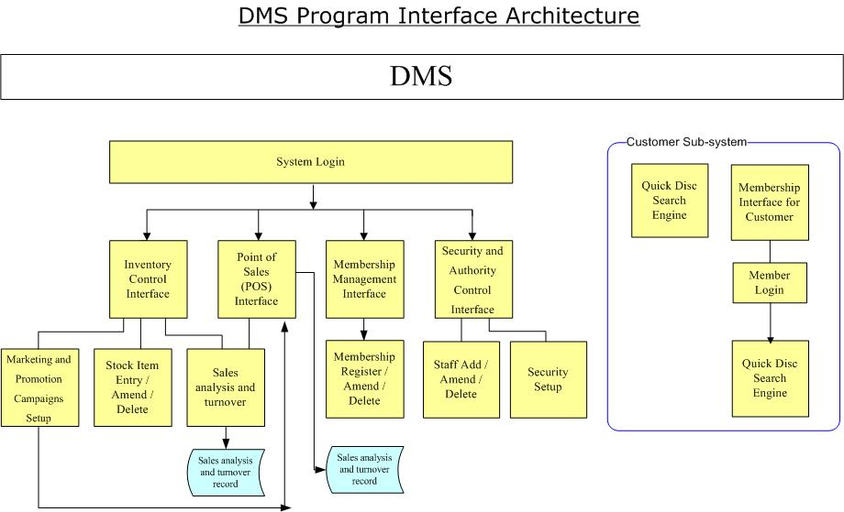

    - Program Requirements

The following general requirements on different aspects of the DMS application were laid out:

Authentication
- Each user must use their dedicated username and password to login the system. Each username was defined as different user group which restricted the accessibility of different interface.
- User who had passed the authentication will access the function interface directly.
- Administrator can access all interfaces and functions, also, the setup of access right and user group will be performed by the administrator.

Customer Enquiry and Membership Registration
The customer subsystem interface contains product search engine and membership registration station.
- Customer can search the product information by input the attributes such as Artist, director from the search engine.
- Member ID must be entered to access the membership information page.
- Simple, user-friendly membership application interface for customers to apply, update or inquire for their membership information.

Point of Sales (POS)
- Cashier and administration officer access only.
- Cashier can create / amend sales transaction; amend the transaction content and print / reprint sales memo.
- Sales memo can be retrieved and then voided by the authorized person.
- Inventory will be update automatically on every transaction completed and saved without manual interference.
- Daily / Monthly sales report can be generated.
- Shortcut for product price, membership and inventory information quick look up.
- Handle VIP add on service such as goods reserved, bonus point accumulated, special discount.
- Allows different payment methods, such as cash, credit card, octopus.
- Support multi currency and set exchange rate on every transaction.

Inventory Control Solution
- Administration officer access only
- Daily and monthly sales and inventory turnover report can be generated.
- Administration officers can set the promotion price and discount by theme category, or any combination of product attributes, like artist / director, released date, label, etc.
- Inventory items could be add, amend and deleted by administration officers.

Membership Management Interface
- Shop assistant and administration officer access only.
- Member information can be add, update and delete.
- Member purchasing report can be generated.

System Security and Authority Control
- Administrator access only
- Different staff can be set to different workgroup that allow them to access to the specific function directly after logon.
- Administrator can add new staff, amend staff record, delete deployed staff record and set up the access level for different function for each staff.
- Each function can be set for each user to browse, add, edit and delete.

Interface Enhancement
- A user-friendly interface without using database language should be used.
- Support English and Traditional Chinese. The interfaces and reports will be displayed according to the selected language.

Database Administrative Interface
This interface must also be user-friendly and with guides so that the administration officer can administrate the database system with ease.

    - Extended Enhancement

Database Nature
The current database is an offline system. In the future, we would like to improve it into an online database system, i.e. members can search for information through World Wide Web.

Training
Administration officer need to be trained in order to administrate and maintain the database system.

  - Major Constraints
Time
We only have about 4 weeks to interview client and prepare all the documents. We do not have time to discuss the system with the client in detail. We can gather more information if we can do more interviews.

- USAGE SCENARIO
  - User Profiles
There will be four levels of users for the main DMS system and one level for customer sub-system:

For DMS main system:
- Full Control (Administrator)
- Read/Write/Modify All (Administration Officer)
- Read/Write/Modify Point of Sales, Membership (Cashier)
- Read/Write/Modify Membership (Shop Assistant)

For Customer sub-system:
- Read/Write/Modify Membership (Customer)

  - User-cases
Full Control Users
This is a system administrative level. Users in this level can change any settings and give rights to different level of users. They are also responsible to perform the basic system maintenance.

Read/Write/Modify All Users
This level of users does all the maintenance of records. They can view all information of membership, inventory and sales.

Read/Write/Modify Point of Sales, Membership
This level of user is supposed to be a cashier. Users under this level can work with the point of sales and membership features. They can also view all information of inventor.

Read/Write/Modify Membership
Users under this level can view all information of inventory and work with the membership features.

Read/Write/Modify Membership (Customer)
This is the customer level. Customers can only read parts of the inventory information from the inventory database and they can submit their membership application from the customer interface.

- DATA STRUCTURE AND DESCRIPTION
  - Logical Data Structure
    - Data Description

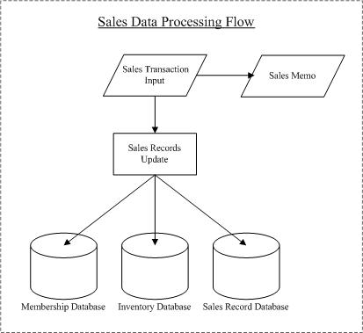

    - Data Objects and Dictionary
Member
Field | Description
CName | Chinese Name of member
EName | English Name of member
Nickname | Nickname of member
MID | Membership ID
Email | Member’s e-mail
Hphone | Member’s home phone number
Mobile | Member’s mobile phone number
Birthday | Member’s birthday
Group | Standard/VIP
Address | Member’s address
Sex | Female/Male
Count | Number of disc that the member has bought

Staff
Field | Description
SCName | Chinese Name of Staff
SEName | English Name of Staff
SNick | Nickname of Staff
SID | Staff ID
SHphone | Staff’s home phone number
SMobile | Staff’s mobile phone number
SBirthday | Date of Birth
SGroup | Administrator/Administration Officers/Cashier/Shop Assistant
SAddress | Staff address
SSex | Female/Male

Inventory
Field | Description
catalogue | Product ID
CFilm | Chinese Name of Disc
EFilm | English Name of Disc
cast | Name of Director and artists
released | Date of release
label | Produced by
format | Format of disc (DVD/VCD/HD DVD/CD)
price | Unit Price
disc | Number of discs
audio | Audio compression (Dolby Digital/DTS)
availability | Balance of stock
language | Language of the disc
subtitles | Subtitles of the film
time | Duration of the disc
discount | Discount rate or Special offer

Sales
Field | Description
tranID | Transaction ID
Date | Transaction Date
Time | Transaction Time
Catalogue | Product ID
Quantity | Quantity of disc
Amount | Total amount of the transaction
memo | Sales Memo Number
MID | Membership ID
discount | Discount rate or Special offer

    - Data Relationships

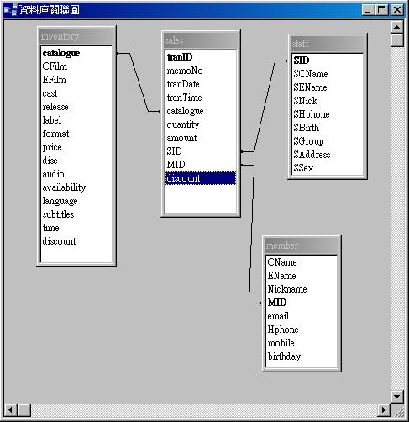

- FUNCTIONAL MODEL AND DESCRIPTION
  - Description for functions
    - Add new member

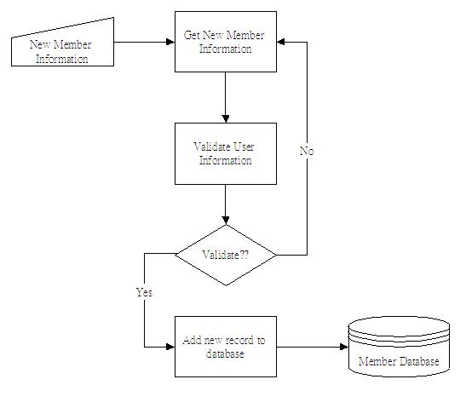

    - Update member record

    - Delete member record

    - Search member

    - Sales transaction

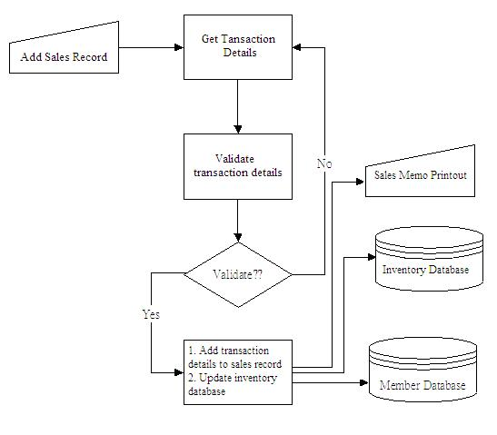

    - Generate report

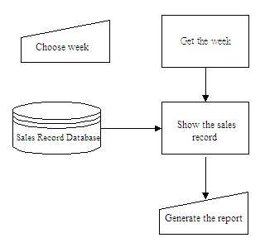
    - Add inventory item

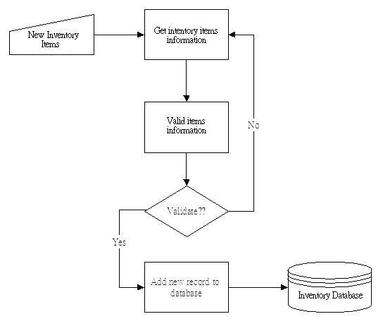

    - Add new staff

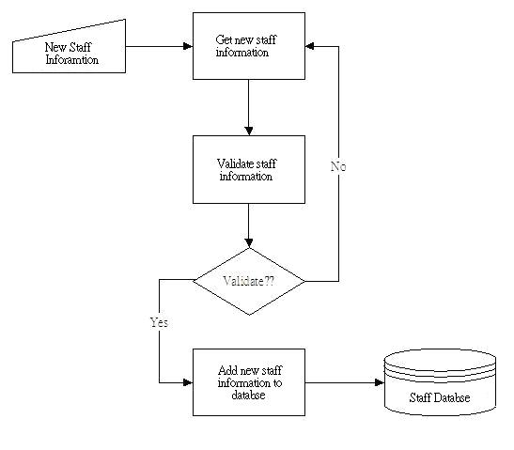

  - Software Interface Description
    - Login page

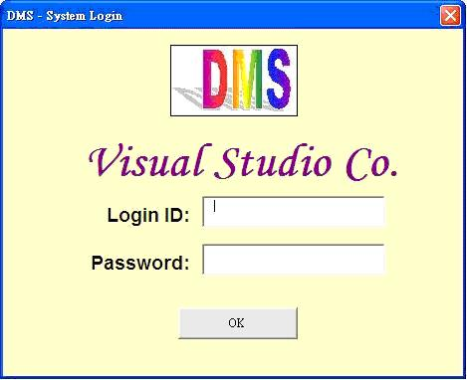

    - Administration Page

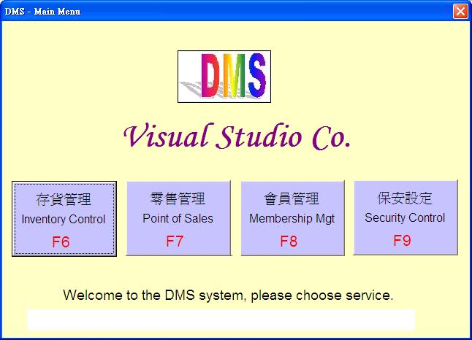

- VALIDATION CRITERIA
To focus on the input of data of the system and its expected output, black box testing is carried out as follows.

Test Function | Test Case | Expected Result
Login | Valid login ID & password (Member account) | Logging to the membership page.
Login | Valid login ID & password (Cashier account) | Logging to the POS interface.
Login | Invalid login ID & password | Display “Invalid login ID or password. Please make sure you are using the correct ID and password.”
Add New Member Record | New phone number (or home) | Can add new member
Add New Member Record | Duplicate phone number | Can’t add new member
Delete Member Record | Valid student ID | Can delete member record
Delete Member Record | Invalid student ID | Can’t delete member record
E-mail Promotion | Add a new message | Send to correct e-mail account
E-mail Promotion | Choose send to group1 | Only send to group 1 member
E-mail Promotion | Choose send to all member | Send to all member

