Deities of the World of Greyhawk
[Home] [Library] [Geography] [Download] [Journal] [Links]

The Powers of Oerth rarely intercede directly in the affairs of Oerth. They expect their servants to be their right (and left) hands in the world. Clerics, priests, paladins, and less exalted but still valued souls are the agents of Powers, however minor their deeds may be. The Powers have an implicit understanding that if one of them should act too directly, others will act in concert to oppose the meddler, for if all acted in such a manner, Oerth would be destroyed by the Powers.
This helps us understand why the demigod Iuz has been able to effect so much evil in the Flanaess. The Prime Material is his home plane, and therefore, he has a direct involvement in its affairs that other Powers do not. The servants must oppose Iuz, not the Powers themselves. One partial exception to this is St. Cuthbert of the Cudgel. Other Powers allow St. Cuthbert to act in limited ways to oppose Iuz. Why they do this, and how far St. Cuthbert is allowed to act, is a matter known only to the Powers.
In other respects, the Powers regard mortals as they do in almost all worlds. Mortals give reverence and their clerics and priests receive spells. The Powers watch with varying degrees of involvement. Greater Powers tend to have less involvement than Lesser Powers, because Greater Powers are more absorbed in the affairs of many worlds and transcendent events that are far beyond the affairs of mortals.
Mortals regard Powers as they do in most worlds: with reverence, awe, fear, attempts at placation, and so on. In the Flanaess, however, special factors are at work after the wars. The following is true for the nonevil lands of the central Flanaess:
First, there is a general increase in prayer, reverence, and all forms of devotion to Powers. In uncertain times, mortals turn to the great ones for succor, protection, and reassurance. Clerics and priests are widely respected and are given more offerings by even the poorest of their flocks. General superstitiousness is a by-product of all this.
Second, there are changes in patterns of worship. Mortals most often revere Powers who have everyday affairs of mortals as central concerns - deities of nature, children, health, community, and the like are more widely revered than those of philosophy, arcane knowledge, and ethics. But on Oerth, Powers of war, healing, protection, strength, endurance, and revenge are increasingly turned to for succor. Many people who before the war would have given small offerings to the goddess Beory (nature, Oerth Mother) or Rao (peace and serenity) now turn to a deity such as Trithereon (liberty and retribution), Heironeus (justice and valor), or the rising cult of Mayaheine (protection and endurance) instead. There is also an increasing tendency to appease, if not actually revere, deities of fate such as Istus, and deities of luck such as Ralishaz. Of course, this is less true of wise folk and specialists who might revere a Power of magic, metal-working, or similar niche.
Demihumans are another matter, although deities such as Clangeddin Silverbeard, the dwarven god of battle, have not lost followers in times of conflict. Arvoreen the halfling defender Power receives many offerings and prayers these days.
Deities are divided into four groups: greater, intermediate, lesser, and demi-powers. The basis of this broad distinction is as follows:

Greater Powers:
These are distant Powers, far removed from most mortal affairs. Some may be held to be among the Creator Powers of the multiverse or of Oerth. They typically have many spheres of concern, or are absolute masters of just one sphere.

Intermediate Powers:
While lacking the great creative force of Greater Powers, they are still very powerful and hold major sway over one or two spheres of concern. In some nations, they may be held as a patron Powers, even above a Greater Power.

Lesser Powers:
A lesser Power may serve greater ones as a messenger or aide, may be a cast-out or solitary Power, or may hold sway over a very narrow sphere of concern. Some Lesser Powers may be declining from exalted status or may be ascending to greater force.

Demipowers:
These are the least powerful and are in many ways similar to Lesser Powers. Some may be mortals who have undergone divine ascension (Zagig and Mayaheine being prime examples). Some may even be referred to as Hero Powers.

For a more in-depth look at all the Powers download the World of Greyhawk Fantasy Game Setting from our Download section.

Greater Powers

Name: | Beory | Symbol: 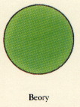
Sex: | Female
Alignment: | Neutral
Origin: | Flan
Notes: | Also known as The Oerth Mother, Nature, Rain.

Name: | Boccob | Symbol: 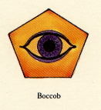
Sex: | Male
Alignment: | Neutral
Origin: | Common
Notes: | Called The Uncaring, is the Lord of all Magics and is the Archmage of the Deities. Whether or not any worship or serve him seems of no importance to him.

Name: | Incabulus | Symbol: 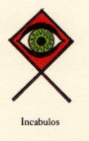
Sex: | Male
Alignment: | Neutral Evil
Origin: | Common
Notes: | The deity of evil sendings - plague, sickness, drought, nightmares and the like. His chief delights are woe and wickedness. Thus he is feared by even the princes of Hades and dukes of Hell.

Name: | Istus | Symbol: 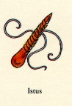
Sex: | Female
Alignment: | Neutral
Origin: | Baklunish
Notes: | Also known as The Lady of Our Fate. She is honoured and feared as the controller of foreordination. She has relatively few faithful devotess, many persons will call upon Istus in time of want or need.

Name: | Kord | Symbol: 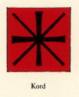
Sex: | Male
Alignment: | Chaotic Good
Origin: | Suloise
Notes: | God of athletics, sport and brawling. Kord is the embidiment of health and fitness. Athletes and sportsmen pay homage to Kord prior to competition. It has been many centuries since offical games have been held in honour of this muscular god, but his worship can still be found in tourneys held throughout the Flanaess.

Name: | Lendor | Symbol: 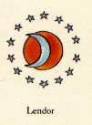
Sex: | Male
Alignment: | Lawful Neutral
Origin: | Suloise
Notes: | God of Time, Tedium.

Name: | Nerull | Symbol: 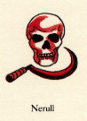
Sex: | Male
Alignment: | Neutral Evil
Origin: | Flan, Common
Notes: | The Reaper. God of death, darkness and Underworld. Nerull is the foe of all good, the hater of life. He is the deity for all those who seek greatest evil for their enjoyment and gain.

Name: | Pelor | Symbol: 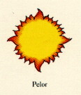
Sex: | Male
Alignment: | Neutral Good
Origin: | Flan, Common
Notes: | God of the sun, strength, light and healing. Pelor is the very antithises of Nerull. The worship of Pelor is the worship of life itself. Death is seen as the start of a journey of enlightenment and undead are seen as a curse which must be destroyed at any cost.

Name: | Procan | Symbol: 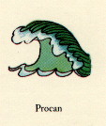
Sex: | Male
Alignment: | Neutral
Origin: | Oeridian, Common
Notes: | Oceans, Sea, Salt.

Name: | Rao | Symbol: 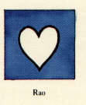
Sex: | Male
Alignment: | Lawful Good
Origin: | Flan, Common
Notes: | Peace, Reason, Serenety.

Name: | Tharizdum | Symbol:
Sex: | Male | Symbol:
Alignment: | Evil | Symbol:
Origin: | Unknown | Symbol:
Notes: | Eternal Darkness, Decay | Symbol:

Name: | Ulaa | Symbol: 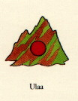
Sex: | Female
Alignment: | Lawful Good
Origin: | Unknown Common
Notes: | Hills, Mountains, Gemstones

Name: | Wee Jas | Symbol: 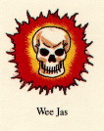
Sex: | Female
Alignment: | Lawful Neutral
Origin: | Suloise
Notes: | Magic, Death

Name: | Zilchus | Symbol: 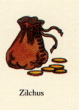
Sex: | Male
Alignment: | Lawful Neutral
Origin: | Oeridian Common
Notes: | Power, Prestige, Influence, Money, Business.

Lesser Powers (most known)

Name: | Celestian | Symbol: 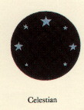
Sex: | Male
Alignment: | Neutral (good)
Origin: | Oeridian, Common
Notes: | Stars, Space, Wanderers

Name: | Ehlonna | Symbol: 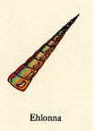
Sex: | Female
Alignment: | Neutral Good
Origin: | Common
Notes: | Forests, Flowers, Meadows.

Name: | Erythnul | Symbol:  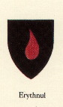
Sex: | Male
Alignment: | Chaotic Evil (neutral)
Origin: | Oeridian, Common
Notes: | Hate, Envy, Malice, Panic.

Name: | Fharlanghn | Symbol: 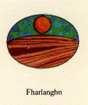
Sex: | Male
Alignment: | Neutral (good)
Origin: | Oeridian, Common
Notes: | Horizons, Distance, Travel

Name: | Heironeous | Symbol: 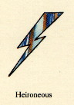
Sex: | Male
Alignment: | Lawful Good
Origin: | Oeridian, Common
Notes: | Chivalry, Honor, Valor, Justice.

Name: | Hextor | Symbol: 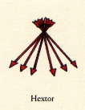
Sex: | Male
Alignment: | Lawful Evil
Origin: | Oeridian, Common
Notes: | War, Discord, Massacre.

Name: | Obad-Hai | Symbol: 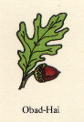
Sex: | Male
Alignment: | Neutral
Origin: | Flan, Common
Notes: | Nature, Freedom, Hunting.

Name: | Olidammara | Symbol: 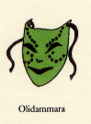
Sex: | Male
Alignment: | Neutral
Origin: | Common
Notes: | Music, Rougery, Wine.

Name: | Pholtus | Symbol: 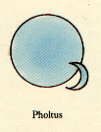
Sex: | Male
Alignment: | Lawful Good (neutral)
Origin: | Oeridian, Common
Notes: | Light, Resolution, Law.

Name: | Ralishaz | Symbol: 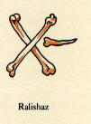
Sex: | Male
Alignment: | Chaotic Neutral (evil)
Origin: | Common
Notes: | Chance, Ill-luck, Misfortune.

Name: | St. Cuthbert | Symbol: 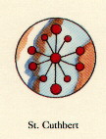
Sex: | Male
Alignment: | Lawful Good (neutral)
Origin: | Common
Notes: | Wisdom, Dedication, Zeal.

Name: | Trithereon | Symbol: 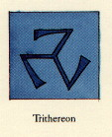
Sex: | Male
Alignment: | Chaotic Good
Origin: | Commom
Notes: | Individuality, Liberty, Retribution.

Demi-Powers (most known)

Name: | Iuz | Symbol:  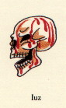
Sex: | Male
Alignment: | Chaotic Evil (neutral)
Origin: | Flan, Common
Notes: | Oppression, Deceit, Pain.

Name: | Zagyg | Symbol: 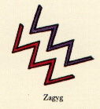
Sex: | Male
Alignment: | Chaotic Neutral (good)
Origin: | Common
Notes: | Humor, Occult Studies, Eccentricity.

[Home] [Library] [Geography] [Download] [Journal] [Links]

AD&D is a Registered Trademark of TSR, Inc. Original AD&D material Copyright 1978 by TSR Games and 1989 by TSR, Inc. All Rights Reserved. Greyhawk is a Registered Trademark of TSR, Inc. Original Greyhawk material Copyright 1983 and 1992 by TSR, Inc. All Rights Reserved. Used without permission. Any use of TSR Inc.'s copyrighted material or trademarks in this file should not be viewed as a challenge to those copyrights or trademarks.

