Netherworlders  As the war raged across the new world, mighty magics were released without heed to the consequences. At the sites of battles involving heavy use of spells, small rips began to appear in the fabric of reality. On the other side of these tears, beings from beyond this world gathered to watch the conflict. They waited with anticipation, hoping to join in the fray.  Finally, a large enough rift was formed to allow beings from the Ether to enter the young world. Death awaited the creatures and seized many of the first to pass through the portals. Those that escaped the clutches of Death fled back to their own realm. Those that were captured were bent to serve the Corrupter. These hybrids of Ether and Death then launched themselves into battle. As their mental powers grew in our reality they summoned monsters from their own realm to aid them in the battle.  All other races quickly learned that the Netherworlders are a force to be reckoned with!  The Netherworlders are beings made of Ether and Death. Ether is a new element, introduced here for the first time, and is represented by purple. |  |  |  |  |  | Netherworlder Special Abilities:  Mental Powers: All Netherworlders have mental powers. They use these powers to cast their magic. The Netherworlders also form it into bolts of mental energy and use these as missiles. During missile actions all Netherworlder magic icons rolled are counted as missile hits.  Magic Use: Since they are from outside Nature, Netherworlders do not double magic points when ID icons are rolled unless they use the Ether Bridge spell. They may cast spells from the Basic Black Spell list, as well as the spells from the Basic Purple Spell list, included here. They may also cast Black and Purple Spells from the expanded lists of unique Netherworlder spells, also included herein. They cannot use the usual method of burying the dead to double their Black magic points as other races do.  Reinforcements: Netherworlders, and all other ether hybrid races, can summon other members of their races during the course of the game. There are two ways to have this occur. The Gate SAI, found on rare magic-users and some monsters and the Reinforce spell. A summoning pool is created at the beginning of the game. This pool consists of one-fourth the number of ether hybrids initially put into play. The forces in the pool may be of any race brought to play and must be in proportion to the units in play. Once the pool is empty, no more troop summoning many occur.
Creature Descriptions:  All of the Netherworlders are humanoid in shape, except for the monsters they bring with them.  Common Units:  Wanderer: Minor soldiers, they skirmish and fight ferociously.  Vagrant: Common troops. They fight with determination and hurl their mental bolts when at a distance.  Razer: The weakest of the mental missile bearers. They have some physical combat ability.  Protector: Weak magic users that use their limited combat abilities in a pinch.  Mystic: Capable of only the simplest of magical tasks, these spell casters use their abilities to bolster the powers of others.  Uncommon Units:  Nomad: Swift of foot, and able to use missile attacks, these uncommon soldiers defend their troops faithfully.  Transient: These warriors are always moving from battle to battle, never staying in the same place long.  Render: They attack from a distance with bolts of pure psychic energy.  Warder: These uncommon spell casters turn their magics to the task of protecting their fellow warriors from harm.  Binder: These magic wielders concentrate on keeping themselves and the other Netherworlders bound to the Ether so their powers do not wane. |  |  |  |  |  | Rare Units:  Traveler: These mighty warriors are revered as leaders and are unrivaled in combat strength among the Netherworlders.  Wayfarer: Leaders in the army, they strike swiftly, then fall back to plan their next attack.  Reaver: Their mighty mental onslaught has been the end of many a mortal mind.  Gatekeeper: The most powerful of the Ether wizards, they are dedicated to maintaining the passages between Esfah and the Netherworld.  Summoner: These powerful magicians focus their energy on calling reinforcements to the battleground.  Monster Units:  Cerebral Leach: These bloated worms drain opponents’ mental energy on contact.  Ether Knight: Generals in the Netherworld army, many of their attacks cannot be defended.  Intellect Devourer: These grotesque mockeries of animals lash out with their minds, and their claws.  Mind Flayer: The most feared of all creatures from the Ether. Mind Flayers use their awesome mental powers to destroy all but the strongest of opponents.  Phantom Lights: Appearing as softly glowing lights in the sky, these creatures use mind control to paralyze or charm their enemies.
Netherworlder Icons |  |  |  |  |  | Normal Action Icons |  | Special Action Icons
 | Common |  | Uncommon |  | Rare
Heavy Troop | 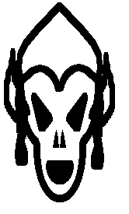 |  | 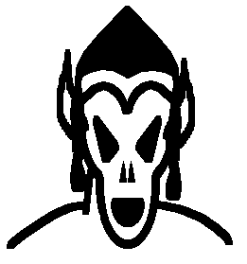 |  | 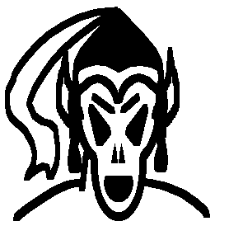 |  | 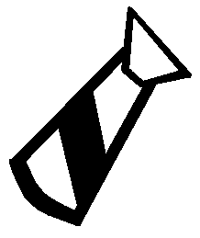 | 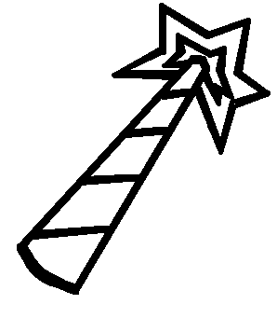 | 
 | Wanderer |  | Nomad |  | Traveler | Melee | Magic | Bullseye | Cantrip
Light Troop | 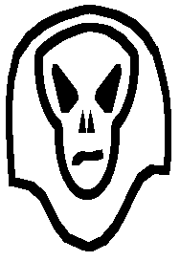 |  | 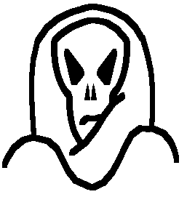 |  | 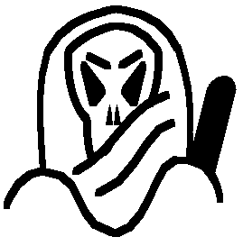 | 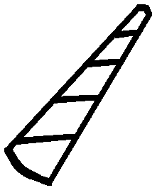 |  | 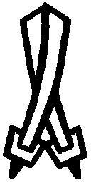 | 
 | Vagrant |  | Transient |  | Wayfarer | Missile | Save | Counter | Gate
Missile | 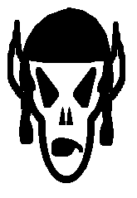 |  | 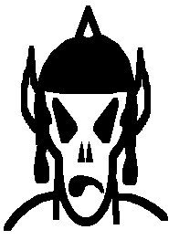 |  | 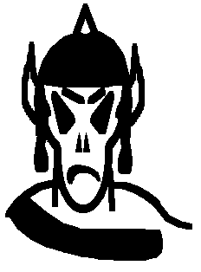 |  |  | 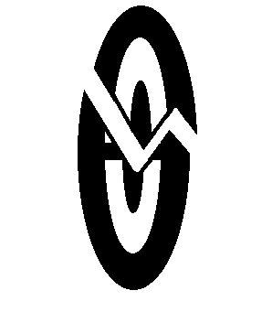
 | Razer |  | Render |  | Reaver | Maneuver |  | Smite
Heavy Magic | 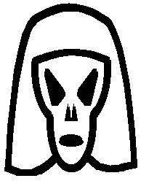 |  | 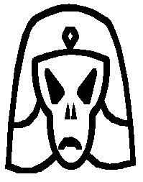 |  | 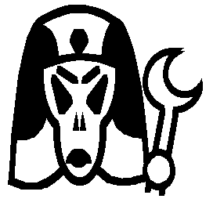
 | Protector |  | Warder |  | Gatekeeper
Light Magic | 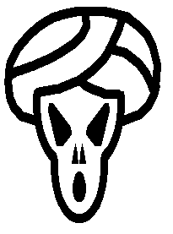 |  | 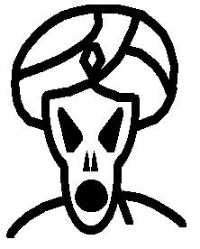 |  | 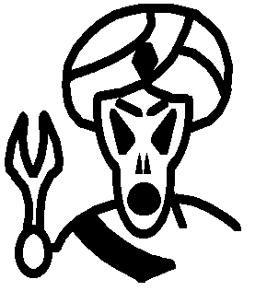
 | Mystic |  | Binder |  | Summoner
Netherworlder Monster Icons |  |  |  |  |  | Special Action Icons:  Bullseye: During a missile action, this attack targets a unit of the acting player’s choice. Only the target rolls to save. If it does not save it is removed to the dead area before the army rolls for saves against any other missile damage.  Cantrip: During a magic action, the cantrip counts as normal magic. During any other action, including rolls for saves, it can be used to purchase immediate spells.  Counter: During a melee attack, the counter acts as a normal hit. During a roll for saves during melee, it counts as both a save and an immediate hit upon the attacking army, which cannot save against it. Counter never causes a rout.  Gate: During a magic action, Gate icons count as normal magic. During maneuver rolls Gate icons are negated. During any other action, they allow the caster to summon a unit from the ether hybrid pool. Any opposing army at the same terrain as the casting army may attempt to counter the Gate effect by making a roll for magic. Only magic icons are counted, the highest opposing magic roll is retained and one gate icon is negated for every two magic ions rolled (rounded down). A single Dispel Magic negates all Gate icons. Only one unit may be summoned per unit rolling Gate icons and this unit must have health equal to or less than the adjusted number of Gate icons rolled.  Smite: During a skirmish attack, no saves count against these hits. Units killed by the smite are removed before the defending army rolls for saves.
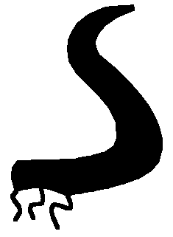 |  | 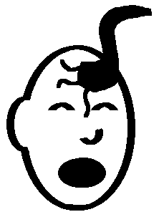
Cerebral Leech |  | Mind Drain
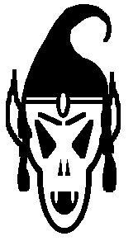
Ether Knight |  | Smite |  | Counter
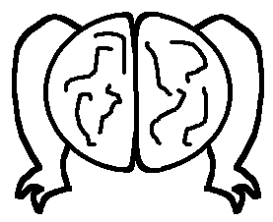 |  | 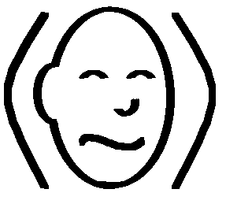 |  | 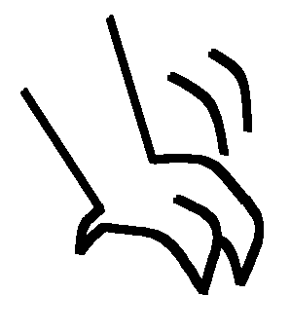
Intellect Devourer |  | Mind Control |  | Rend
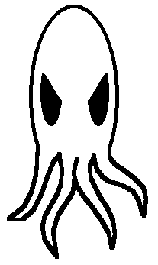 |  | 
Mind Flayer |  | Psychic Blast
 |  |  |  | 
Phantom Lights |  | Charm |  | Paralyze
Rules for Monster Units:  • All standard Monster rules apply.  • The ID icon of the Phantom Lights counts as four points of the needed effect, and the die is rerolled . This continues until something other than an ID icon is rolled.  Monster Special Action Icons:  Charm: During melee, four health worth of opposing units, attacker’s choice, add their rolls to yours. Units must be chosen before their rolls are made.  Mind Control: Causes four health units in the opponent’s army to roll a skirmish attack against their own army. The remainder of the army can roll to defend, and counter or smite results must be applied. When rolled during a Dragon attack, choose one unit in any other army at the terrain to add their roll to yours against the Dragon.  Mind Drain: Kills two health points of the enemy, owner’s choice, no save possible. Counts as two points damage during a Dragon attack.  Paralysis: Four health worth of opposing units, owner’s choice, can only roll for saves until the end of the owner’s next turn.  Psychic Blast: When rolled during missile or melee, this power targets four health worth of the opponent’s army. Defender chooses units, those that do not roll individual saves are killed and buried. However, if all the defending units roll ID icons the attack is reflected upon the Mind Flayer, who must save against its own attack. For purposes of this save only, the Psychic Blast icon functions as saves. Counts as four points of damage during a dragon attack.  Rend: During maneuver, counts as four maneuvers, during melee, counts as four points of damage and unit is rerolled for additional effect. |  |  |  |  |  | New Spells: The following spells are useable by all beings of Ether. This is the basic spell list for Ether spells.  Ether (Purple) Spells:  Cost Spell  3 Portal: Restores one unit of health from the dead area. Multiple castings may bring back multiple units, or units of higher health values as the caster chooses.  4 Vortex: Creates an Ether vortex that moves all one health units to the owner’s reserve area unless a maneuver is rolled per unit. The entire army is rolled and the number of maneuvers rolled is the number of one health units that can remain at the terrain. Multiple castings only affect the remaining one health units at the terrain, never units of higher health.  5 Ether Bridge: When cast, this spell enhances the flow of magic from the Ether at the affected terrain. All ID icons rolled during a magic phase can be doubled if used for purple magic. This effect applies to all armies at the terrain, and lasts until the end of the caster’s next turn. This cannot be cast on an army in reserve.  6 Reinforce: Opens a gate to the Ether. Allows caster to promote up to 3 Ether Units in target army by trading in for units one health higher from the dead area. 3 health units may be promoted to monsters.  7 Summon Purple Dragon: Send a Purple Dragon to any terrain.
Ether (Purple) Spells (Netherworlder Only):  4 Blink: Target unit cannot be affected by any sort of action for the duration of the spell, being effectively hidden from harm. Similarly, the unit may not participate in any action for the duration of the spell.  - Time Trick: Force the opposing army to reroll four health worth of units after their roll has been made. Caster chooses which units reroll. This spell may be cast during a player’s turn, then held until needed. The effect must be used before the end of the caster’s next turn or it is lost. All of the dice must be chosen from the army on the same roll.  Death (Black) Spells (Netherworlder Only):  2 Energy Drain: Target unit must be exchanged for a unit one heath point less from the owner’s dead pile. This slays a one health unit. No saves can stop this attack. This is only effective if an appropriate unit is available. Target unit and replacement unit must be of the same race. Multiple castings affect multiple units or larger units as the caster chooses.  5 Magic Jar: Target one unit up to three health. If unit saves there is no effect. If unit fails to save roll affected unit in a skirmish attack against one unit in its own forces, chosen by the caster. The chosen unit may save against this attack. After this roll affected unit rolls to save again. If successful unit is returned to its army as normal. If the target unit fails to save this time it is killed.  6 Stinking Cloud: All melee results at target terrain are halved until start of caster’s next turn. Multiple casting must target another terrain. |  |  |  |  |  | Additional New Items and Creatures:  Ether Dragon: May be a Drake or a Wyrm. Identical to other Drakes and Wyrms except for its breath weapon.  Breath Weapon: Psychic Shriek: Kills 5 units in target army. During the counter attack on the dragon all units rolling ID ignore these results when figuring save, melee and missile results. Additionally these units are Stunned (per the SAI) until the start of their owner's next turn.  Note: This is a substantial change from the original Psychic Shriek I created. The revised Black Dragon breath now has an effect essentially identical to the initial Psychic Shriek so this revision was needed.

