Reptilians: The Lizardmen  On every front the forces of Nature were defeated. They sought to stop the carnage and slaughter while preserving life. The forces of Death attacked mercilessly, slowly driving the forces of Nature back. To balance the power Nature knew she would need a new ally. She turned to Ether, master of the netherworld. He agreed to help her produce hybrid races. For the first she chose to bind ether to water, the most malleable of the elements. The new race arose, filled with ferocity and power, armed with primitive weapons.  The Reptilians joined in the battle with a fury never before seen on Esfah, and woe to the forces of destruction!  Reptilians are creatures of Water (Green) and Ether (Purple). Ether is a new element. The basic spells for Ether are contained in these rules. |  |  |  |  |  | Reptilian Special Abilities  Magic Use: Since they are from outside Nature, Reptilians do not double magic points unless they use the Ether Bridge spell, or have control of a terrain with standing stones visible. They may cast spells from the basic Green list, as well as the spells from the basic Purple list, included here. They may also cast spells from the expanded spell list included with this supplement.  Swimming: The Reptilians are excellent swimmers. They may use this ability to travel directly between any two terrain dice with the water (green) aspect in a single reserve move, bypassing the reserve area entirely.  Morale: Due to their innate fierceness Reptilians will never rout under any circumstances. An army containing Reptilians cannot be routed, even a single Reptilian unit prevents routs entirely. Reptilians are not rolled when the Revolt face is indicated on a Village minor terrain die. Other troops in the same army are affected normally by a revolt face.  Susceptibility to Fire: All fire (red) magic spells and fire-based SAI’s that cause damage inflict double the normal amount of damage to Reptilians when they are targeted. This includes: Firebolt, Firestorm, Firecloud, Burning Hands and Volcanic Eruption.  Reinforcements: Reptilians, and all other ether hybrid races, can summon other members of their races during the course of the game. There are two ways to have this occur. The Gate SAI, found on rare magic-users and some monsters and the Reinforce spell. A summoning pool is created at the beginning of the game. This pool consists of one-fourth the number of ether hybrids initially put into play. The forces in the pool may be of any race brought to play and must be in proportion to the units in play. Once the pool is empty, no more troop summoning many occur.
Creature Descriptions  Common Units:  Caiman-Man: The smallest of the heavy troops rely on thick skin for protection.  Chameleon-Man: These warriors are masters of camouflage, striking without warning.  Frilled Lizard-Man: Light shock troops who seek to intimidate their foes with their neck frills.  Skink-Man: Fleet runners that strike quickly and run away.  Gecko-Man: Crafter with rudimentary skills in ether craft.  Uncommon Units:  Gavial-Man: The eyes of this beast-man glimmer with cunning.  Spiked Chameleon-Man: Their prehensile tail often wields an extra weapon.  Monitor Lizard-Man: Built for battle these creature rush to the slaughter with revel.  Tegu-Man: These monsters move rapidly to close the distance to their enemy’s camp.  Anole-Man: Moderately powered spellcrafters with a touch of melee power for battle situations. |  |  |  |  |  | Rare Units:  Crocodile-Man: Lumbering brutes that wade through enemy forces with ease.  Horned Chameleon-Man: Three horns top the head of the most powerful of these vanishing troops.  Komodo Dragon-Man: These massive lizardmen often lead charges and tear through opposition.  Basilisk Lizard-Man: These beasts are quick enough to run across the surface of water!  Iguana-Man: Capable of bending the forces of water and ether to do their bidding these shaman command the respect of their troops.  Monsters:  Dryad: These spirits of water use their spell casting abilities to protect the reptilians in battle.  Ether Eel: Vaporous serpents that drift on the wind and seek to drain other beings of their life-essence.  Green Slime: This mutated algae slithers along the ground and envelops its prey, utterly destroying all it touches.  Kracken: This mutant behemoth lies at the bottom of swamps and oceans until called to assist its allies.  Velociraptor: Ancient throwbacks that tower above their allies. Their razor teeth and claws slash enemies mercilessly.
Lizardman Icons |  |  |  |  |  | Normal Action Icons |  | Special Action Icons
 | Common |  | Uncommon |  | Rare
Heavy Troop | 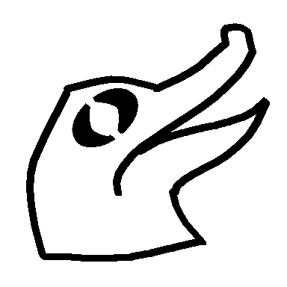 |  | 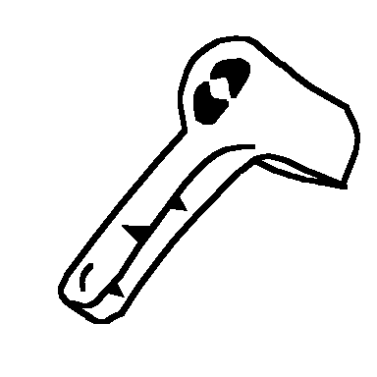 |  | 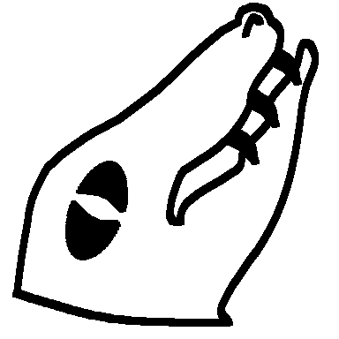 | 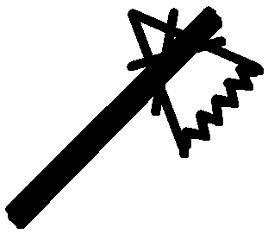 | 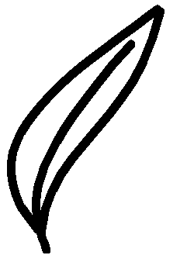 |  | 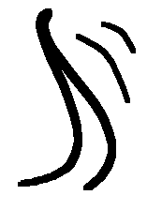
 | Caiman-Man |  | Gavial-Man |  | Crocodile-Man | Melee | Magic | Backstrike | Lash
Light Troop | 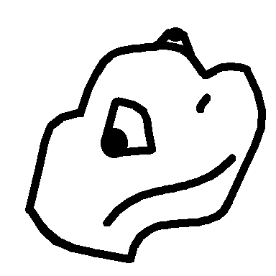 |  | 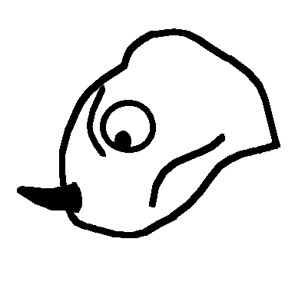 |  | 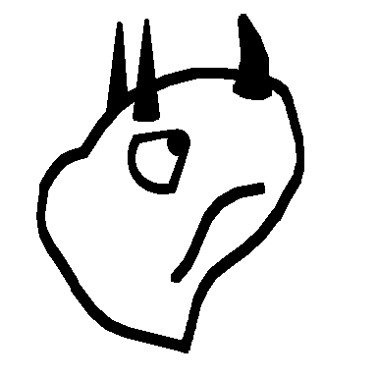 | 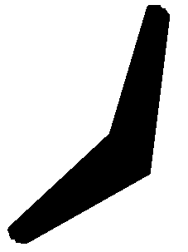 | 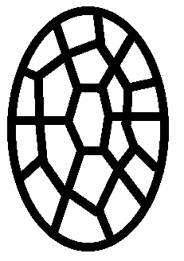 | 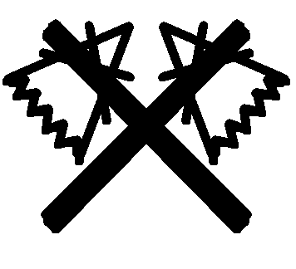 | 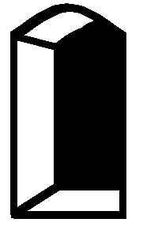
 | Chameleon-Man |  | Spiked Chameleon-Man |  | Horned Chameleon-Man | Missile | Save | Counter | Gate
Skirmisher | 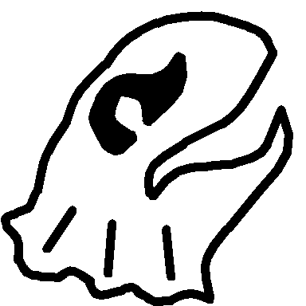 |  | 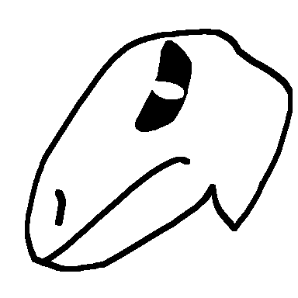 |  | 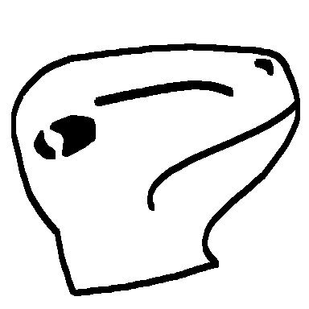 | 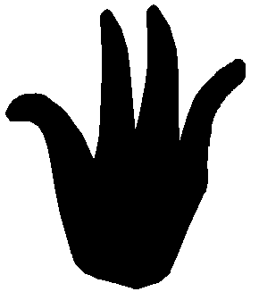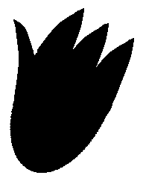 |  | 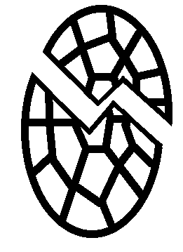 | 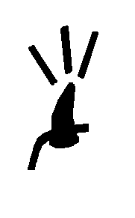
 | Frilled Lizard-Man |  | Monitor Lizard-Man |  | Komodo Dragon-Man | Maneuver |  | Smite | Gore
Calvary | 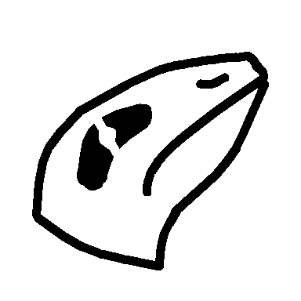 |  | 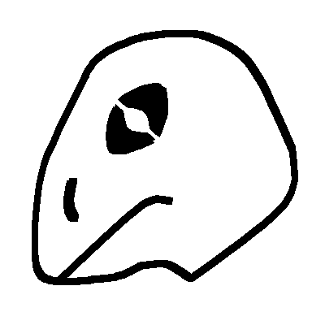 |  | 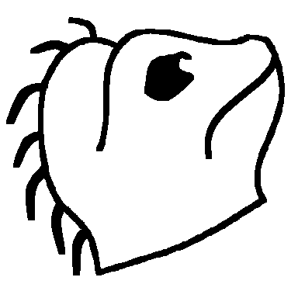
 | Skink-Man |  | Tegu-Man |  | Basilisk Lizard-Man
Magic | 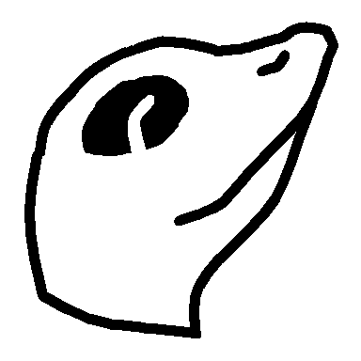 |  | 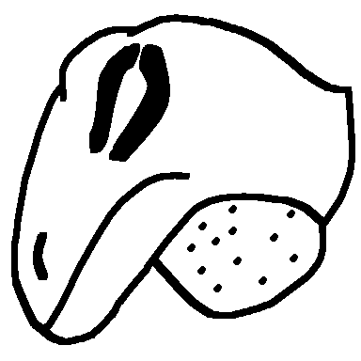 |  | 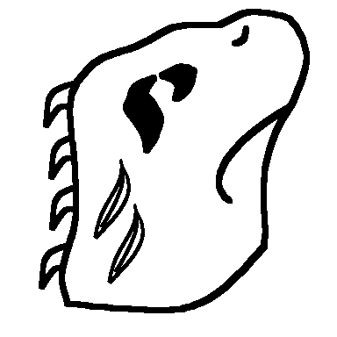
 | Gecko-Man |  | Anole-Man |  | Iguana-Man
Reptilian Monster Icons |  |  |  |  |  | Special Action Icons:  Backstrike: During a missile action, this icon inflicts one point of damage. The rolling unit is then re-rolled and the effects are cumulative. The unit continues to reroll until an icon other than Backstrike is rolled.  Counter: Normal effect  Gate: During a magic action, Gate icons count as normal magic. During maneuver rolls Gate icons are negated. During any other action, they allow the caster to summon a unit from the ether hybrid pool. Any opposing army at the same terrain as the casting army may attempt to counter the Gate effect by making a roll for magic. Only magic icons are counted, the highest opposing magic roll is retained and one gate icon is negated for every two magic ions rolled (rounded down). A single Dispel Magic negates all Gate icons. Only one unit may be summoned per unit rolling Gate icons and this unit must have health equal to or less than the adjusted number of Gate icons rolled.  Gore: During melee target a single unit to save against the total damage done by the gore icons. If the unit saves there is no effect. If it fails to save it is killed and buried.  Lash: During a melee attack, skirmish or charge, each lash icon counts as a single point of damage and the unit that rolls the lash is rolled again with the new result being applied as well. This continues until a result other than lash is obtained.  Smite: Normal Effect
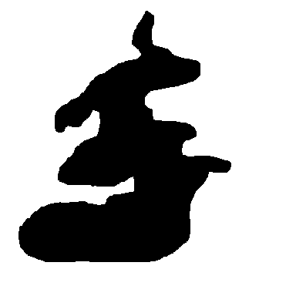 |  | 
Green Slime |  | Disintegrate
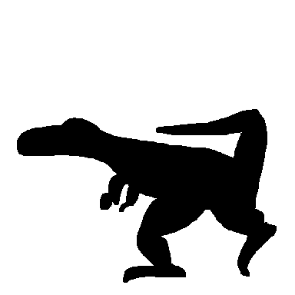 |  |  |  | 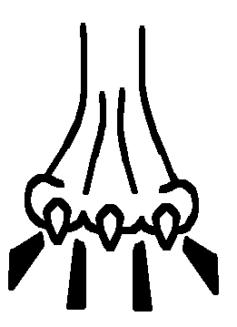
Velociraptor |  | Lash |  | Trample
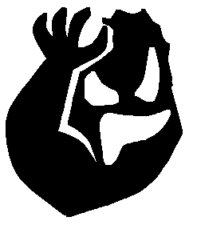
Kracken |  | Gate |  | Smite
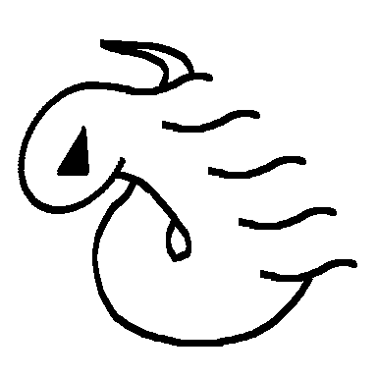 |  | 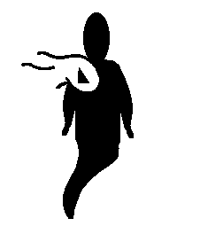
Ether Eel |  | Ichor Drain
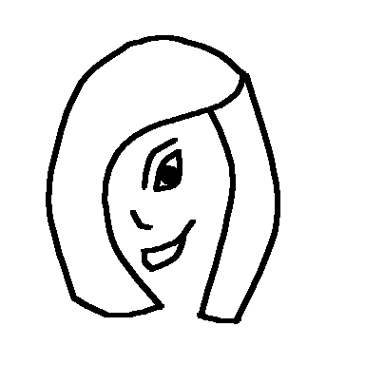 |  | 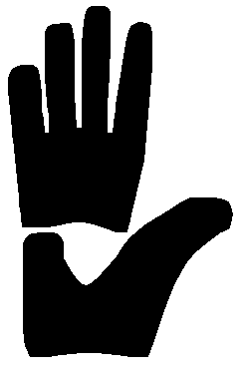 |  | 
Dryad |  | Cantrip |  | Charm
Rules for Monster Units:  • All standard Monster rules apply.  Monster Special Action Icons:  Cantrip: Normal Effect  Charm: Normal Effect  Disintegrate: During melee target a single unit, 3 health or less, in the opposing army. That unit must roll against points of damage. If killed the unit is rolled again. The unit needs an ID results to save. If it fails to roll its ID it is buried.  Ichor Drain: Target 1 unit, any size. The target unit makes all rolls at -2 until the beginning of its owner’s next turn. At the beginning of the owner’s next turn the target unit is rolled. If it rolls its ID icon it is killed.  Lash: During a melee attack, skirmish or charge, lash counts as a 4 points of damage and the unit that rolls the lash is rolled again with the new result being applied as well. This continues until a result other than lash is obtained.  Trample: Normal effect |  |  |  |  |  | New Spells: The following spells are useable by all beings of Ether. This is the basic spell list for Ether spells.  Ether (Purple) Spells:  Cost Spell  3 Portal: Restores one unit of health from the dead area. Multiple castings may bring back multiple units, or units of higher health values as the caster chooses.  4 Vortex: Creates an Ether vortex that moves all one health units to the owner’s reserve area unless a maneuver is rolled per unit. The entire army is rolled and the number of maneuvers rolled is the number of one health units that can remain at the terrain. Multiple castings only affect the remaining one health units at the terrain, never units of higher health.  5 Ether Bridge: When cast, this spell enhances the flow of magic from the Ether at the affected terrain. All ID icons rolled during a magic phase can be doubled if used for purple magic. This effect applies to all armies at the terrain, and lasts until the end of the caster’s next turn. This cannot be cast on an army in reserve.  6 Reinforce: Opens a gate to the Ether. Allows caster to promote up to 3 Ether Units in target army by trading in for units one health higher from the dead area. 3 health units may be promoted to monsters.  7 Summon Purple Dragon: Send a Purple Dragon to any terrain.
Ether (Purple) Spells (Reptilians Only):  4 Mirror Image: Target 1 unit of the caster’s choice. Until the beginning of the caster’s next turn this unit is rolled twice in every action taken by the army, and the appropriate results are totaled. If the unit under the effect of this spell is targeted by any SAI or spell that affects an individual unit (e.g. Bullseye) the mirror image is dispelled and the target unit automatically saves against the effect  6 ESP: Target any army in play at any terrain. Target army may roll to avoid the effects of the spell. If the target generates 6 or more ID faces (not points) then they are able to resist the spell and there is no effect. If the army fails to roll enough ID faces then this army may not participate in an action, nor may any of the units in the army be used in a reserve move during its owner’s next turn. Units may still be move into and out of the target army through magical means.  Water (Green) Spells (Reptilians Only):  2 Dehydrate: Inflict one point of damage on a target army. The army may roll for saves. This spell may be multiplied. The target army only gets one save roll regardless of how many Dehydrate spells target it at once.  5 Deluge: Target any terrain in play. All missile attacks into, out of or at the targeted terrain are halved until the beginning of the caster’s next turn. Multiple castings of deluge in a single action must target another terrain. If deluge targets a terrain where deluge is already in effect the net result is an extension of the amount of time the deluge spell remains effective. |  |  |  |  |  | Water (Green) Spells (Reptilians Only):  6 Watery Grave: Target a single unit in any army in play, dead units are immune. Unit is allowed a single roll. The effect on the unit is as follows: Non-ID save for no effect. ID face indicates the unit is killed and buried. Any other result indicates the unit is killed.  Additional New Items and Creatures:  Ether Dragon: May be a Drake or a Wyrm. Identical to other Drakes and Wyrms except for its breath weapon.  Breath Weapon: Psychic Shriek: Kills 5 units in target army. During the counter attack on the dragon all units rolling ID ignore these results when figuring save, melee and missile results. Additionally these units are Stunned (per the SAI) until the start of their owner's next turn.  Note: This is a substantial change from the original Psychic Shriek I created. The revised Black Dragon breath now has an effect essentially identical to the initial Psychic Shriek so this revision was needed.

