IBUY Tutorial 3

IBUY Use Case Diagram – iteration 1.
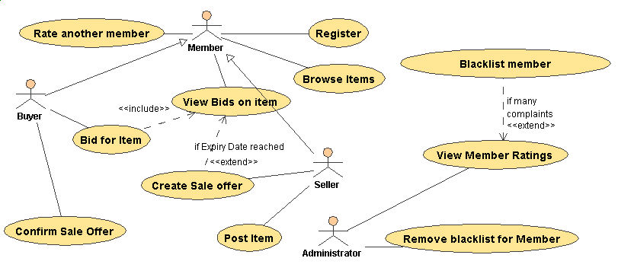
Buyer and Seller are specializations of Member.
Note the use of the lines and direction of arrows for <<extends>> and <<includes>>

The use case “Bid for Item” INCLUDES “View Bids on Item”
The use case “Create Sale Offer” EXTENDS “View Bids on Item” – only if the expiry date is reached.

See next page for activity diagram.
Activity Diagram: 