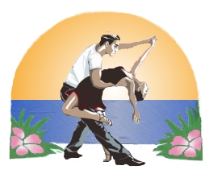UNLIMITED SOCIAL dancing for Country, Swing/Hustle and Salsa dancers
Great Workshops and Three Grand Ballrooms
So…
Come and DANCE with us at the

250 Racquet Road in Weston, FL (954) 61-1234
Reservations (mention Sunshine State Dance Challenge)

For more information, check out www.salsajam.com or www.sunshinestatedancechallenge.com

*New: Children’s Workshops and Line Dancing

The event will have Couples Strictly Swing, Strictly Salsa and Strictly Hustle. In addition, there are Swing, Salsa and Hustle Pro-Am divisions. The event is certified as a WSDC event so you swing Jack & Jill points will count. Jack and Jill Two Step will also be offered on Sunday. All Swing, Salsa & Hustle Divisions will be danced on Friday Night.

Saturday Night Show is included in weekend pass. We offer Spectator's Pass at $25.00 (Early Bird) or $40.00 at the door. Proceeds go to "Make a Wish" Foundation

