Some relevant VR research projects

Waymaker (Strohecker/ Barros/ Back at MIT Dept. of Urban Studies and Planning, StrataVarious Software)

Based on Lynch’s (Lynch 1960) idea of “imaging the city” Strohecker and Barros developed an environment that uses Lynch’s navigational tools in order to shape a new landscape. Users could drag and drop symbols of Lynch main image-shaping elements into a 2D map and the system would generate 3D VR walkthrough views of this map by using Cézanne paintings as underlying artwork to fill in the scenario.
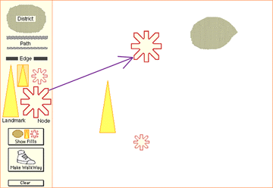

fig 1 – example of a 2D map created in WayMaker

Users could choose which Cézanne paintings should be used in what part of the map and what path to use going “through” the created map.
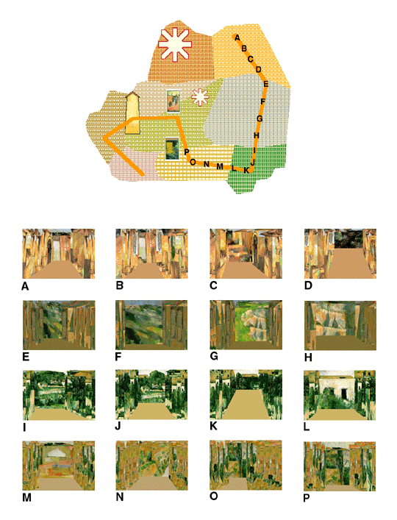

fig 2 – example for a path through a 2D map and its 3D representation using motifs from Cézanne

WayMaker uses a reversed approach in comparison to Wayfarer. Wayfarer relies on real existing maps that help the user to navigate by quoting official icons and symbols from map generation. WayMaker uses these icons – or to be precise: the five basic structuring symbols from Lynch – to enable the user to create a map, which can be encounter in 3D afterwards without any further interaction during the walkthrough.
It is insofar of importance to Wayfarer as it heavily focuses on the notion of landmarks as navigational elements. The VR gets structured by the positioning of the landmarks and the special artwork chosen for the specific area. This also mirrors the possible “puzzle” piece approach of Wayfarer that allows designers to re-use certain parts of different maps in new combinations.

Lit:
- Lynch, Kevin (1960) The Image of the City. Cambridge, MIT Press.
- Strohecker, Carol/ Barros, Barbara/ Slaughter, Adrienne (1998)
Mapping Psychological and Virtual Spaces. A Contribution to Design Computing on the Net ’98. http://www.merl.com/projects/waymaker/DCNet98/index.html

The Virtual Reality Roving Vehicle (University of Washington)

The Human Interface Technology Laboratory at the University of Washington developed the Virtual Reality Roving Vehicle VRRV in as educational 3D environments for school children. Based on the idea of constructivism – that is, using symbols and the connection of symbols to “make meaning” of one’s own environment, experiences and interaction – the use of computer generated 3D environments was addressed. The final piece was a mobile VR unit that could be transported to different schools in a van.
The work focuses on the creation of a 3D environment with biology content (wetlands ecology) by the students. Each environment was created by a team of students who shared the tasks of management, documentation, modelling, art direction, and defining the behaviour design during the project.
The world-building process proved to be successful if integrated into the school’s daily curriculum and taught over a longer (3-4 weeks) time (Osberg 1997, 129). But the more ‘extra-curricular’ the project was treated the more problems showed up. Osberg concludes: “On the Constructivist side, findings indicate that by incorporating the student’s creativity and design skills, metacognitive skills, freedom to make their own design and navigational decisions, and their whole body into the learning process, students have a very wide avenue of opportunity for cognitive, somatic and affective growth and experience” (Osberg 1997, 124). But traditional, teacher-led lectures and textbook methods seem to be equally educationally valuable.
Nevertheless, constructivism via single elements in a computer-generated environment seemed to be a helpful tool especially for students who do not respond to traditional classroom pedagogic.
The VRRV project insofar offers valuable information to the Wayfarer project as it addresses comparable problems within its approach. The system was tested on over 3000 students in over 70 schools and evaluated in a PhD thesis.
The VRRV approach of clearly defined teamwork by the students might prove to be helpful in future multi-user versions of the Wayfarer system. Sharing responsibilities and combining efforts to optimise the performance in VR requires and probably improves social skills among the students and might have an educational value in itself.

Lit:
- Osberg, Kimberley M (1997) Constructivism in Practice: The Case for
Meaning-Making in the Virtual World. PhD Thesis, University of
Washington.
http://www.hitl.washington.edu/publications/r-97-47/
- Rose, Howard (1995) Assessing Learning in VR: Towards Developing a
Paradigm Virtual Reality Roving Vehicles (VRRV) Project.
http://www.hitl.washington.edu/publications/r-95-1/

InterFIRE VR (Bureau of Alcohol, Tobacco & Firearms, American Re-Insurance Company, the U.S. Fire Administration, and the National Fire Protection Association)

InterFIRE is a commercially available product for the training of US firemen. Instead of a three-dimensional world representation, the developers did chose Quicktime VR as presentation tool and added professional film sequences as educational material. The result is a multimedia training CD-ROM with a three divided info structure. It includes; 1) a scenario 2) a tutorial 3) resource files.
It is of interest for the development of Wayfarer insofar as it offers direct access to a website that offers constantly updated information from a wide field ranging from legal issues to a message board and specific articles. Interconnection of CD-ROM and web media seems to be the most powerful part in a project that in itself bear few new elements.

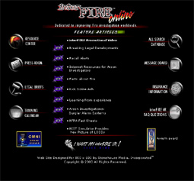 fig x – screenshot from the InterFIRE VR homepage

A development of a web-based platform (e.g. as a portal for linking schools) might be an interesting feature for a multi-user version of Wayfarer. It also addresses input from other sources than the original CD-ROM designer as the page includes articles and data from various other sources.

Lit:
- InterFIRE VR web page at: http://www.interfire.org/

Introduction to Geographic Information courses 137 & 247 (Ludwig at University of Missouri)

Started in 1992 (as course 137) these projects are ongoing (course 247 opened early 2000) courses in the Department of Geography. Their main focus is computer added mapping of various data in different ways.
While Wayfarer concentrates on the navigational aspects, these projects aim more at map generation with the help of computers but address a comparable target audience – college students. The goal of the program is to teach mapping and cartography as part of geographic education but Ludwig includes VR in his approach: “How can the relationship between topographic relief, land use and people be visualized and studied in a manner that is understandable? The answer, potentially, is Virtual Reality ….” (Ludwig 1996). Using Vista Pro to generate 3D models of the 2D maps VR lead to simple 3D maps that can be used for walkthroughs and illustration. These 3D exploration offers very little interactive access for the user inside the environment, though.

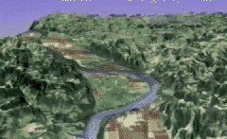 fig x – teaching Vertical Exaggeration / Central Missouri

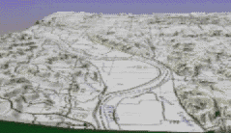 fig x – example for a topographic map

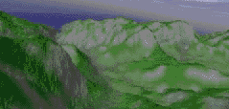 fig x – example of terrain interpretation / Hawaii

On the dominating 2D side various mapping tools were used (e.g. ArcView, ArcInfo, AtlasPro etc.) in order to allow students to create accurate maps. These maps can focus on various special content, not only spatial structures but also, for example, mapping crime.
This layering of different information could improve the Wayfarer maps significantly as it ads social, historical, and cultural background to a spatially defined area.
As it was suggested in the “Treasure Hunt” scenario, this additional information can not only enhance the motivation for optimal navigation but could also refer to other curricular content.
In addition, Ludwig refers to the “teach-ability” of geographic information in general and his experience might offer valuable insight.

Lit:
- Ludwig, Gail S (1996) VIRTUAL REALITY: A New World for Geographic Exploration. Earthworks. at: http://www.utexas.edu/depts/grg/eworks/wie/ludwig/earthwor.html
- course #137 at: http://ludwig.missouri.edu/137/index.html
- course #247 at: http://ludwig.missouri.edu/247/index.html

ExploreNet (Hughes / Moshell at University of Central Florida)

Based on 1990’s LucasFilm’s “Habitat” system, ExploreNet uses 2 ½ dimensional cartoon-like graphics to present their various online worlds. This system allows multiple users to share the same environment and communicate to each other via typing chat messages. It runs on low performance PCs with a Java conversion coming up that would make the system even run cross-platform. ExploreNet is available free of charge for non-profit entities since 1995. It has been tested in schools of different cultural background (including American and German).

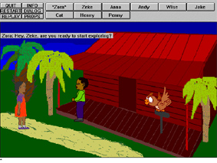fig x – a typical screen of the ExploreNet world

It also has been tested in a variety of settings using different virtual environments such as a Dinoworld, or Autoland where users have to solve different tasks.
The concept is of interest for a future Wayfarer implementation as it heavily relates to a networking of different physical locations. It also addresses the notion of cross-platform performance on standard computers that are available and affordable for educational institutions. It furthermore heads towards a wider educational content – a development that might prove interesting for future Wayfarer versions.

Lit:
- Hughes, Charles E/Moshell, Michael J (1995?) Shared Virtual Worlds
for Education: The ExploreNet Experiment. ACM Multimedia. at:
(http://www.cs.ucf.edu/~ExploreNet/papers/VA.Experiment1195.html)
- ExploreNet homepage http://longwood.cs.ucf.edu/ExploreNet/
- ftp site ftp://ftp.cs.ucf.edu/pub/ExploreNet

Game environments

3D games have an important position in the commercial game market. Either as first person titles (starting from “Castle Wolfenstein”) or third person exploration games (such as “Tomb Raider”). With the growing popularity of the Internet, some of these games have concentrated on multi-player systems (“Quake III Arena” heavily depends on this feature). Usually there are several thousand players online at any given moment.
Like Wayfarer, these games heavily rely on navigational skills, way finding, and orientating in a virtual 3D environment.
Each game title has a certain amount of available maps and levels but as a special feature some of these titles provide the user with a free map-editing program to generate own maps and levels. Namely Half-Life’s popular editor “Worldcraft” is used by a large community of game devotees who create their own “mods” – that is, own maps, characters, and game settings. These maps are usually downloadable for free and prominent packages such as “Counter-Strike” or the upcoming “Day of Defeat” are free add-ons to the original Half-Life game. The source code for some of the early first 3D first person shooter titles – such as “DOOM”, “Quake I”, and “Castle Wolfenstein” – is available free and has since been modified by various users.
Wayfarer appeal relates to the immense popularity of these 3D games by concentrating on three-dimensional graphical representation. If future implementations of Wayfarer would include the “mod culture” of these titles combined with the multi-player aspect, a growing community of users could be assembled to enhance the Wayfarer system. The fast growing popularity and improving graphics are the technical background the Wayfarer project can build on.

Lit:
- id Software: source code for DOOM, Quake I and Castle Wolfenstein
http://www.idsoftware.com/archives/sourcearc.html
- Counter-Strike homepage http://www.counter-strike.net/
- Day of Defeat homepage http://www.dayofdefeat.com
- Half-Life homepage
http://www.sierrastudios.com/games/half-life/overview.html

VRML worlds

Various VRML worlds with an educational background are available online. For example the Active Worlds Educational Universe AWEDU is solely dedicated to educational purposes (for a list of some of the available worlds at AWEDU: http://www.activeworlds.com/edu/newsletter/1200.html).
Dickey’s research on the use of the Active Worlds technology (blaxxun interactive Contact 4.0) revealed that “many unique learning opportunities were presented by the use of AW as an education medium” (Dickey 1999, in her summary p. 3).
Her findings about the use and value of 3D VRML worlds – for example the quality of “plasticity” that allows users access to the world’s design – are of importance for the development of Wayfarer as in-world navigation, presence in the virtual environment, and dealing with in-world tasks is part of the content design of both, Wayfarer and the AWEDU worlds. Although Wayfarer works on a different platform both systems deal with these basic elements and especially a multi-user version of Wayfarer should refer to the results of Dickey’s work.

Lit:
- Dickey, Michele D (1999) 3D Virtual Worlds and Learning: An Analysis of the Impact of Design Affordances and Limitations in Active Worlds, blaxxun interactive, and OnLive! Traveller. PhD thesis at the Ohio State University. At:
http://michele.netlogix.net/side3/dissertation.htm

