Play Music on Yahoo Messenger with No Microphone
Step 1: right click on the speaker icon on your desktop toolbar:
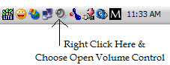
Step 2: Select Options from the Toolbar & Click on Properties
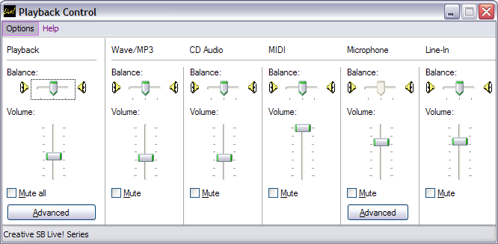

Step 3: In the Properties Menu Click on Recording & checkmark Stereo Mix and Microphone then click OK
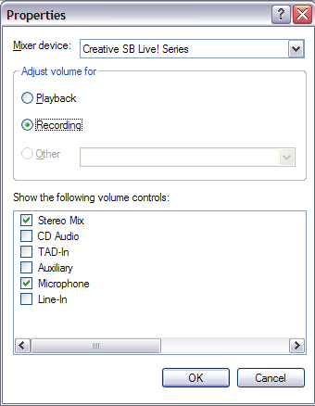
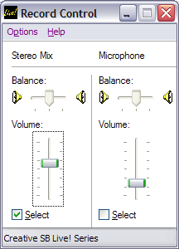
Make sure you keep this Record Control box open at all times while chatting if you want to broadcast music while in voice chat, also Yahoo! Likes to keep the settings on Microphone checked so each time you chat & broadcast make sure you have Stereo Mix selected as shown in the screenshot to the left.

