Beginning Bobbin Lace

Ranvaig the Weaver
ranvaig@columbus.rr.com
http://www.geocities.com/ranvaig/
http://groups.yahoo.com/group/SCA-lace/

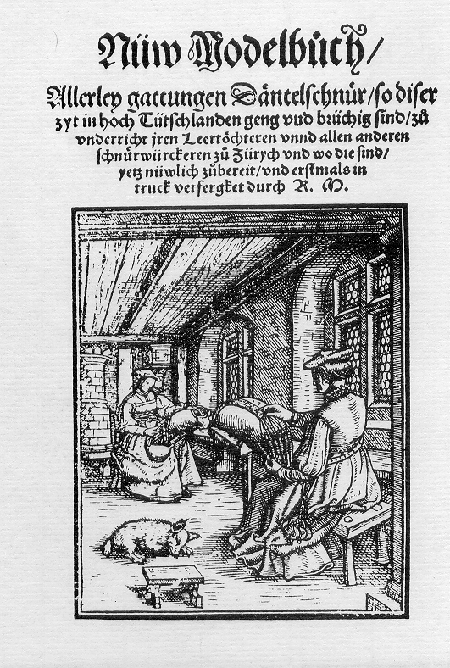

The first Bobbin lace pattern book, LePompe, was published in 1557 in Venice. The designs are already sophisticated and the lace obviously has a long history already.
It only includes patterns, there are no working directions, not even the number of bobbins to use, and is meant for people who already know how to make lace. It was probably intended for people who taught lacemaking. Even then, only the very poor could earn a living making lace.
In 1561 Nuw Modelbuch was published in Zurich. The author, R. M., says that bobbin lace was introduced from Italy and had been known in Switzerland for 25 years, that is since 1536, when Italian merchants introduced it.
The patterns in this book are for the most part simpler and appear earlier than the ones in LePompe. Nearly all have two straight edges, not the points that became so popular. There are no working directions in this book either, although she does list the number of bobbins, and recommends some patterns for color or use with gold thread.
The pattern books are part of a growing market for pattern books of all sorts. This is linked to the rise in literacy and of course to the increasing use of the printing press. There are many pattern books for needle lace, but few for bobbin lace. A middle class lady might spend her time with needlelace, but probably purchased bobbin lace.
Bobbin lace was related to the Passementarie industry, which used heavier silk or gold threads with bobbins to make braids to be applied on clothing or furnishings. The patterns became more open and worked with finer threads. The popularity of whitework made white linen lace popular.
Many books suggest that lacemaking may have begun in convents. This may be true, but I haven’t found any documentation. This belief may be simply because so many examples where saved in churches, while domestic lace was worn out and discarded.
Bobbin Lace like other needlework became more popular as clothing and household furnishing became more elaborate. This is related to the general prosperity of the time and the rise of the middle class.
The rise of lacemaking may also be connected with the increasing popularity of the spinning wheel. You can make linen smooth enough for weaving with a hand spindle, but the very fine, even thread required for lace is easier with a spinning wheel.

Bibliography:
Arnold, Janet, Queen Elizabeth’s Wardrobe Unlocked, 1988, Maney Publishers, Great Britain, ISBN 0-901286-20-6.
Burkhard, Claire, Fascinating Bobbin Lace, 1986 Haupt Publishers, Switzerland, ISBN 3-258-03610-1. Includes facsimile of Nuw Modelbuch by R.M. c.1561.
Cook, Bridget, Practical Skills in Bobbin Lace, 1987 Dover; ISBN 0-486-25561-1; details of a variety of techniques to start, end, join, etc.
Gillian Dye, Elizabethan Lace, 1995, The Elviston Press, Boston SPA, England, ISBN 0-9522709-3-5.
Levey, Santina, Lace: A History, published by the V&A in association with Maney. Published in England.
Levey, Santina and Payne, Patricia, Le Pompe, 1559, Patterns for Venetian Bobbin Lace Intro by Santina Levey, Technical Section by Patricia Payne; Includes facsimile of 1559 edition and selected pages from 1560 edition of Book II; 1983 Ruth Bean; ISBN 0-903585-16-2.
Lotz, Arthur, Bibliograpie der Modelbucher, 1933, Karl Heirsemann, Leipzig. Bibliography of 16th century pattern books for embroidery, lacis, needlelace, and bobbin lace. Includes facsimile covers of many pattern books with woodcuts of weaving, spinning, lacemaking, sewing etc.
Reigate, Emily, An Illustrated Guide to Lace, 1986 Antique Collectors Club, ISBN 1-85149-003-5.
Ricci, Elisa, Antiche Trine Italiane Vol. 1, 1908, Bergamo, Istituto Italiano D’arti Graphiche. Needlelace, Macrame, Lacis, Mezzo Mandolina.
Ricci, Elisa, Antiche Trine Italiane Vol. II, 1911, Bergamo, Istituto Italiano D’arti Graphiche. Bobbin Lace.
Ricci, Elisa, Old Italian Lace, Vol I and II, 1913, London: William Heinemann / Philadelphia:J.B. Lippincott. In English.
Ricci, Elisa, Italian Lace Designs 243 Classic Examples, 1993 Dover, ISBN 0-486-27588-4. Reprints a selection of photographs from Old Italian Lace, Vol I and II, 1913.
Risselin-Steenebrugen, M., Trois Siecles de Dentelles, 1980, Musees Royaux D’art et D’Histoire, Bruxelles.

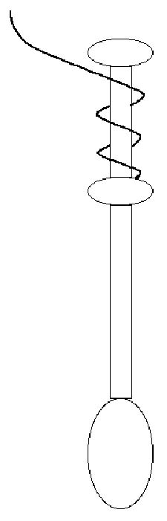 | Wind the thread onto the bobbins, making sure to wind in the same direction. The thread comes up on the right and wraps to the left.  Wind in pairs, when the first bobbin is wound, wind a second bobbin onto the other end of the thread.  If the threads are very long, it may be easier to wind all the thread onto one bobbin, then wind back to the middle.
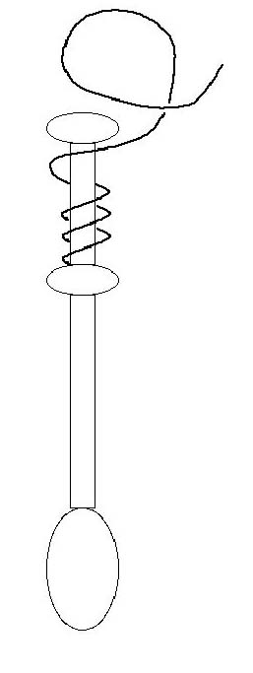 | 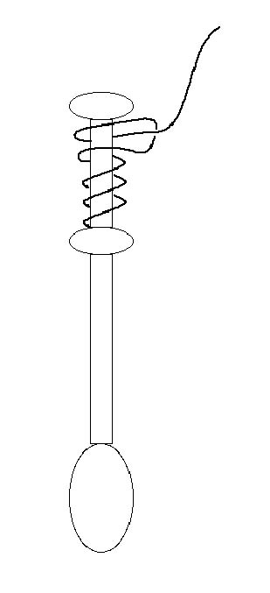 | End with a half hitch. Pay attention as you make the knots, because if they are not made properly, the bobbins will unwind as you work.  You can unwind more thread as you work by rotating the bobbin so the half hitch is on top.  Put a pin in the loop of the half hitch to wind up extra thread.
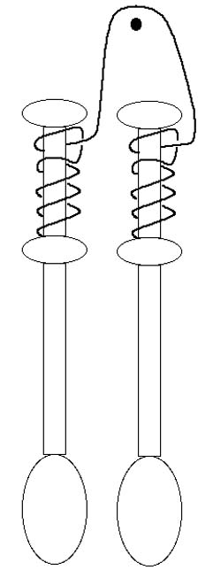  Hung in Pairs | Two pairs from one pin.
 | 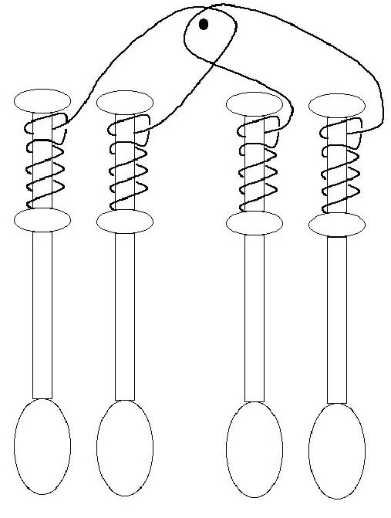  Juxtaposed |  | 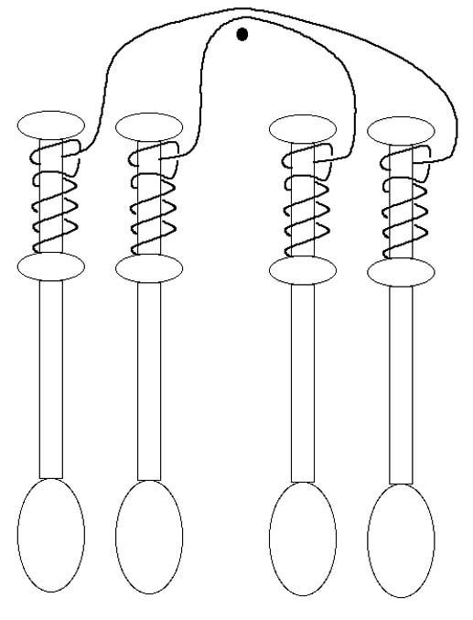  Superposed

