MIROIRS 1 (2001)

A collection of pieces I made between July and September 2001.

The title, “Miroirs” (Mirrors) came naturally after piece n.1, which actually uses pitch mirroring in the sequencer. Later I discovered that someone else not only already used the pitch-mirorring technique (a fact that was, after all, largely expected), but also made of it a (short-lived) commercial product. See references below.

But the mirroring is wider, most of this music is composed “after” someone else, or with the memories and feelings of other music I specially know and like. Most of the pieces exploit the “joking” side of my personality, as they are a kind of wordplay in themselves, besides of the jokes in the titles.

I worked hard for two months, and it was an unrepeatable experience I wasn’t used to.

Sometimes the results are still not up to my expectations, either because I’m not really a professional composer and because I have only a limited amount of resources in audio hardware and especially in available time. And because of the children I could only work with headphones.

Note 1 – All references to existing music, persons and situations are intentional.
I – Altamura
For tuba and orchestra
This piece starts from a MIDI file found by chance on the Net, the first movement of the Clarinet concerto by F.S.Mercadante, an Italian composer of the first half of 19th century, born in Altamura (whence the title).
The original piece sounds already a bit funny to my ears because of all the language conventions of its time, and it becomes even funnier after the mirroring of the pitches around a pivot, which reverses the intervals and morphs the major key into minor (e.g. C major into F minor, or Ab phrygian mode if you like).
The temporal ordering of events has not been changed and the corrections to the dissonances generated by the mirroring have been minimal. The melody, now into the low range, has been given to a tuba, counterpointed by a trumpet halfway between baroque and spaghetti western.

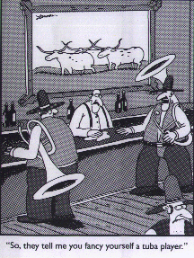

II – Prière Après La Communion, As Performed By Frank Zappa

For guitar and rock orchestra
Since the first moment I knew the “Prière Après La Communion” from “Livre du Saint Sacrément” for organ by Messiaen, I “heard” it played by a Zappa band of the ‘80s; I don’t know why, maybe the descending triolets of the melody, or the quasi-tonal harmonization, but I liked it most that way, and eventually I found the resources to attempt a rendering. The original piece is much slower and almost all in pianissimo; also a bit boring in my opinion. In this ‘Zappa-version’ I kept all the original pitches, while rhythms have been “flattened” (distorted, quantized). After some experiments, I discarded the last page full of dissonant chords because it broke the coherence of the piece. Sorry.

III – Cinque Variazioni Del Menga su una canzone di Lucio Battisti
Five stupid variations on a pop song, for piano
An experiment in automatic generation which starts from the chord sequence of a well-known piece by Battisti; the melody has been removed but seems to come out anyway. I tried different settings of style and soloists, mostly in the classical range, but I didn’t succeed in getting anything better than this, which I hope is already funny enough.

IV – Violazioni
For viola and other stuff
Violations, viola-actions, violently violating the viola. Some variations for ‘bass violin’ I wrote in the early ‘80s on a childlike theme, revised and lenghtened, with the added noises and effects made possible by the sampler.

V – Sunevenus
For orchestra
(sune)V(enus), a reversal both in pitch and time of a piece from “The Planets” by Holst, with a slightly different orchestration.

VI – Four Dances for the Bear Market
For piano (with many hands)
When you lose more than 20% of your vital energy you enter the Bear Market. There are signs of global slowdown. Investors brace themselves for any signs of good news, which usually start fast, furious and short-lived rallies. Consumer spending, which fuels two thirds of the economy, has kept you until now from recession. But bear markets can last a long time, and no recovery is in sight. So better shut up and play yer piano.

VII – Dances With Lobos
For horn and string orchestra
An eight-minute improvisation I did in a cold July evening, which remembered me of some adagios by Villa-Lobos (a brazilian composer I like much, and a Fish like me and my son) and, because of the atmosphere and choice of instruments, of the movie “Dances with Wolves”: from there the wordplay of the title. The piece in itself is serious and a bit sad. Editing has been minimal.

VIII – Leftodavel
For cembalo
Looks like I got this piece out of Conlon Nancarrow’s dumpster one day he probably had an headache attack. The piece evolves from atonality to a kind of spanish firework in E major. I don’t know what the title means, perhaps it just “sounded right”.
IX – Bossa Bassa
For piano and pop orchestra
“Low bossa”: a piece dated Nov.1979, reworked in a Jobim style with a little help from the computer and a lot of TV-show violins. It is “low” because it goes down a whole tone at every repetition.

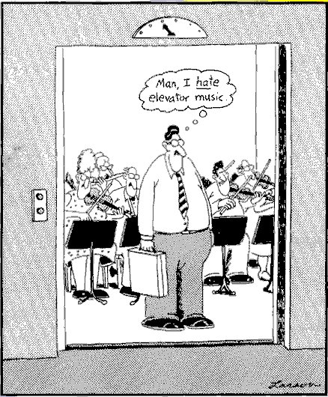

X – Sy(renée)s
Electronic music
An old myth, and an old memory. A remade of a piece I made in the SMET analog studio in 1975, but with updated sounds, because nowadays mermaids sing with the sampled voices of industrial music [“damn!”,”I’m coming”,”come on,man!”]. The piece has a background structure based on the 5-20-65 ratios of the engine control software, which distributes events between the accompanying instruments (harp, violins and percussion). As the piece goes on, the voices become more and more fragmented in a monster-like crescendo. We all know what the myth says about getting too near to such creatures.
It seems to be unavoidable to do stuff like this at least once when you have a CD of vocal samples…

XI - Rag-Bis
For organ

Two different ragtime-like pieces generated by algorithmic software, reversed and mixed in various ways with the harmony wandering from major to minor, and arranged for church organ with a result I hope is as funny as it was for me during its set-up.

XII – La Ville De Rien
For orchestra

A short piece between Messiaen and Rimski-Korsakov. A vision suddenly brokes out of the clouds with a horn theme developing into a climax following by a fugato of the strings. The vision disappears in the halo of a vibraphone.

XIII - WTC
For string orchestra and percussion
I improvised this piece in the night of Sep.12,2001, in a really frightened mood. The background rhythm is taken from Ravel’s “Le Gibet” and is played by a Native American drum.
The show goes on, but there’s a burning hole in it.

References and links

The Mirror Music page (Mirrormaker program no more available)
http://www.mirrormusic.co.uk/
F.S.Mercadante: Concerto per clarinetto
http://karadar.cs.unitn.it/Midi/mercadante_concert_cl_1mov.mid
Olivier Messiaen: Livre du Saint Sacrément – Vingt Regards n.4 – Ėclairs sur l’Au-Delà –
Méditations (Langage Communicable)
Frank Zappa : Joe’s Garage - Civilization Phase III („put a motor in yourself“)
Lucio Battisti: Umanamente Uomo
Gustav Holst: The Planets - Venus, the bringer of Peace
http://midiworld.com/DavidSiu/
CNNfn – the financial network
http://money.cnn.com
Kevin Costner: Dances with Wolves
Heitor Villa-Lobos: Bachianas Brasileiras n.1
Luciano Berio: Thema-Omaggio a Joyce – Questo Vuol Dire Che – Sequenza VI
Conlon Nancarrow: Studies for Player Piano
Maurice Ravel: Gaspard de la Nuit(Le Gibet)
The Viola jokes page:
http://www.mit.edu/~jcb/jokes/viola.html

J.L.Borges – Complete Works

And, of course, Gary Larsons „Far Side“ cartoons.

Materials

PC Athlon 800MHz
Creamware Pulsar + A-D converters Creamware A16
Keyboard Yamaha DX7
Sound modules: Roland SC-8850, M-OC1, M-SE1; Emu Proteus 1,Proteus 2
Samplers: Creamware STS4000
Sound libraries: Peter Siedlaczek Advanced Orchestra, Voice Spectral 2
Sequencer: Logic Audio 3.7
Audio editing: Cool Edit 2000
Other: Band-In-A-Box v8

Home Page: http://www.geocities.com/harawi.geo/
http://www.mp3.com/alberto_vignani

Composers on the cover, from top left:
Erik Satie – Luciano Berio – Lucio Battisti
Olivier Messiaen – Frank Zappa – Heitor Villa-Lobos
Conlon Nancarrow – Saverio Mercadante – Gustav Holst

