
Crusaders Explorer Scout Unit
(North Baddesley)

Membership Award

The Membership Award is only completed by those joining from outside the Movement. Scout Section members complete the Moving-On Award from the Scout Section.

To gain the Membership Award, the following requirements need to be completed:
- Describe the various options available locally to become an Explorer Scout.
- Show an understanding of the Scout Promise and Law.
- Demonstrate an understanding of local, national and international Scouting.
- After discussion with your Explorer Scout Leader, describe the Unit management and support available to you, including the Unit Constitution.
- Make the Scout Promise and accept the Scout Law.

You make the Promise and gain the Membership Award only once in Explorer Scouts, no matter how many Units you join. The location for making the Promise should be appropriate and memorable. The Promise should be made in front of the other Explorer Scouts.

You should make the Promise within a period of between six and twelve weeks of joining. Those who have been Scouts will probably be ready sooner than those who have not.

The Scout Promise
On My Honour, I promise that I will do my best
To do my duty to God and to the Queen,
To help other people
And to keep the Scout Law

The Scout Law
- A Scout is to be trusted
- A Scout is loyal
- A Scout is friendly and considerate
- A Scout belongs to the worldwide family of Scouts
- A Scout has courage in all difficulties
- A Scout makes good use of time and is careful of possessions and property
- A Scout has self-respect and respect for others

The Scout Motto
Be Prepared

Uniform
Uniform can be purchased from:
- Oasis Christian Centre, Church Street, Romsey
- 14th Eastleigh Group, Allbrook, Eastleigh, SO50 4LY
  - Opening hours are 14:00 to 16:00 Saturday and 18:00 to 20:00 Thursday
- John Lewis stock Scout uniform, but not the Explorer shirt or Romsey District Explorer scarf. However, you should be able to obtain other items there if they need to be replaced in future; the activity trousers, belt, and woggle are the same as for other Scout sections.

It is the Group's policy to encourage all Members to wear uniform as appropriate, but no-one will ever be barred because they cannot provide their own uniform. In cases of difficulty, please discuss the matter in confidence with a Leader.

Explorer Scout Uniform consists of:
- Beige long sleeve shirt or blouse ^{#1}
- Scout activity trousers ^{#2}
- Scout belt with buckle
- Romsey District Explorer scarf (Gold with a black border)
- Woggle

Note #1: Be careful to get the right colour shirt. The Explorer and adult shirts are quite similar, and we have been aware of cases where the shop has provided adult Leader (“stone” colour) shirts to Explorer Scouts who require an adult size. Explorer Scouts need the darker colour (“beige”) shirt.

Note #2: Smart Scout trousers are also available, but we wear the activity trousers with uniform, even at the remembrance and St. George's Day parades. You are not expected to have the smart trousers just for these two annual events.

Investiture Ceremony
You complete the final requirement of the Membership Award - to make the Scout Promise and accept the Scout Law - at the investiture ceremony. This is one of the most important ceremonies in Scouting and should be treated with respect. Your parents are welcome to attend your investiture, if you would like them to. You will need to have full Explorer Scout Uniform in time for your investiture, and wear it for the ceremony; everyone else in the Unit should also be in uniform.

Before the ceremony, you will be reminded of what will happen:
- The Unit will assemble and be called to the alert, and you'll be asked to come forward.
- After confirming that you understand the importance of the Scout Promise and Law, you and anyone else who has previously made their Promise make the Scout Sign. You'll make the Promise, “repeat-after-me style” so don't panic if you can't remember the exact words!
- You'll then be presented with your scarf and badges, and shake hands with the leader; Scouts shake hands with their left hand, as a sign of trust.
- The Leader will salute you, and you return the salute. You then turn to face the rest of the unit, salute them, and they return the salute.
- You return to the rest of the unit, as a fully invested member.

You may wear uniform before you have been invested, but without the badges and scarf.

Badge Positions
You will be presented with the following badges:
- “Crusader Explorer Unit” nametape - worn by all members of our Unit
- “Romsey District Explorers” nametape - worn by all Explorer Scouts in Romsey District
- Romsey District / Hampshire County badge - worn by all Scouts in Romsey District
  - The Hampshire County part of this badge is worn by all Scouts in Hampshire
- Membership badge - worn by all Scouts worldwide

The diagram below shows where these and other badges should be positioned on your uniform.
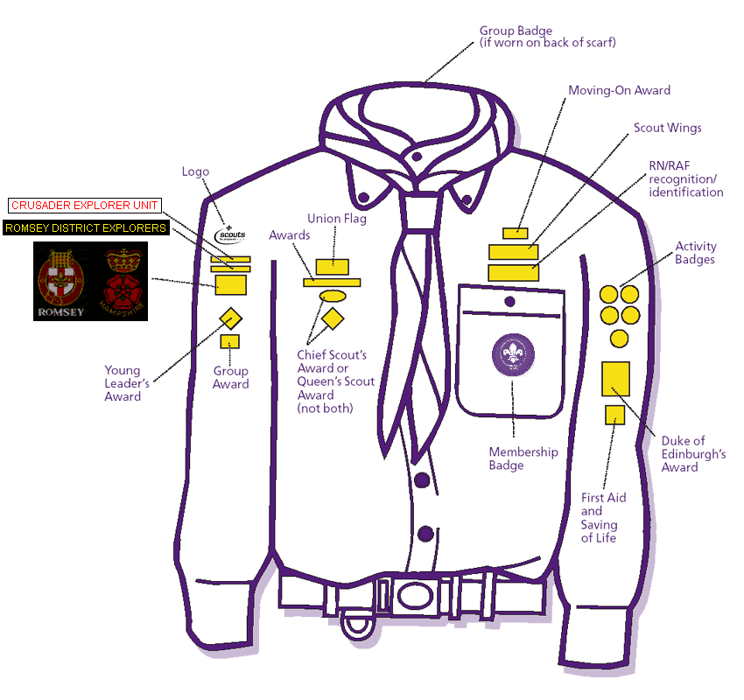
It is recommended that badges are sewn neatly onto your uniform, if possible using thread closely matching the boarder of each badge. Glues are available for fixing badges to clothing, but they can sometimes come unstuck around the edges and also make removing or replacing the badges difficult. This is particularly a problem with the staged activity badges and Chief Scout's Awards, which are replaced when you achieve a higher level.

