Digital Video Recorder Menu

Installation
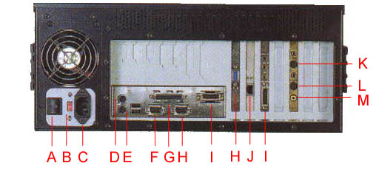
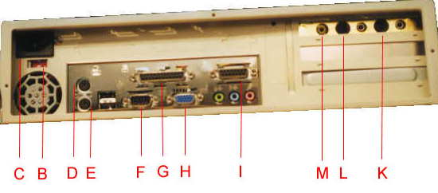
A. Main power switch
B. Voltage switch
- Power cord
- PS/2 mouse
- PC keyboard
- RS-232C
- Keypro
- PC VGA monitor
- Jog Shutter
- 10 / 100 Ethernet
- Video or S video in !!! plug in convert cable for video in
- S video out
- Video out
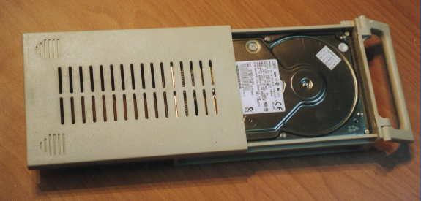

Put approved by Baming Enterprise co ltd. Harddisk into mobile rack

After installation

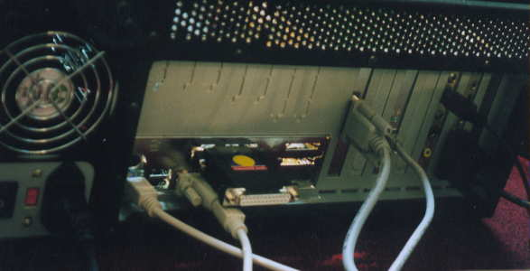
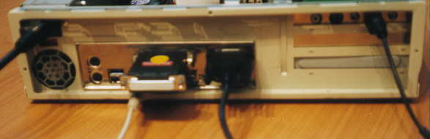

Operation
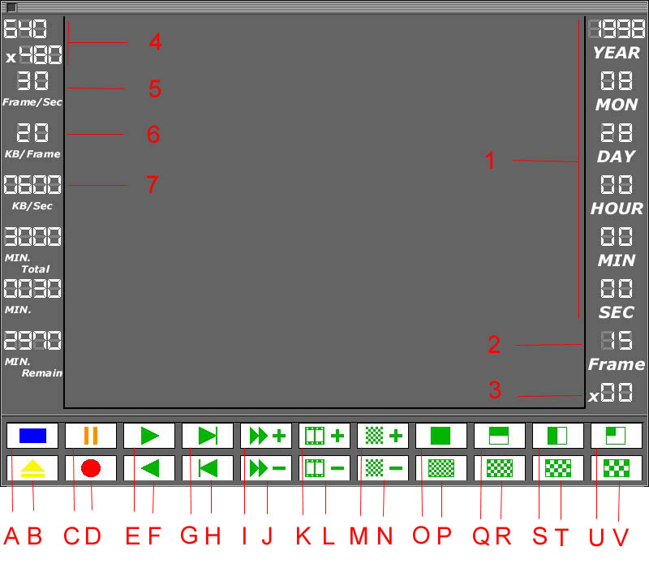
- Real time clock when stop & Recording display right time , when playing display the time when the frame record . and every frame has itself time code.
- Frame NTSC 30 frame PAL 25 frame
- Play speed 1 / 90 ~ 300 X
- Resolution control by O. 640 x 480 , Q. 640 x 240 , S. 320 x 480 , U. 320 x 240 .
- Frame per second control by K , L .
- Quality or frame size control by M , N .
- Data rate automatic count by digital video recorder.

- Stop
- Out put one frame to floppy disk in targa file .tga when pause
- Pause
- Record
- Play forward
- Play Backward
- Forward single frame
- Backward single frame
- Playing speed increase
- Playing speed decrease
- Frame per second increase
- Frame per second decrease
- Frame size increase
- Frame size decrease
- 640 x 480
- Preset frame size 50 KB / frame
- 640 x 240
- Preset frame size 30 KB / frame
- 320 x 480
- Preset frame size 20 KB / frame
- 320 x 240
- Preset frame size 16 KB / frame

CAUTION:

Don’t record different system ( NTSC , PAL ) or resolution ( 640 x 480 , 640 x 240 , 320 x 480 , 320 x 240 ) in the same harddisk

Jog shuttle
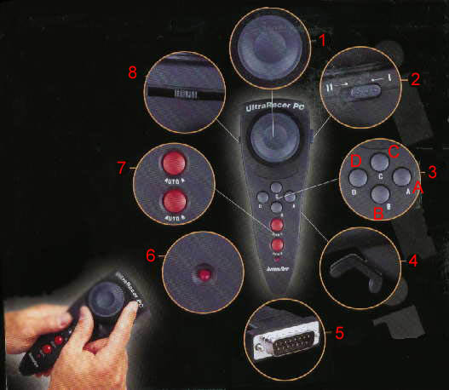

Also can use normal PC 4 button joystick

- Jog right turn for forward left turn for backward 1 ~ 300 X when normal playing mode , 1 / 90 ~ 1 X slow motion when in pause mode.
- Please set to mode II
- 4 button A , B , C , D
- Reserve
- Connect to Installation I cnnector
- Reserve
- Reserve
- Axis trim control

- Play forward when normal playing mode after B push forward single frame when pause mode , pause mode is when normal playing and push B again .
- Play or Pause push for normal play and push again for pause and push again back to normal play
- Stop or Record push to stop when normal playing mode when stop mode push C and push B to prepare record and push B again start record
- Play backward when normal playing mode after B push backward single frame when pause mode , pause mode is when normal playing and push B again .

If you turn right or left JOG then release will automatic back to center and pause but this is not in pause mode , you should push B again into normal playing mode and push B again to get into pause mode .

When in stop mode you can push D and hold then turn jog left and right to adjust frame size or video quality .

Finally thank you for purchase our products

Baming Enterprise Co., Ltd.
No 6, lane 39, sec 6, Roosevelt Rd. Taipei, Taiwan, R.O.C.
Tel: 886-2-2935-3693 Fax: 886-2-2931-5019
Email: service@baming.com Web site:www.baming.com

