Baming Vision Systems, Inc.
Remote Digital Monitoring Security System
FEATURES：
- D.I.Y Cost-effective
- Up to 3 video inputs.
- Plug-and-play installation (USB Interface).
- Build-in web server for internet browsing.
- Use a standard web browser as your client application.
- View the video of all cameras simultaneously or separately.
- Password for the authorized logging in.
- Support Windows Net-meeting .
- Send video E-mail when sensor sensed Alarm Trigger.
- Auto dialing when Alarm Trigger (Optional).
- Video recording.
- Local site or remote site monitoring.
- Alarm status reporting from remote site.
- Alarm setting from remote site.
- Home automation control from remote site (Option).
- Alarm logging reports.
- Scheduling video E-mail.

USB203SP spec:

PCB Module Type
USB Interface ( connector )
Power Indicator
Power supply form USB bus
Low Power Consume
3 CVBS Video in ( connector ) 4 CVBS Video in ( on chip )
Video System support NTSC , PAL
Video 1.0 Vpp

SYSTEM CONSTRUCTION： DESCRIPTION：
LOCAL SITE:
CCTV1 CCTV2 CCTV3 CCTV4 1. CCTV1~CCTV3：
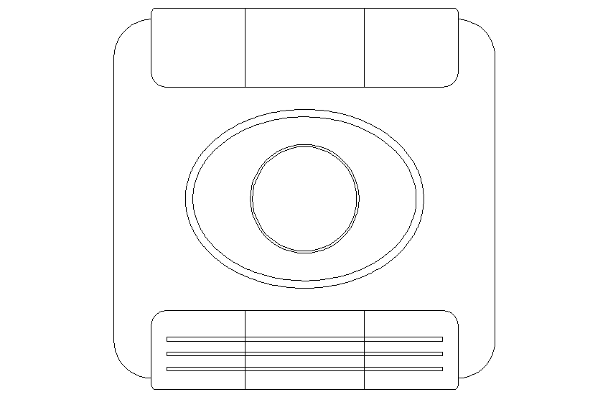
Camera with/without PIR Sensor

2. CCTV 4 WAY SWITCHER：
a. 3 Video Input
CCTV
4 Way
Switcher
b. Video System Support NTSC, PAL
c. USB Interface
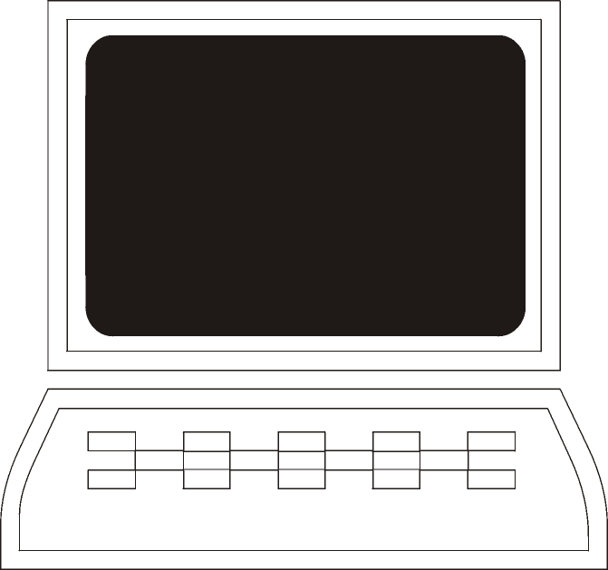
USB
RS-232
PC
ALARM
SYSTEM
RS-232
GSM Module
OR H.A. Controller
Auto Dialer
Network
Interface
3. PC REQUIREMENT：
a. Pentium 200 minimum
b. Windows 98 minimum
c. CD-ROM Drive
d. USB Port
32M DRAM minimum
64M DRAM Recommend
e. Outlook Express email
f. Network Interface：
•ADSL,XDSL MODEM
•CABLE MODEM
•ISDN
•PSTN (Dial-up Modem)
4. Alarm System
5. Auto Dialer (Option)
6. GSM Module (Option)
7. Home Automation Controller (Option)
GSM
ROUTE：
- INTERNET
PSTN
INTERNET
- PSTN
- GSM



REMOTE SITE：
TelephoneMobile Phone PC
- PC REQUIREMENT：
- Telephone
- Mobile Phone：
•GSM/GPRS
•SMS

