 Targeting &Tracing System
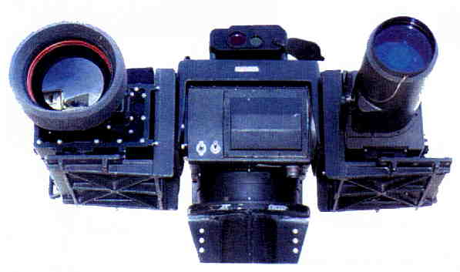

Video Out

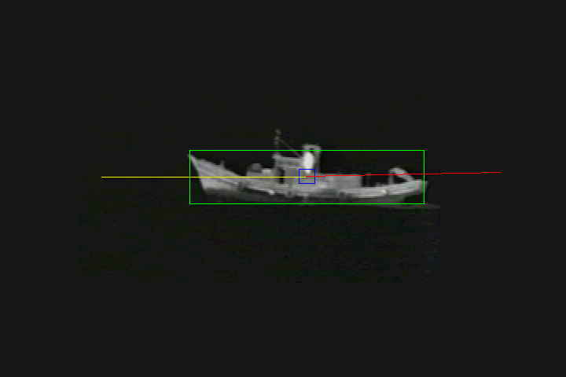

RS-232 Control output
Control Pan Tilt Zoom
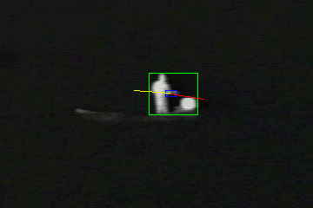

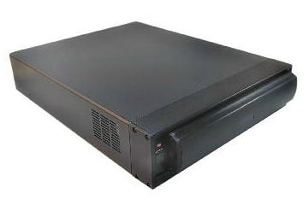

Thermal Video

Baming Vision Systems,Inc.

No 6, lane 39, sec 6, Roosevelt Rd. Taipei, Taiwan, R.O.C.
Tel: 886-2-2935-3693 Fax: 886-2-2931-5019
Http://www.baming.com

Email: sales@baming.com

