Compact / 2U 19” Rackmount
Digital Recorder Specification
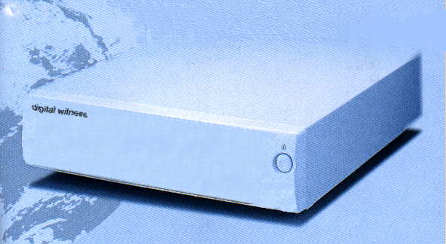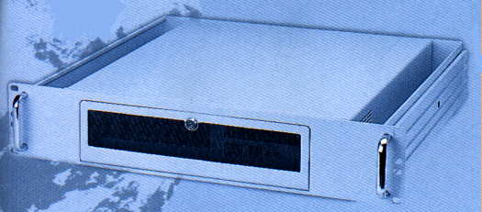

Power Requirement : AC 90 V ~ AC 240 V, 50 ~ 60 Hz , DC 12V , 24 V
Operating Temperature : - 10℃ to 50℃
Approx. Weight : 8 Kg
Compact Dimension: 423 D * 350 W * 85 H mm
2U 19” Rackmount Dimension: 415 D * 429.5 W * 88 H mm
Recording Media : 25 GB Hard-Disk
Shock Prevent ( mobile use ): build in shock reduce mechanism
All specification same with STANDARD Digital Recorder Except Above
Application Example :
Disk Capacity (GB) 25 25 25 25 25 25
Rec. Quality (KB/Frame) 15 20 20 20 30 30
Rec. Frame Rate (Frame/Sec) 5 10 25 30 25 30
Rec. Capacity (KB/Sec) 75 200 500 600 750 900
Max. Rec. Time (Hour) 92.59 34.72 13.8 11.57 9.25 7.71
PAL NTSC PAL NTSC
S-VHS quality LaserDisk quality

