Baming Vision Systems, Inc.
Personal Digital Video Recorder

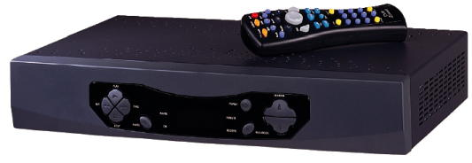

BVS Personal Digital Video Recorder (PVR) can make it easy to capture shows on a hard disk and watch them whenever you want. PVR can act as a personal assistant, changing channels for you, recording programs that interest you, letting you watch shows whatever and whenever you want. With BVS PVR, you can easily control live TV with the ability to pause, forward, rewind, and instantly replay television shows as they are broadcasting.

Features:
- Pause live TV during interruption: up to 30 ~ 60 minutes
- Fast forward with three speeds: 2x, 4x and 8x
- Slow motion with three speeds: 1/2x, 1/4x, and 1/8x
- Instant replay button jumps you back 8 seconds
- Instant replay
- User defined video-quality level
- Automatic nightly clock set
- Compatible with cable, satellite, and antenna programming feeds
- Schedule recording within 90 days
- Program status bar displays where you are in the show for cached and real time

Electrical Specification
MPEG2/MPEG1 CODEC
Hard Disk Driver: 20G byte (Default)
System and Graphic SDRAM: 8 M byte
System Flash: 1 M byte
Audio R/L

Power Supply
Input AC power: 110/220 V AC, 50/60 Hz
Power consumption: 50W max , 25W typical

Mechanical Specification
Dimension (W x D x H):
416.6mm x 277.7mm x 81.0mm
Net weight: 3.4 Kg

Connections
Composite Video Input x 2
Audio Input x 4 (L & R x 2)
Composite Video Output x 1
Audio Output x 2 (L & R x 1)
S-Video Input x 1
S-Video Output x 1

Baming Vision Systems, Inc.
Rm. 1, 9FL, No. 101, Sec. 2, Ho Ping E. Rd., Taipei, Taiwan
Tel: 886-2-2701-5178 Fax: 886-2-2703-5801
No. 6, Lane 39, Sec 6, Roosevelt Rd., Taipei, Taiwan
Tel: 886-2-2935-3693 Fax: 886-2-2931-5019
http://www.baming.com/ Email: sales@baming.com

