Aims and Objectives
- To serve as a Model of good practice in Urban food growing using solely Organic (HDRA approved) methods.
- To encourage the growing of older varieties of vegetables no longer commercially available, and an interest in the nutritional value of the vegetables grown. (Seed to be saved where possible).
- To provide a managed wildlife habitat and promote bio-diversity.
- To provide a focus and a stimulus for community action.
- To provide a community composting scheme.
- Subsidiary Aims
- To provide educational facilities for gardening, composting and nature studies.
- To encourage whole family involvement (as do continental allotment sites.)
- To keep records of the Garden's evolution, inputs and outputs, plantings and a wildlife log.
- To introduce novel and improved methods of gardening making maximum use of recycled and locally obtained materials

Why Organic
Growing food organically means using nature’s balanced means to enrich the soil – plenty of home-made compost.

Rather than use pesticides, natural predators are encouraged – birds, hedgehogs and frogs are mostly friends in the garden.

Started and supported by Poole Local Agenda 21, and East Dorset Friends of the Earth, in collaboration with Poole Council.

No experience required.

For more information or to join see www.geocities.com/poole_la21/tops.htm , ring Gary 01202 679517 or Andy on 389782 (evenings) or just come along on the third Saturday of the month between 10am and 3pm.

Andy Hadley - Ver 10.07
Tatnam Organic Patch, Sherrin Close, Oakdale

Calling all aspiring gardeners.
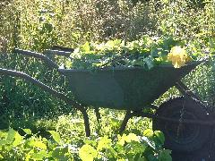

How would you like to be involved in the garden of the future ? Come and join us at TOP (the Tatnam Organic Patch community allotment). Get gentle exercise, far more cheaply than at a gym. Grow delicious organic fruit and vegetables in good company in an environmentally friendly way. Join us in cropping, cooking and sampling seasonal delights like squash soup, bean stew, apple and blackberry crumble.
Come and watch the huge variety of wildlife in this urban oasis. We welcome families, and also organise a number of school visits during the year.

Why HDRA ?
HDRA stands for the Henry Doubleday Research Association. They research, demonstrate, and promote sustainable growing techniques, and offer the Heritage Seed Library.
http://www.gardenorganic.org.uk/ We follow their guidelines, which suggest avoiding wood preservative and copper sulphate, promote crop rotation and composting etc.

Food Miles
Shop bought food may have travelled many miles. Some food undergoes long journeys to be packaged and further distributed. The sugars in many vegetables turn to starch once picked. There is nothing so fresh or satisfying as food you have grown yourself. And at Tatnam Organic Patch, we share work according to skills and ability, and crops according to what’s ready, and who is about.

School Visits
We encourage local schools to visit the site on organised trips, and will share our enthusiasm.
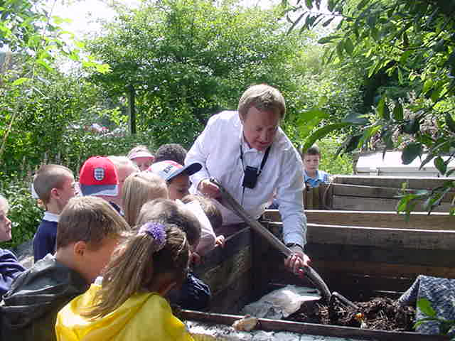

Wildlife Garden
The Tatnam Patch is not a pristine garden, we have planted, encouraged or tolerated many ‘weeds’, especially where these provide food or egg-laying sites for butterflies and moths. Many native plants are becoming rarer with modern farming methods and garden makeovers.

We have nesting boxes, resident foxes, frogs and newts. We have dug several ponds to encourage the latter.

There are a wide variety of trees on-site. We have planted fruit trees, hazel and walnut, but there are also mature oaks and willow.

Trees provide shade, windbreaks, and cover for birds.
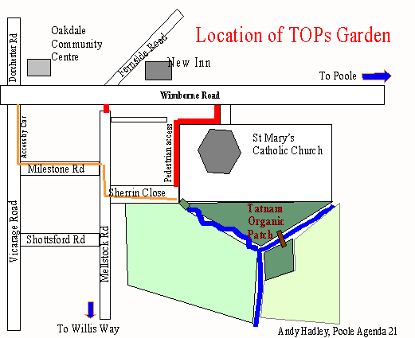

Permaculture
The garden was not set-up as a permaculture site, but has grown towards it. Permaculture is a philosophy of designing human settlement around natural eco-systems. To live more lightly on the planet, and to maximise the benefits from a space through observing and working with the land, rather than attempting to force methods or plants that do not suit.

We are learning about making this work.

